Waverley Local Government Area (LGA)

Household size
The size of households in general follows the life-cycle of families. Households are usually small at the stage of relationship formation (early marriage), and then increase in size with the advent of children. They later reduce in size again as these children reach adulthood and leave home. Household size can also be influenced by a lack (or abundance) of affordable housing. Overseas migrants and indigenous persons often have a tradition of living with extended family members which significantly affects household size.
Household size in Australia has generally declined since the 1970s, but the rate of decline has slowed in recent years.
An increasing household size in an area may indicate a lack of affordable housing opportunities for young people, an increase in the birth rate or an increase in family formation in the area. A declining household size may indicate children leaving the area when they leave home, an increase in retirees settling in the area, or an attraction of young singles and couples to the area.
For greater insight, Bondi Beach's Household Size data should be viewed in conjunction with Household Summary, Age Structure, Dwelling Type, Household Income and Language Spoken at Home.
Household size
Bondi Beach - Households (Enumerated) | 2021 |  |  | 2016 |  |  | Change
Number of persons usually resident | Number | % | Waverley Council area % | Number | % | Waverley Council area % | 2016 to 2021
1 person | 1,867 | 36.0 | 29.9 | 1,536 | 32.4 | 27.7 | +331
2 persons | 2,067 | 39.9 | 36.0 | 1,946 | 41.1 | 36.0 | +121
3 persons | 681 | 13.1 | 15.0 | 701 | 14.8 | 16.3 | -20
4 persons | 434 | 8.4 | 13.3 | 412 | 8.7 | 13.6 | +22
5 persons | 100 | 1.9 | 4.6 | 112 | 2.4 | 4.8 | -12
6 or more persons | 34 | 0.7 | 1.2 | 29 | 0.6 | 1.6 | +5
Total classifiable households | 5,183 | 100.0 | 100.0 | 4,736 | 100.0 | 100.0 | +447
Household size - Summary
Bondi Beach - Enumerated | 2021 |  |  | 2016 |  |  | Change
Dwellings | Number | % | Waverley Council area % | Number | % | Waverley Council area % | 2016 to 2021
Occupied private dwellings | 5,503 |  |  | 5,578 |  |  | -75
Persons in occupied private dwellings | 10,876 |  |  | 11,130 |  |  | -254
Average household size (persons per dwelling) | 1.98 |  | 2.27 | 2.00 |  | 2.27 | 0.02
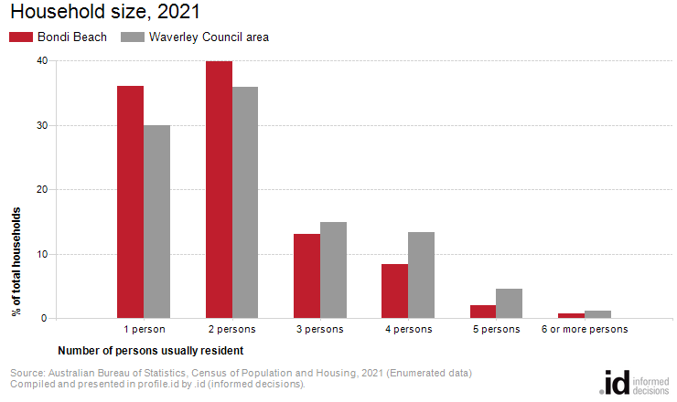
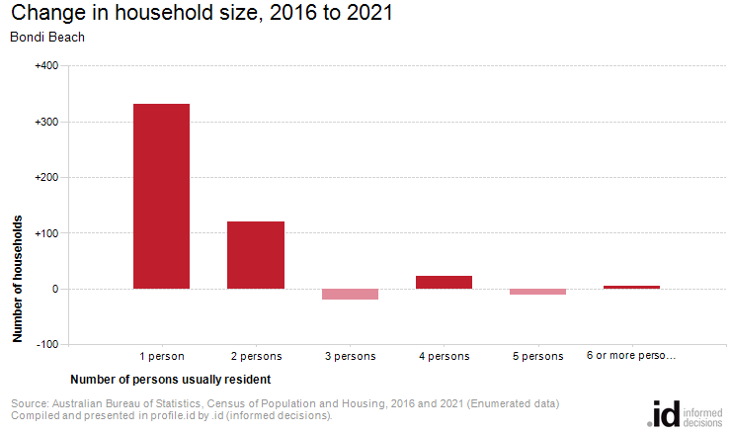
Analysis of the number of persons usually resident in a household in Bondi Beach compared with Waverley Council area shows that there were a higher proportion of lone person households, and a lower proportion of larger households (those with 4 persons or more). Overall there were 36.0% of lone person households, and 11.0% of larger households, compared with 29.9% and 19.1% respectively for Waverley Council area.
The major differences in the household size for Bondi Beach and Waverley Council area were:
- A larger percentage of households with 1 person usually resident (36.0% compared to 29.9%)
- A larger percentage of households with 2 persons usually resident (39.9% compared to 36.0%)
- A smaller percentage of households with 4 persons usually resident (8.4% compared to 13.3%)
- A smaller percentage of households with 5 persons usually resident (1.9% compared to 4.6%)
The number of households in Bondi Beach increased by 447 between 2016 and 2021.
The largest changes in the number of persons usually resident in a household in Bondi Beach between 2016 and 2021 were:
- 1 person (+331 households)
- 2 persons (+121 households)

