Southern Sydney Regional Organisation of Councils (SSROC)

Religion
Inner West Council area's religion statistics provide an indicator of cultural identity and ethnicity when observed in conjunction with other key variables. Religion data reveal the major concentrations of religions as well as revealing the proportion of people with no religious affiliation. There are a number of reasons for different religious compositions across areas including the country of birth and ethnic background of the population, the age of the population (belief in religion is generally stronger, the older the population) and changes in values and belief systems.
Inner West Council area's religion statistics should be analysed in conjunction with other ethnicity statistics such as Country of Birth data and Language Spoken data to assist in identifying specific cultural and ethnic groups.
Please note: Due to changes in ABS rules around perturbation and additivity of data to protect the confidentiality of individuals, counts of individual religion groups and totals derived from them may differ slightly from those published by the ABS.
Religion - Summary
Inner West Council area - Total persons (Usual residence) | 2021 |  |  | 2016 |  |  | Change
Religion totals | Number | % | SSROC region % | Number | % | SSROC region % | 2016 to 2021
Christian total | 64,979 | 35.5 | 42.8 | 72,209 | 39.7 | 46.7 | -7,230
Non Christian total | 14,212 | 7.8 | 16.5 | 15,194 | 8.3 | 15.0 | -982
Non-classifiable religious belief | 1,419 | 0.8 | 0.5 | 1,611 | 0.9 | 0.5 | -192
No Religion/secular beliefs | 92,301 | 50.5 | 33.5 | 74,636 | 41.0 | 28.1 | +17,665
Not stated | 9,916 | 5.4 | 6.7 | 18,387 | 10.1 | 9.7 | -8,471
Total Population | 182,827 | 100.0 | 100.0 | 182,037 | 100.0 | 100.0 | +790
Religion - Ranked by size
Inner West Council area - Total persons (Usual residence) | 2021 |  |  | 2016 |  |  | Change
Religion | Number | % | SSROC region % | Number | % | SSROC region % | 2016 to 2021
Western (Roman) Catholic | 36,438 | 19.9 | 21.1 | 39,803 | 21.9 | 22.5 | -3,365
Anglican | 10,577 | 5.8 | 7.0 | 12,988 | 7.1 | 8.8 | -2,411
Greek Orthodox | 6,426 | 3.5 | 4.8 | 6,520 | 3.6 | 4.8 | -94
Buddhism | 6,059 | 3.3 | 4.2 | 6,565 | 3.6 | 4.2 | -506
Hinduism | 3,751 | 2.1 | 3.0 | 4,407 | 2.4 | 2.5 | -656
Islam | 2,497 | 1.4 | 7.2 | 2,534 | 1.4 | 6.2 | -37
Christian,nfd | 2,496 | 1.4 | 2.0 | 2,364 | 1.3 | 1.9 | +132
Presbyterian and Reformed | 1,801 | 1.0 | 1.2 | 2,345 | 1.3 | 1.6 | -544
Uniting Church | 1,724 | 0.9 | 1.1 | 2,231 | 1.2 | 1.5 | -507
Judaism | 933 | 0.5 | 1.7 | 769 | 0.4 | 1.6 | +164
Baptist | 905 | 0.5 | 0.9 | 983 | 0.5 | 1.0 | -78
Maronite Catholic | 892 | 0.5 | 1.0 | 854 | 0.5 | 0.8 | +38
Pentecostal | 586 | 0.3 | 0.6 | 769 | 0.4 | 0.7 | -183
Other Protestant | 433 | 0.2 | 0.4 | 496 | 0.3 | 0.4 | -63
Serbian Orthodox | 408 | 0.2 | 0.2 | 386 | 0.2 | 0.2 | +22
Macedonian Orthodox | 371 | 0.2 | 0.7 | 345 | 0.2 | 0.7 | +26
Jehova's Witnesses | 316 | 0.2 | 0.2 | 295 | 0.2 | 0.2 | +21
Lutheran | 293 | 0.2 | 0.1 | 357 | 0.2 | 0.2 | -64
Other Non-Christian Religions | 285 | 0.2 | 0.1 | 290 | 0.2 | 0.1 | -5
Other Eastern Orthodox | 260 | 0.1 | 0.3 | 206 | 0.1 | 0.3 | +54
Russian Orthodox | 243 | 0.1 | 0.2 | 231 | 0.1 | 0.2 | +12
Coptic Orthodox | 192 | 0.1 | 0.4 | 212 | 0.1 | 0.4 | -20
Paganism | 148 | 0.1 | 0.0 | 102 | 0.1 | 0.0 | +46
Sikhism | 130 | 0.1 | 0.1 | 139 | 0.1 | 0.2 | -9
Seventh Day Adventist | 117 | 0.1 | 0.1 | 165 | 0.1 | 0.1 | -48
Chinese and Japanese Religions | 112 | 0.1 | 0.1 | 142 | 0.1 | 0.1 | -30
Other Eastern Catholic | 86 | 0.0 | 0.1 | 73 | 0.0 | 0.1 | +13
Other Christian | 83 | 0.0 | 0.0 | 108 | 0.1 | 0.1 | -25
Latter Day Saints (Mormons) | 73 | 0.0 | 0.1 | 109 | 0.1 | 0.1 | -36
Baha'i | 71 | 0.0 | 0.0 | 63 | 0.0 | 0.0 | +8
Salvation Army | 69 | 0.0 | 0.1 | 136 | 0.1 | 0.1 | -67
Other Nature Religions | 67 | 0.0 | 0.0 | 46 | 0.0 | 0.0 | +21
Other Oriental Orthodox | 60 | 0.0 | 0.1 | 79 | 0.0 | 0.1 | -19
Wiccan/Witchcraft | 58 | 0.0 | 0.0 | 33 | 0.0 | 0.0 | +25
Spiritualism | 55 | 0.0 | 0.0 | 71 | 0.0 | 0.0 | -16
Australian Aboriginal Traditional Religions | 46 | 0.0 | 0.0 | 29 | 0.0 | 0.0 | +17
Armenian Apostolic | 46 | 0.0 | 0.0 | 47 | 0.0 | 0.0 | -1
Churches of Christ | 39 | 0.0 | 0.0 | 62 | 0.0 | 0.1 | -23
Assyrian Apostolic | 29 | 0.0 | 0.0 | 32 | 0.0 | 0.0 | -3
Christadelphian | 16 | 0.0 | 0.0 | 21 | 0.0 | 0.0 | -5
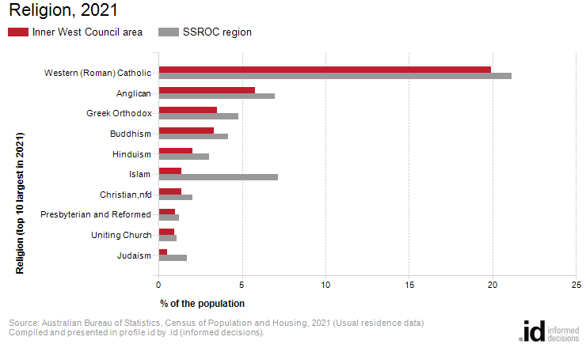
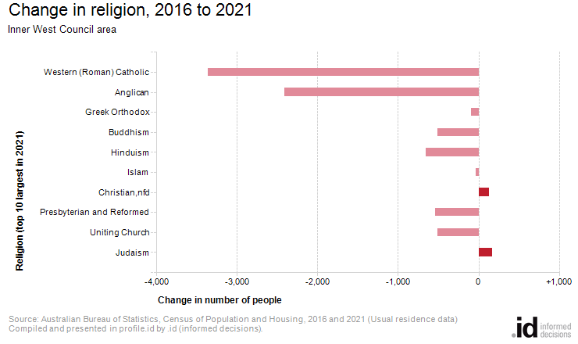
Analysis of the religious affiliation of the population of Inner West Council area in 2021 compared to SSROC region shows that there was a lower proportion of people who professed a religion and a higher proportion who stated they had no religion.
Overall, 43.3% of the population nominated a religion, and 50.5% said they had no religion, compared with 59.4% and 33.5% respectively for SSROC region.
The largest single religion in Inner West Council area was Western (Roman) Catholic, with 19.9% of the population or 36,438 people as adherents.
The major differences between the religious affiliation for the population of Inner West Council area and SSROC region were:
- A smaller percentage who nominated Islam (1.4% compared to 7.2%)
- A smaller percentage who nominated Greek Orthodox (3.5% compared to 4.8%)
- A smaller percentage who nominated Western (Roman) Catholic (19.9% compared to 21.1%)
- A smaller percentage who nominated Anglican (5.8% compared to 7.0%)
The largest changes in the religious affiliation of the population in Inner West Council area between 2016 and 2021 were for those who nominated:
- Western (Roman) Catholic (-3,365 persons)
- Anglican (-2,411 persons)
- Hinduism (-656 persons)
- Presbyterian and Reformed (-544 persons)

