Shellharbour City Council

Volunteer work
The voluntary work sector is an important part of Australia's economy. The level of volunteering can indicate the cohesiveness of the community and how readily individuals are able to contribute to that community. Factors impacting on the level of volunteering in Albion Park Rail include the Age Structure of the population, the level of Proficiency in English, Income and Education levels.
Volunteer numbers for the 2021 Census declined in many parts of Australia due to lockdowns and COVID-19 distancing measures.
Volunteer work
Albion Park Rail - Persons aged 15+ (Usual residence) | 2021 |  |  | 2016 |  |  | Change
Volunteer status | Number | % | Shellharbour City % | Number | % | Shellharbour City % | 2016 to 2021
Volunteer | 537 | 9.4 | 9.7 | 809 | 14.3 | 14.7 | -272
Not a volunteer | 4,901 | 85.8 | 85.2 | 4,302 | 76.3 | 78.2 | +599
Volunteer work not stated | 272 | 4.8 | 5.1 | 529 | 9.4 | 7.1 | -257
Total persons aged 15+ | 5,710 | 100.0 | 100.0 | 5,640 | 100.0 | 100.0 | +70
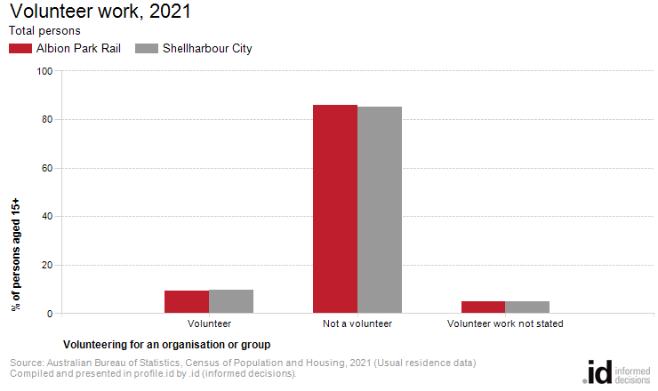
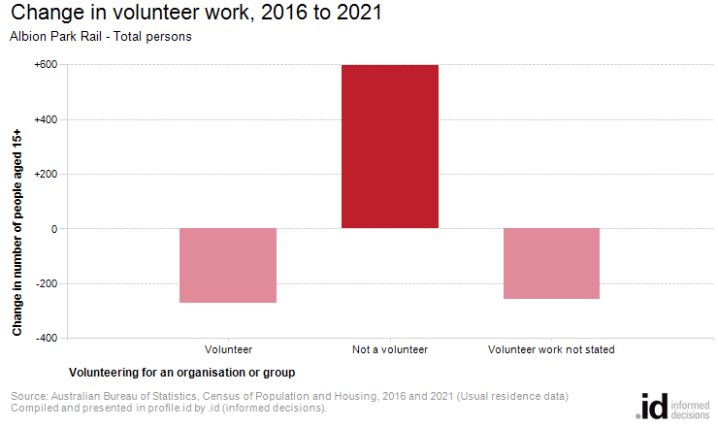
Analysis of the voluntary work performed by the population in Albion Park Rail in 2021 compared to Shellharbour City shows that there was a similar proportion of people who volunteered for an organisation or group.
Overall, 9.4% of the population reported performing voluntary work, compared with 9.7% for Shellharbour City.
The number of volunteers in Albion Park Rail decreased by 272 people between 2016 and 2021.

