Rockhampton Regional Council

Education institution attending
The share of Rockhampton's population attending educational institutions reflects the age structure of the population, as it is influenced by the number of children attending school; proximity to tertiary education, which can mean young adults leaving home to be nearer to educational facilities and; the degree to which people are seeking out educational opportunities in adulthood, especially in their late teens and early twenties.
This data is often combined with Age Structure to identify areas with significant university student populations.
Learn more about planning education provision here.
Education institution attending
Rockhampton - Total persons (Usual residence) | 2021 |  |  | 2016 |  |  | Change
Type of institution | Number | % | Regional QLD % | Number | % | Regional QLD % | 2016 to 2021
Pre-school | 1,221 | 1.5 | 1.5 | 779 | 1.0 | 1.2 | +442
Primary school | 7,118 | 8.7 | 8.0 | 7,053 | 8.8 | 8.5 | +65
Primary - Government | 4,292 | 5.2 | 5.4 | 4,407 | 5.5 | 5.8 | -115
Primary - Catholic | 1,933 | 2.4 | 1.6 | 1,805 | 2.3 | 1.6 | +128
Primary - Independent | 893 | 1.1 | 1.1 | 841 | 1.1 | 1.1 | +52
Secondary school | 6,038 | 7.4 | 6.7 | 5,585 | 7.0 | 6.3 | +453
Secondary - Government | 2,682 | 3.3 | 4.1 | 2,353 | 3.0 | 3.9 | +329
Secondary - Catholic | 2,129 | 2.6 | 1.3 | 1,960 | 2.5 | 1.3 | +169
Secondary - Independent | 1,227 | 1.5 | 1.3 | 1,272 | 1.6 | 1.2 | -45
TAFE/Vocational | 1,313 | 1.6 | 2.0 | 1,196 | 1.5 | 1.5 | +117
University | 2,615 | 3.2 | 3.2 | 2,710 | 3.4 | 3.3 | -95
Other | 708 | 0.9 | 0.8 | 605 | 0.8 | 0.7 | +103
Not attending | 56,576 | 69.0 | 70.1 | 55,069 | 69.1 | 69.9 | +1,507
Not stated | 6,373 | 7.8 | 7.5 | 6,731 | 8.4 | 8.7 | -358
Total | 81,962 | 100.0 | 100.0 | 79,728 | 100.0 | 100.0 | +2,234
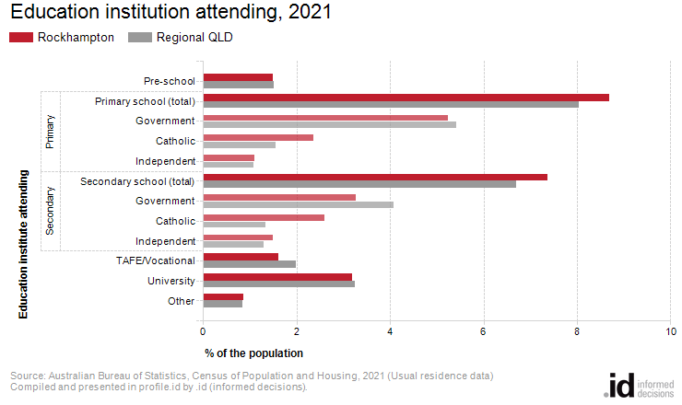
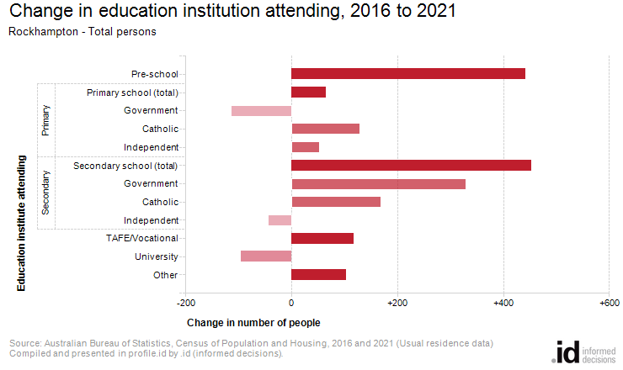
Analysis of the share of the population attending educational institutions in Rockhampton in 2021 compared to Regional QLD shows that there was a higher proportion attending primary school, a higher proportion attending secondary school, and a similar proportion engaged in tertiary level education.
Overall, 8.7% of the population were attending primary school, 7.4% of the population were attending secondary institutions, and 4.8% were learning at a tertiary level, compared with 8.0%, 6.7% and 5.2% respectively for Regional QLD.
The major differences between the share of the population attending learning institutions in Rockhampton and Regional QLD were:
- A larger percentage of persons attending a Catholic secondary school (2.6% compared to 1.3%)
- A smaller percentage of persons not attending (69.0% compared to 70.1%)
From 2016 to 2021, Rockhampton's population increased by 2,234 people (+2.8%). This represents an average annual change of 0.55% per year over the period.
The largest changes in the number of persons attending education institutions in Rockhampton, between 2016 and 2021 were in those who nominated:
- Secondary school (+453 persons)
- Pre-school (+442 persons)
- Secondary - Government (+329 persons)
- Secondary - Catholic (+169 persons)

