Redland City Council

Proficiency in English
Proficiency in English measures the self-assessed proficiency in spoken English of people who speak a language other than English at home. The data, when viewed with other ethnic and cultural indicators, such as Ancestry, Country of Birth, Language Spoken at Home and Religion, reflects Redland Bay's ethnic composition and how long the overseas born have been in Australia. This helps service providers determine whether they need to communicate with the local population in languages other than English.
Proficiency in English
Redland Bay - Total persons (Usual residence) | 2021 |  |  | 2016 |  |  | Change
English proficiency | Number | % | Redland City % | Number | % | Redland City % | 2016 to 2021
Speaks English only | 15,589 | 91.4 | 88.9 | 14,018 | 89.9 | 88.9 | +1,571
Speaks English well or very well | 867 | 5.1 | 6.9 | 736 | 4.7 | 6.2 | +131
Speaks English not well or not at all | 72 | 0.4 | 0.7 | 69 | 0.4 | 0.7 | +3
Not stated | 531 | 3.1 | 3.4 | 770 | 4.9 | 4.2 | -239
Total population | 17,059 | 100.0 | 100.0 | 15,593 | 100.0 | 100.0 | +1,466
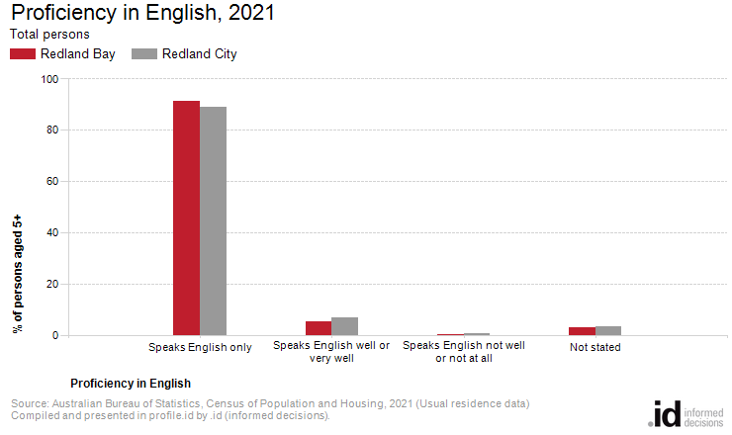
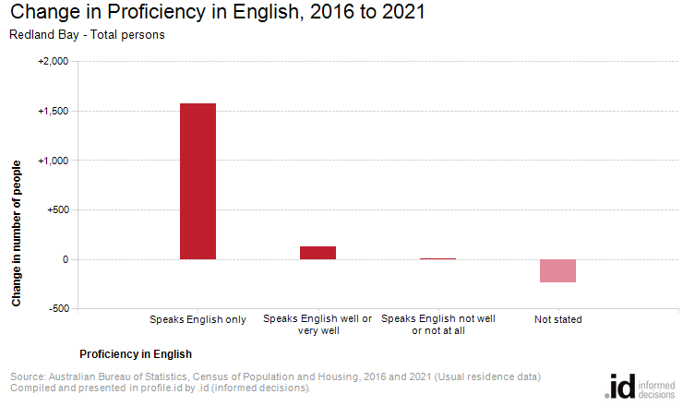
Analysis of the proficiency in English data of the population in Redland Bay in 2021 compared to Redland City shows that there was a higher proportion of people who spoke English only, and a similar proportion of people who spoke another language and English not well or not at all.
Overall, 91.4% of people spoke English only, and 0.4% spoke another language and English not well or not at all, compared with 88.9% and 0.7% respectively for Redland City.
The most significant changes in the proficiency in English of the population in this area between 2016 and 2021 were in those speaking:
- Speaks English only (+1,571 persons)
- Speaks English well or very well (+131 persons)

