Redland City Council

Highest level of schooling
Redland Bay's school completion data is a useful indicator of socio-economic status. With other indicators, such as Proficiency in English, the data informs planners and decision-makers about people's ability to access services. Combined with Educational Qualifications it also allows assessment of the skill base of the population.
Learn more about planning education provision here.
Persons aged 15 years and over
Highest level of secondary schooling completed
Redland Bay - Total persons (Usual residence) | 2021 |  |  | 2016 |  |  | Change
Level of schooling | Number | % | Redland City % | Number | % | Redland City % | 2016 to 2021
Year 8 or below | 417 | 3.1 | 3.6 | 458 | 3.8 | 4.3 | -41
Year 9 or equivalent | 694 | 5.1 | 5.0 | 599 | 4.9 | 4.9 | +95
Year 10 or equivalent | 3,631 | 26.6 | 24.7 | 3,442 | 28.3 | 26.5 | +189
Year 11 or equivalent | 1,122 | 8.2 | 8.0 | 1,089 | 9.0 | 8.3 | +33
Year 12 or equivalent | 7,220 | 52.8 | 53.8 | 5,734 | 47.2 | 49.7 | +1,486
Did not go to school | 31 | 0.2 | 0.3 | 24 | 0.2 | 0.2 | +7
Not stated | 549 | 4.0 | 4.7 | 798 | 6.6 | 6.0 | -249
Total persons aged 15+ | 13,664 | 100.0 | 100.0 | 12,144 | 100.0 | 100.0 | +1,520
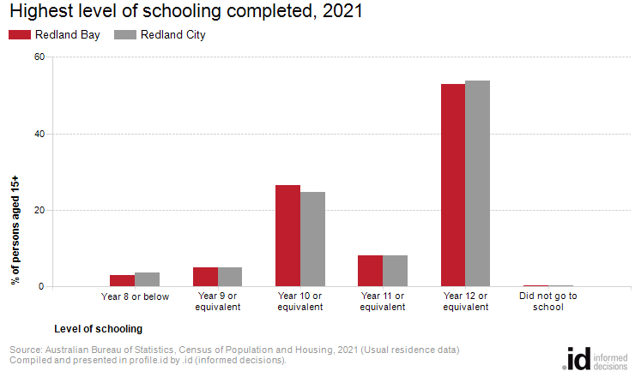
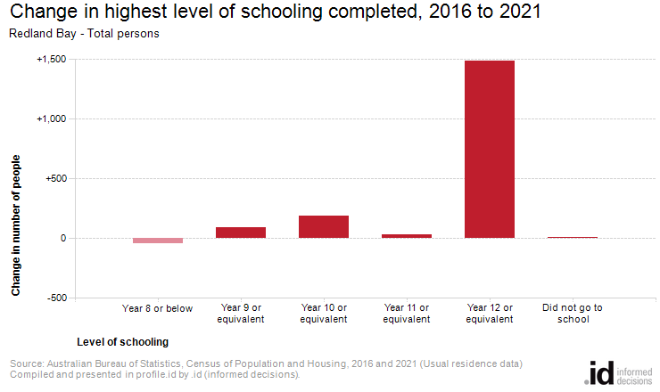
Analysis of the highest level of schooling attained by the population in Redland Bay in 2021 compared to Redland City shows that there was a higher proportion of people who had left school at an early level (Year 10 or less) and a lower proportion of people who completed Year 12 or equivalent.
Overall, 34.9% of the population left school at Year 10 or below, and 52.8% went on to complete Year 12 or equivalent, compared with 33.5% and 53.8% respectively for Redland City.
The major difference between the level of schooling attained by the population in Redland Bay and Redland City was:
- A larger percentage of persons who completed year 10 or equivalent (26.6% compared to 24.7%)
The largest changes in the level of schooling attained by the population in Redland Bay, between 2016 and 2021 were:
- Year 12 or equivalent (+1,486 persons)
- Year 10 or equivalent (+189 persons)
- Year 9 or equivalent (+95 persons)

