Redland City Council

Industry sector of employment
Ormiston's industry statistics identify the industry sectors in which the residents work (which may be within the residing area or elsewhere). This will be influenced by the skill base and socio-economic status of the residents as well as the industries and employment opportunities present in the region.
When viewed in conjunction with Residents Place of Work data and Method of Travel to Work, industry sector statistics provide insights into the relationship between the economic and residential role of the area.
Industry sector of employment
Ormiston - Employed persons (Usual residence) | 2021 |  |  | 2016 |  |  | Change
Industry sector | Number | % | Redland City % | Number | % | Redland City % | 2016 to 2021
Agriculture, Forestry and Fishing | 16 | 0.5 | 0.7 | 26 | 0.9 | 0.8 | -10
Mining | 36 | 1.2 | 1.0 | 45 | 1.6 | 1.1 | -9
Manufacturing | 190 | 6.2 | 7.1 | 165 | 6.0 | 7.6 | +25
Electricity, Gas, Water and Waste Services | 38 | 1.2 | 1.2 | 31 | 1.1 | 1.1 | +7
Construction | 283 | 9.2 | 12.3 | 258 | 9.3 | 11.9 | +25
Wholesale trade | 100 | 3.2 | 3.1 | 75 | 2.7 | 3.5 | +25
Retail Trade | 314 | 10.2 | 9.9 | 275 | 9.9 | 10.3 | +39
Accommodation and Food Services | 206 | 6.7 | 5.5 | 170 | 6.1 | 5.5 | +36
Transport, Postal and Warehousing | 145 | 4.7 | 5.4 | 154 | 5.6 | 5.9 | -9
Information Media and Telecommunications | 39 | 1.3 | 0.9 | 40 | 1.4 | 1.3 | -1
Financial and Insurance Services | 86 | 2.8 | 2.7 | 76 | 2.7 | 2.7 | +10
Rental, Hiring and Real Estate Services | 70 | 2.3 | 1.7 | 77 | 2.8 | 1.9 | -7
Professional, Scientific and Technical Services | 283 | 9.2 | 6.1 | 235 | 8.5 | 5.8 | +48
Administrative and Support Services | 88 | 2.8 | 3.4 | 101 | 3.7 | 3.6 | -13
Public Administration and Safety | 178 | 5.8 | 5.7 | 167 | 6.0 | 5.8 | +11
Education and Training | 291 | 9.4 | 8.5 | 253 | 9.2 | 8.3 | +38
Health Care and Social Assistance | 467 | 15.1 | 14.7 | 366 | 13.2 | 12.6 | +101
Arts and Recreation Services | 36 | 1.2 | 1.1 | 32 | 1.2 | 1.3 | +4
Other Services | 94 | 3.0 | 4.4 | 108 | 3.9 | 4.3 | -14
Inadequately described or not stated | 128 | 4.1 | 4.4 | 111 | 4.0 | 4.4 | +17
Total employed persons aged 15+ | 3,088 | 100.0 | 100.0 | 2,765 | 100.0 | 100.0 | +323
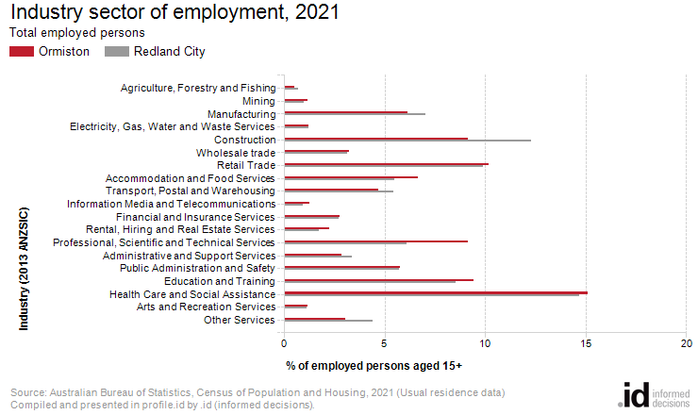
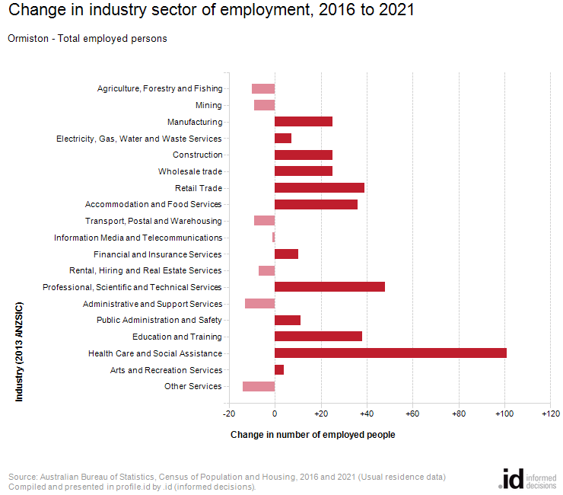
An analysis of the jobs held by the resident population in Ormiston in 2021 shows the three most popular industry sectors were:
- Health Care and Social Assistance (467 people or 15.1%)
- Retail Trade (314 people or 10.2%)
- Education and Training (291 people or 9.4%)
In combination, these three industries employed 1,072 people in total or 34.7% of the total employed resident population.
In comparison, Redland City employed 14.7% in Health Care and Social Assistance; 9.9% in Retail Trade; and 8.5% in Education and Training.
The major differences between the jobs held by the population of Ormiston and Redland City were:
- A larger percentage of persons employed in professional, scientific and technical services (9.2% compared to 6.1%)
- A larger percentage of persons employed in accommodation and food services (6.7% compared to 5.5%)
- A smaller percentage of persons employed in construction (9.2% compared to 12.3%)
- A smaller percentage of persons employed in other services (3.0% compared to 4.4%)
The number of employed people in Ormiston increased by 323 between 2016 and 2021.
The largest change in the jobs held by the resident population between 2016 and 2021 in Ormiston was for those employed in:
- Health Care and Social Assistance (+101 persons)

