Redland City Council

Industry sector of employment
Alexandra Hills's industry statistics identify the industry sectors in which the residents work (which may be within the residing area or elsewhere). This will be influenced by the skill base and socio-economic status of the residents as well as the industries and employment opportunities present in the region.
When viewed in conjunction with Residents Place of Work data and Method of Travel to Work, industry sector statistics provide insights into the relationship between the economic and residential role of the area.
Industry sector of employment
Alexandra Hills - Employed persons (Usual residence) | 2021 |  |  | 2016 |  |  | Change
Industry sector | Number | % | Redland City % | Number | % | Redland City % | 2016 to 2021
Agriculture, Forestry and Fishing | 41 | 0.5 | 0.7 | 50 | 0.6 | 0.8 | -9
Mining | 60 | 0.7 | 1.0 | 61 | 0.7 | 1.1 | -1
Manufacturing | 664 | 7.9 | 7.1 | 696 | 8.4 | 7.6 | -32
Electricity, Gas, Water and Waste Services | 99 | 1.2 | 1.2 | 82 | 1.0 | 1.1 | +17
Construction | 1,048 | 12.5 | 12.3 | 996 | 12.0 | 11.9 | +52
Wholesale trade | 279 | 3.3 | 3.1 | 311 | 3.7 | 3.5 | -32
Retail Trade | 888 | 10.6 | 9.9 | 909 | 10.9 | 10.3 | -21
Accommodation and Food Services | 450 | 5.4 | 5.5 | 459 | 5.5 | 5.5 | -9
Transport, Postal and Warehousing | 504 | 6.0 | 5.4 | 513 | 6.2 | 5.9 | -9
Information Media and Telecommunications | 78 | 0.9 | 0.9 | 102 | 1.2 | 1.3 | -24
Financial and Insurance Services | 170 | 2.0 | 2.7 | 192 | 2.3 | 2.7 | -22
Rental, Hiring and Real Estate Services | 114 | 1.4 | 1.7 | 136 | 1.6 | 1.9 | -22
Professional, Scientific and Technical Services | 437 | 5.2 | 6.1 | 410 | 4.9 | 5.8 | +27
Administrative and Support Services | 280 | 3.3 | 3.4 | 275 | 3.3 | 3.6 | +5
Public Administration and Safety | 480 | 5.7 | 5.7 | 472 | 5.7 | 5.8 | +8
Education and Training | 605 | 7.2 | 8.5 | 600 | 7.2 | 8.3 | +5
Health Care and Social Assistance | 1,300 | 15.5 | 14.7 | 1,156 | 13.9 | 12.6 | +144
Arts and Recreation Services | 86 | 1.0 | 1.1 | 118 | 1.4 | 1.3 | -32
Other Services | 438 | 5.2 | 4.4 | 409 | 4.9 | 4.3 | +29
Inadequately described or not stated | 377 | 4.5 | 4.4 | 384 | 4.6 | 4.4 | -7
Total employed persons aged 15+ | 8,398 | 100.0 | 100.0 | 8,331 | 100.0 | 100.0 | +67
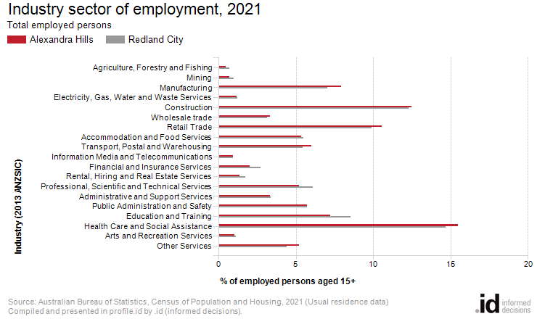
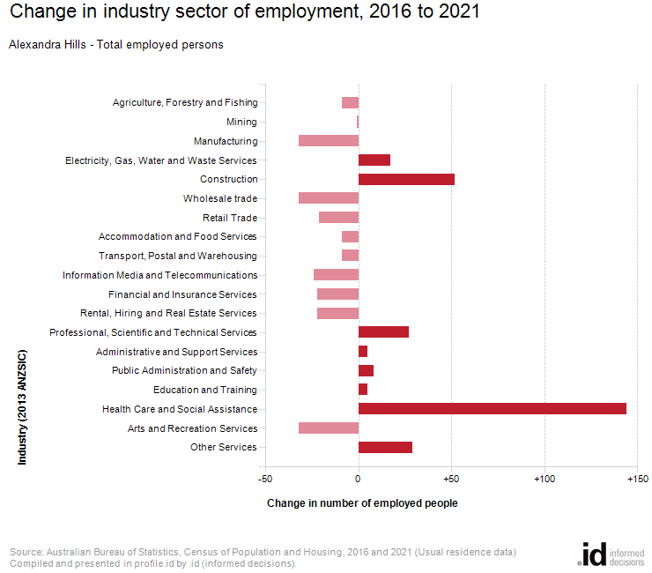
An analysis of the jobs held by the resident population in Alexandra Hills in 2021 shows the three most popular industry sectors were:
- Health Care and Social Assistance (1,300 people or 15.5%)
- Construction (1,048 people or 12.5%)
- Retail Trade (888 people or 10.6%)
In combination, these three industries employed 3,236 people in total or 38.5% of the total employed resident population.
In comparison, Redland City employed 14.7% in Health Care and Social Assistance; 12.3% in Construction; and 9.9% in Retail Trade.
The major difference between the jobs held by the population of Alexandra Hills and Redland City was:
- A smaller percentage of persons employed in education and training (7.2% compared to 8.5%)
The number of employed people in Alexandra Hills increased by 67 between 2016 and 2021.
The largest changes in the jobs held by the resident population between 2016 and 2021 in Alexandra Hills were for those employed in:
- Health Care and Social Assistance (+144 persons)
- Construction (+52 persons)

