Penrith City Council

Proficiency in English
Proficiency in English measures the self-assessed proficiency in spoken English of people who speak a language other than English at home. The data, when viewed with other ethnic and cultural indicators, such as Ancestry, Country of Birth, Language Spoken at Home and Religion, reflects Llandilo's ethnic composition and how long the overseas born have been in Australia. This helps service providers determine whether they need to communicate with the local population in languages other than English.
Proficiency in English
Llandilo - Total persons (Usual residence) | 2021 |  |  | 2016 |  |  | Change
English proficiency | Number | % | Penrith City % | Number | % | Penrith City % | 2016 to 2021
Speaks English only | 1,181 | 72.8 | 74.2 | 1,130 | 69.4 | 77.2 | +51
Speaks English well or very well | 320 | 19.7 | 17.6 | 320 | 19.7 | 15.0 | 0
Speaks English not well or not at all | 55 | 3.4 | 2.2 | 60 | 3.7 | 1.9 | -5
Not stated | 66 | 4.1 | 6.0 | 118 | 7.2 | 5.9 | -52
Total population | 1,622 | 100.0 | 100.0 | 1,628 | 100.0 | 100.0 | -6
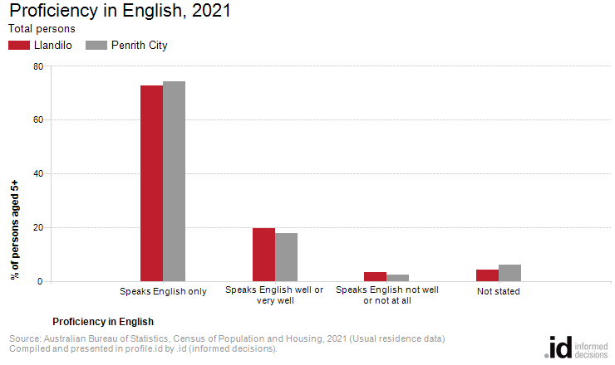
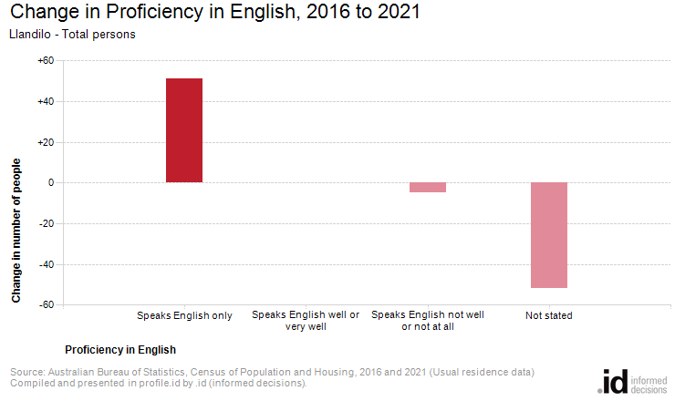
Analysis of the proficiency in English data of the population in Llandilo in 2021 compared to Penrith City shows that there was a lower proportion of people who spoke English only, and a higher proportion of people who spoke another language and English not well or not at all.
Overall, 72.8% of people spoke English only, and 3.4% spoke another language and English not well or not at all, compared with 74.2% and 2.2% respectively for Penrith City.
The most significant change in the proficiency in English of the population in this area between 2016 and 2021 was in those speaking:
- Speaks English only (+51 persons)

