City of Parramatta

Unpaid care
The proportion of people providing unpaid care for the aged and disabled in Dundas can be an important indicator of the level of demand for aged care services and facilities by local and state governments. An increasing proportion of carers among the population may indicate inadequate aged care provision, or the need for in-home support, or support for the carers themselves. The level of care provided by individuals is likely to be affected by Household Income, Age Structure and the ethnic makeup of the community (Language Spoken), as well as the sense of community cohesiveness.
Unpaid care
Dundas - Persons aged 15+ (Usual residence) | 2021 |  |  | 2016 |  |  | Change
Assistance to a person with a disability, long term illness or old age | Number | % | City of Parramatta % | Number | % | City of Parramatta % | 2016 to 2021
Provided unpaid assistance | 429 | 10.4 | 9.1 | 392 | 10.3 | 10.4 | +36
No unpaid assistance provided | 3,547 | 85.8 | 84.6 | 3,165 | 82.8 | 81.4 | +381
Not stated | 159 | 3.8 | 6.3 | 264 | 6.9 | 8.2 | -106
Total persons aged 15+ | 4,135 | 100.0 | 100.0 | 3,823 | 100.0 | 100.0 | +312
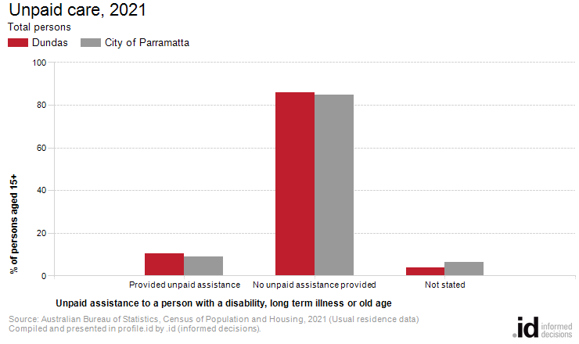
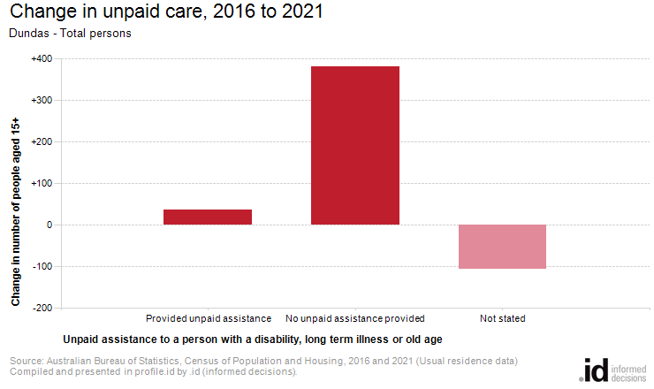
Analysis of the unpaid care provided by the population in Dundas in 2021 compared to City of Parramatta shows that there was a higher proportion of people who provided unpaid care either to family members or others.
Overall, 10.4% of the population provided unpaid care, compared with 9.1% for City of Parramatta.
The number of people who provided unpaid assistance to a person with a disability, long term illness or old age in Dundas increased by 37 between 2016 and 2021.

