City of Parramatta

Occupation of employment
North Rocks's occupation statistics quantify the occupations in which the residents work (which may be within the residing area or elsewhere). This will be influenced by the economic base and employment opportunities available in the area, education levels, and the working and social aspirations of the population. When viewed with other indicators, such as Educational Qualifications and Individual Income, Occupation is a key measure for evaluating North Rocks's socio-economic status and skill base.
Occupation of employment
North Rocks - Employed persons (Usual residence) | 2021 |  |  | 2016 |  |  | Change
Occupation | Number | % | City of Parramatta % | Number | % | City of Parramatta % | 2016 to 2021
Managers | 657 | 16.2 | 13.7 | 537 | 14.9 | 12.7 | +120
Professionals | 1,339 | 33.0 | 35.0 | 1,231 | 34.2 | 31.7 | +108
Technicians and Trades Workers | 434 | 10.7 | 9.0 | 404 | 11.2 | 10.3 | +29
Community and Personal Service Workers | 326 | 8.0 | 8.2 | 302 | 8.4 | 8.3 | +23
Clerical and Administrative Workers | 606 | 14.9 | 14.2 | 527 | 14.7 | 15.4 | +78
Sales Workers | 302 | 7.4 | 7.2 | 283 | 7.9 | 8.4 | +18
Machinery Operators And Drivers | 123 | 3.0 | 4.8 | 107 | 3.0 | 4.8 | +15
Labourers | 190 | 4.7 | 5.9 | 145 | 4.1 | 6.5 | +44
Not stated or inadequately described | 67 | 1.7 | 2.0 | 58 | 1.6 | 2.0 | +8
Total employed persons aged 15+ | 4,056 | 100.0 | 100.0 | 3,600 | 100.0 | 100.0 | +455
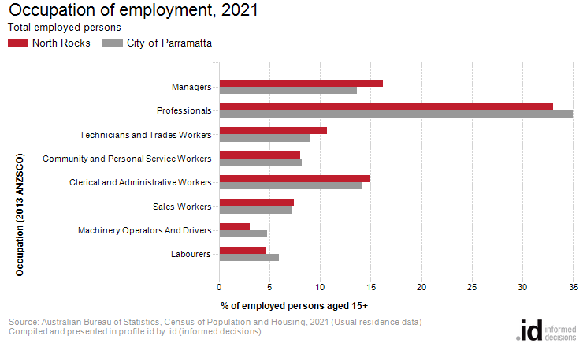
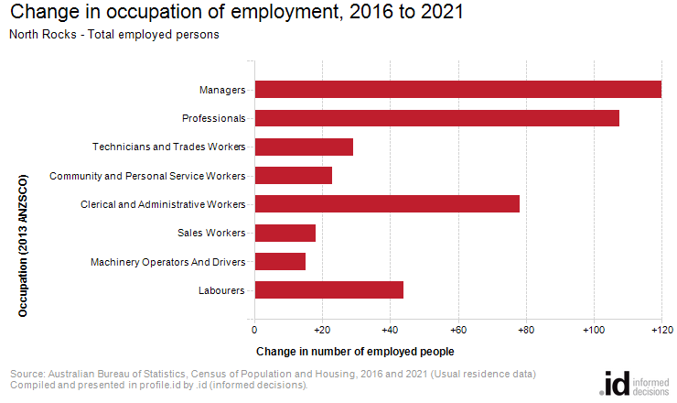
An analysis of the jobs held by the resident population in North Rocks in 2021 shows the three most popular occupations were:
- Professionals (1,339 people or 33.0%)
- Managers (657 people or 16.2%)
- Clerical and Administrative Workers (606 people or 14.9%)
In combination these three occupations accounted for 2,602 people in total or 64.2% of the employed resident population.
In comparison, City of Parramatta employed 35.0% in Professionals; 13.7% in Managers; and 14.2% in Clerical and Administrative Workers.
The major differences between the jobs held by the population of North Rocks and City of Parramatta were:
- A larger percentage of persons employed as Managers (16.2% compared to 13.7%)
- A larger percentage of persons employed as Technicians and Trades Workers (10.7% compared to 9.0%)
- A smaller percentage of persons employed as Professionals (33.0% compared to 35.0%)
- A smaller percentage of persons employed as Machinery Operators And Drivers (3.0% compared to 4.8%)
The number of employed people in North Rocks increased by 456 between 2016 and 2021.
The largest changes in the occupations of residents between 2016 and 2021 in North Rocks were for those employed as:
- Managers (+120 persons)
- Professionals (+108 persons)
- Clerical and Administrative Workers (+78 persons)

