City of Parramatta

Housing rental quartiles
Rental payments in North Rocks are indicative of its residential role and function and are directly related to the value of residential property. When viewed with Household Income data they may also indicate the level of 'housing stress' in the community.
The quartile method is the most objective method of comparing change in the rental costs of a community over time.
A detailed explanation of how Housing Rental Payment quartiles are calculated and interpreted is available in specific data notes.
Housing rental quartiles
North Rocks - Households (Enumerated) | 2021 |  |  | 2016 |  |  | Change
Quartile group | Number | % | City of Parramatta % | Number | % | City of Parramatta % | 2016 to 2021
Lowest group | 23 | 3.4 | 14.8 | 0 | 0.0 | 14.1 | +24
Medium lowest | 96 | 13.9 | 25.8 | 2 | 0.8 | 15.9 | +94
Medium highest | 330 | 47.6 | 38.5 | 102 | 36.4 | 43.5 | +228
Highest group | 243 | 35.1 | 20.9 | 176 | 62.8 | 26.5 | +67
Total households with stated rent | 694 | 100.0 | 100.0 | 281 | 100.0 | 100.0 | +412
Housing rental - Quartile group dollar ranges
Calculated from rental payment data for [theQBMQuartile] | Weekly housing rental payments by Census year
Rental payment ranges | 2021 | 2016 | 2011 | 2006 | 2001 | 1996 | 1991
Lowest group | $0 to $314 | $0 to $266 | $0 to $202 | $0 to $149 | $0 to $114
Medium lowest | $315 to $432 | $267 to $391 | $203 to $311 | $150 to $218 | $115 to $179
Medium highest | $433 to $562 | $392 to $529 | $312 to $421 | $219 to $306 | $180 to $259
Highest group | $563 and over | $530 and over | $422 and over | $307 and over | $260 and over
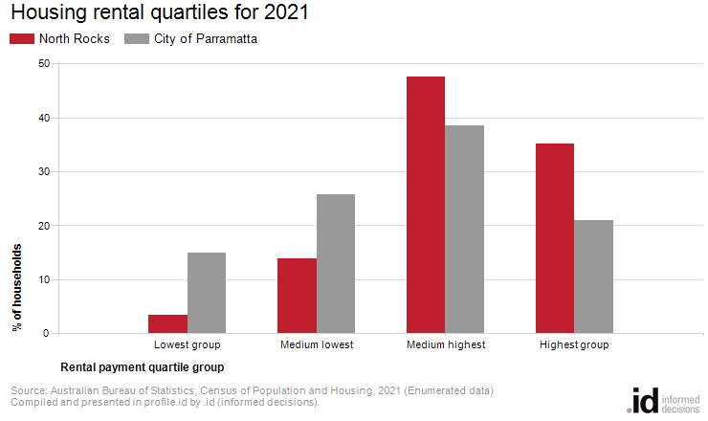
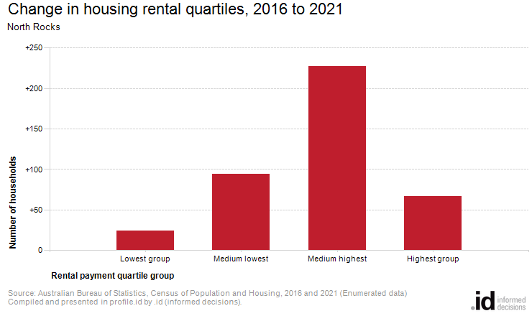
Rental payment quartiles allow us to compare relative rental liabilities across time. Analysis of the distribution of households by rental payment quartiles in North Rocks compared to City of Parramatta shows that there was a larger proportion of households in the highest payment quartile, and a smaller proportion in the lowest payment quartile.
The total number of households renting their dwelling in North Rocks increased by 413 between 2016 and 2021. The most significant change during this period was in the medium highest quartile which showed an increase of 228 households.

