City of Parramatta

Housing loan quartiles
Mortgage repayments in North Rocks are directly related to house prices, length of occupancy and the level of equity of home owners. When viewed with Household Income data it may also indicate the level of housing stress in the community.
The quartile method is the most objective method of comparing change in the mortgage payment profile of a community over time.
A detailed explanation of how Housing Loan Repayment quartiles are calculated and interpreted is available in specific data notes.
Please note, interest rates at the 2021 Census were at a record low in Australia. The first interest rate rises by the Reserve Bank began an upward cycle from May 2022. Please use mortgage payment data with caution as data from the 2021 Census pre-dates all official rate rises in the current cycle.
Housing loan quartiles
North Rocks - Households (Enumerated) | 2021 |  |  | 2016 |  |  | Change
Loan repayment quartile group | Number | % | City of Parramatta % | Number | % | City of Parramatta % | 2016 to 2021
Lowest group | 182 | 18.0 | 17.9 | 159 | 17.5 | 20.3 | +23
Medium lowest | 153 | 15.1 | 22.7 | 129 | 14.2 | 20.8 | +24
Medium highest | 247 | 24.3 | 29.6 | 247 | 27.0 | 29.1 | 0
Highest group | 433 | 42.6 | 29.7 | 377 | 41.3 | 29.9 | +56
Total households with stated mortgage repayments | 1,016 | 100.0 | 100.0 | 913 | 100.0 | 100.0 | +102
Housing loan - Quartile group dollar ranges
Calculated from loan repayment data for [theQBMQuartile] | Monthly housing loan repayments by Census year
Housing loan repayment ranges | 2021 | 2016 | 2011 | 2006 | 2001 | 1991
Lowest group | $0 to $1,381 | $0 to $1,263 | $0 to $1,266 | $0 to $993 | $0 to $723
Medium lowest | $1,382 to $2,123 | $1,264 to $1,989 | $1,267 to $1,995 | $994 to $1,557 | $724 to $1,069
Medium highest | $2,124 to $3,203 | $1,990 to $2,865 | $1,996 to $2,853 | $1,558 to $2,416 | $1,070 to $1,550
Highest group | $3,204 and over | $2,866 and over | $2,854 and over | $2,417 and over | $1,551 and over
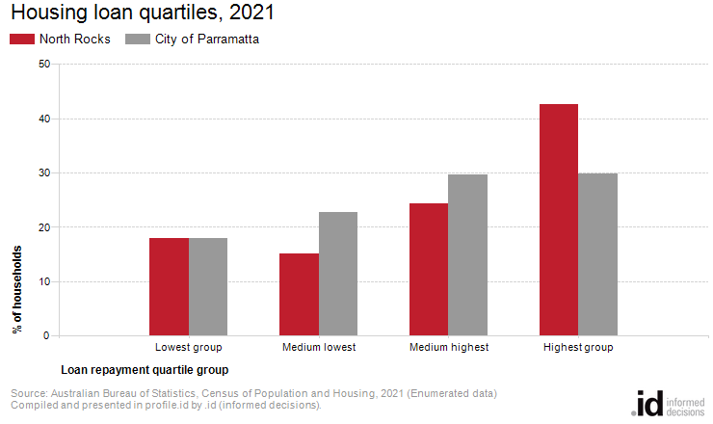
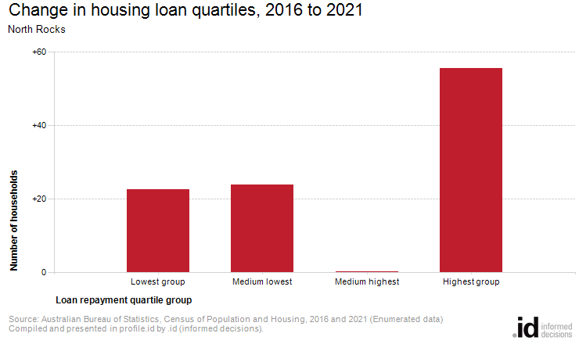
Housing loan repayment quartiles allow us to compare relative repayment liabilities across time. Analysis of the distribution of households by housing loan repayment quartiles in North Rocks compared to City of Parramatta shows that there was a larger proportion of households in the highest repayment quartile, and a similar proportion in the lowest repayment quartile.
The total number of households with a mortgage in North Rocks decreased by 913 between 2016 and 2021. The most significant change in North Rocks during this period was in the highest quartile which showed an increase of 56 households.

