City of Parramatta

Household income quartiles
Households form the common 'economic unit' in our society. Household Income is one of the most important indicators of socio-economic status. With other data sources, such as Qualifications and Occupation, it helps to reveal Oatlands's socio-economic status and economic opportunities. Household income levels are not comparable over time because of the influences of economic change such as wage level fluctuations and inflation. The income quartile method is a powerful and objective way of looking at income data and in particular, how it is changing.
A detailed explanation of how Household Income quartiles are calculated and interpreted is available in specific data notes.
Learn more about the characteristics of low-income households here.
Household income quartiles
Oatlands - Households (Enumerated) | 2021 |  |  | 2016 |  |  | Change
Quartile group | Number | % | City of Parramatta % | Number | % | City of Parramatta % | 2016 to 2021
Lowest group | 369 | 21.1 | 19.5 | 290 | 17.8 | 19.4 | +79
Medium lowest | 345 | 19.7 | 24.9 | 321 | 19.6 | 22.8 | +25
Medium highest | 436 | 24.9 | 28.7 | 452 | 27.7 | 29.4 | -16
Highest group | 601 | 34.3 | 26.9 | 570 | 34.9 | 28.3 | +31
Total Households | 1,753 | 100.0 | 100.0 | 1,634 | 100.0 | 100.0 | +119
Household income - Quartile group dollar ranges
Calculated from income data for New South Wales | Weekly income by Census year
Household income ranges | 2021 | 2016 | 2011 | 2006 | 2001 | 1996 | 1991
Lowest group | $0 to $886 | $0 to $750 | $0 to $614 | $0 to $530 | $0 to $418 | $0 to $337 | $0 to $303
Medium lowest | $887 to $1,824 | $751 to $1,481 | $615 to $1,233 | $531 to $1,034 | $419 to $828 | $338 to $652 | $304 to $587
Medium highest | $1,825 to $3,134 | $1,482 to $2,554 | $1,234 to $2,272 | $1,035 to $1,788 | $829 to $1,462 | $653 to $1,146 | $588 to $981
Highest group | $3,135 and over | $2,555 and over | $2,273 and over | $1,789 and over | $1,463 and over | $1,147 and over | $982 and over
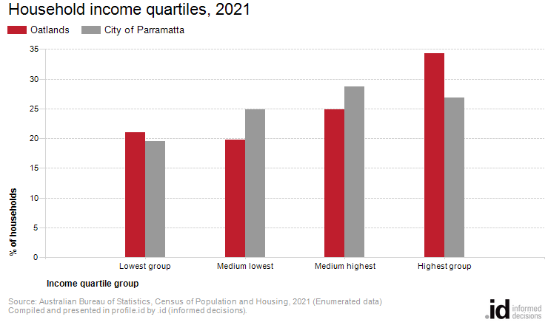
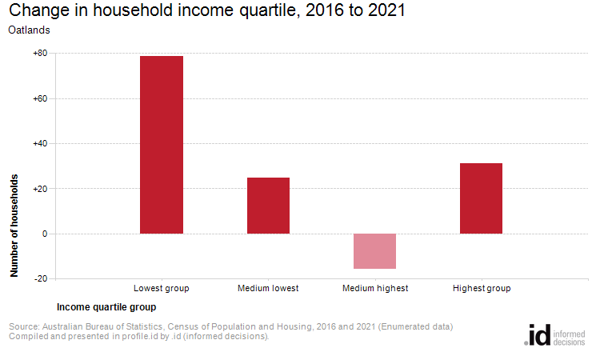
Income quartiles allow us to compare relative income-earning capabilities across time. Analysis of the distribution of households by income quartile in Oatlands compared to City of Parramatta shows that there was greater proportion of households in the highest income quartile as well as a greater proportion in the lowest income quartile.
The most significant change in Oatlands between 2016 and 2021 was in the lowest quartile which showed an increase of 79 households.

