City of Parramatta

Unpaid domestic work
There has been increased interest in identifying, acknowledging and valuing the unpaid work that supports home and community life. The changing amount of time spent on unpaid housework in different Household Types and, particularly the distribution of this work within the household, can indicate the changing roles of males, females and older children in society. The level of unpaid domestic work in North Rocks may also be related to Household Income, as higher income households are able to outsource some of these tasks.
Unpaid domestic work
North Rocks - Persons aged 15+ (Usual residence) | 2021 |  |  | 2016 |  |  | Change
Hours spent on unpaid domestic work | Number | % | City of Parramatta % | Number | % | City of Parramatta % | 2016 to 2021
Did unpaid domestic work | 4,950 | 71.9 | 63.0 | 4,599 | 76.3 | 66.2 | +351
Less than 5 hours | 1,286 | 18.7 | 17.4 | 1,420 | 23.6 | 22.6 | -135
Between 5 and 14 hours | 1,894 | 27.5 | 25.0 | 1,699 | 28.2 | 24.3 | +194
Between 15 and 29 hours | 1,051 | 15.3 | 11.9 | 811 | 13.5 | 10.7 | +239
30 hours or more | 719 | 10.4 | 8.7 | 667 | 11.1 | 8.6 | +52
Did no unpaid domestic work | 1,728 | 25.1 | 30.9 | 1,208 | 20.0 | 25.8 | +520
Not stated | 205 | 3.0 | 6.1 | 223 | 3.7 | 8.0 | -19
Total persons aged 15+ | 6,883 | 100.0 | 100.0 | 6,031 | 100.0 | 100.0 | +852
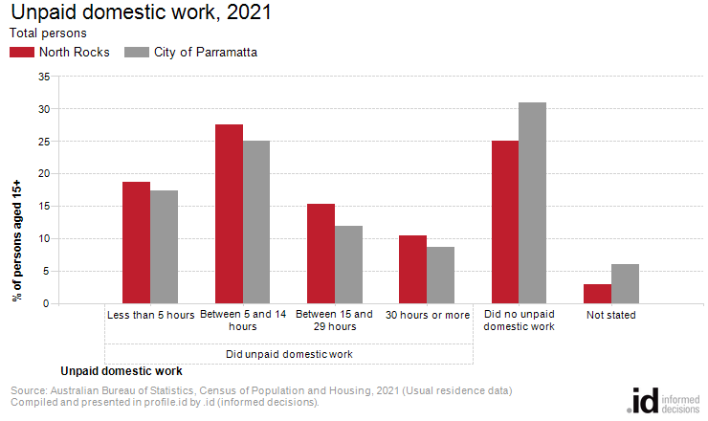
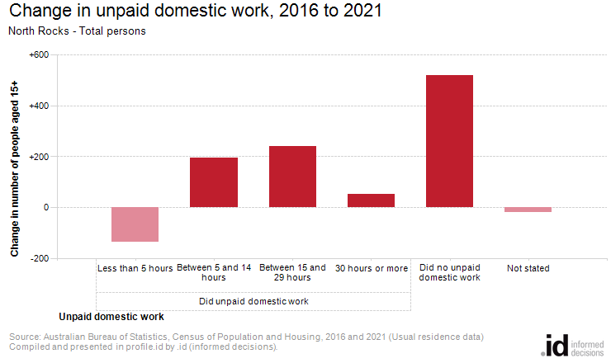
Analysis of the unpaid domestic work performed by the population in North Rocks in 2021 compared to City of Parramatta shows that there was a higher proportion of persons who performed 15 hours or more of unpaid domestic work per week.
Overall, 25.7% of the population reported performing 15 hours or more of unpaid domestic work, compared with 20.6% for City of Parramatta.
The major differences between the share of the population performing unpaid domestic work in North Rocks and City of Parramatta were:
- A larger percentage of persons who did unpaid domestic work (total) (71.9% compared to 63.0%)
- A larger percentage of persons who did between 15 and 29 hours of domestic work (15.3% compared to 11.9%)
- A larger percentage of persons who did between 5 and 14 hours of domestic work (27.5% compared to 25.0%)
- A smaller percentage of persons who did no unpaid domestic work (25.1% compared to 30.9%)
The largest changes in the number of people performing unpaid domestic work in North Rocks, between 2016 and 2021 were those who:
- Did no unpaid domestic work (+520 persons)
- Did unpaid domestic work (+351 persons)
- Did between 15 and 29 hours of domestic work (+239 persons)
- Did between 5 and 14 hours of domestic work (+194 persons)

