Shire of Mundaring

Housing loan repayments
Mortgage repayments are directly related to house prices in Greenmount, length of occupancy and the level of equity of home owners. When viewed with Household Income data it may also indicate the level of housing stress households in the community are under. In mortgage belt areas it is expected that households will be paying a higher proportion of their income on their housing compared to well-established areas. First home buyer areas are also likely to have larger mortgages than upgrader areas where households move in with equity from elsewhere.
Mortgage payment levels are not directly comparable over time because of inflation. For comparison of mortgage payments over time, go to Housing Loan Quartiles.
Please note, interest rates at the 2021 Census were at a record low in Australia. The first interest rate rises by the Reserve Bank began an upward cycle from May 2022. Please use mortgage payment data with caution as data from the 2021 Census pre-dates all official rate rises in the current cycle.
Further reading: How can Councils influence affordable housing.
Monthly housing loan repayments
Greenmount - Households (Enumerated) | 2021
Monthly repayment amount | Number | % | Shire of Mundaring %
$299 or less | 21 | 4.7 | 4.5
$300 - $599 | 11 | 2.5 | 3.1
$600 - $999 | 37 | 8.4 | 6.6
$1,000 - $1,199 | 25 | 5.6 | 4.4
$1,200 - $1,399 | 17 | 3.8 | 6.0
$1,400 - $1,599 | 45 | 10.2 | 7.2
$1,600-$1,799 | 54 | 12.2 | 9.2
$1,800 - $1,999 | 47 | 10.6 | 7.1
$2,000 - $2,199 | 54 | 12.2 | 12.5
$2,200 - $2,399 | 32 | 7.2 | 5.6
$2,400-$2,599 | 14 | 3.2 | 3.9
$2,600-$2,999 | 22 | 5.0 | 8.1
$3,000-$3,999 | 31 | 7.0 | 9.7
$4,000-$4,999 | 6 | 1.4 | 3.7
$5000 and over | 6 | 1.4 | 2.3
Not stated | 21 | 4.7 | 5.8
Total | 443 | 100.0 | 100.0
Housing tenure
Greenmount - Households (Enumerated) | 2021 |  |  | 2016 |  |  | Change
Tenure type | Number | % | Shire of Mundaring % | Number | % | Shire of Mundaring % | 2016 to 2021
Fully owned | 398 | 40.3 | 37.8 | 368 | 37.4 | 36.0 | +30
Mortgage | 436 | 44.2 | 46.7 | 442 | 44.9 | 46.0 | -6
Renting - Total | 100 | 10.1 | 10.8 | 110 | 11.2 | 11.1 | -10
Renting - Social housing | 11 | 1.1 | 1.1 | 21 | 2.1 | 1.3 | -10
Renting - Private | 89 | 9.0 | 9.6 | 89 | 9.0 | 9.7 | 0
Renting - Not stated | 0 | 0.0 | 0.1 | 0 | 0.0 | 0.1 | 0
Other tenure type | 17 | 1.7 | 1.3 | 12 | 1.2 | 1.2 | +5
Not stated | 36 | 3.6 | 3.4 | 52 | 5.3 | 5.7 | -16
Total households | 987 | 100.0 | 100.0 | 984 | 100.0 | 100.0 | +3
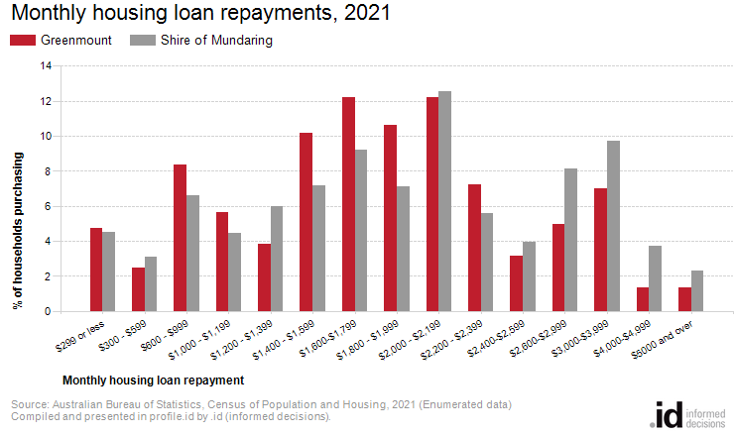
Analysis of the monthly housing loan repayments of households in Greenmount compared to Shire of Mundaring shows that there was a smaller proportion of households paying high mortgage repayments ($2,600 per month or more), and a larger proportion of households with low mortgage repayments (less than $1,200 per month).
Overall, 14.7% of households were paying high mortgage repayments, and 21.2% were paying low repayments, compared with 23.9% and 18.7% respectively in Shire of Mundaring.
The major differences between the household loan repayments of Greenmount and Shire of Mundaring were:
- A larger percentage of $1,800 - $1,999 (10.6% compared to 7.1%)
- A larger percentage of $1,400 - $1,599 (10.2% compared to 7.2%)
- A larger percentage of $1,600-$1,799 (12.2% compared to 9.2%)
- A smaller percentage of $2,600-$2,999 (5.0% compared to 8.1%)

