City of Moreton Bay

Individual income quartiles
Rural Planning Area's income statistics are an indicator of socio-economic status. With other data sources, such as Household Income, Qualifications and Occupation, they help tell the story of the area's economic opportunities and socio-economic status. Individual income levels are not comparable over time because of the influences of economic change such as wage level fluctuations and inflation. The income quartile method is the most objective method of comparing change in the income profile of a community over time.
A detailed explanation of how Individual Income quartiles are calculated and interpreted is available in specific data notes.
Individual income quartiles
Rural Planning Area - Persons aged 15+ (Usual residence) | 2021 |  |  | 2016 |  |  | Change
Quartile group | Number | % | City of Moreton Bay % | Number | % | City of Moreton Bay % | 2016 to 2021
Lowest group | 7,132 | 25.8 | 25.5 | 6,262 | 25.3 | 24.9 | +870
Medium lowest | 5,950 | 21.5 | 25.9 | 5,309 | 21.4 | 25.6 | +641
Medium highest | 6,047 | 21.9 | 25.7 | 5,573 | 22.5 | 26.0 | +474
Highest group | 8,534 | 30.9 | 22.9 | 7,620 | 30.8 | 23.5 | +914
Total persons aged 15+ | 27,665 | 100.0 | 100.0 | 24,766 | 100.0 | 100.0 | +2,899
Individual income - Quartile group dollar ranges
Calculated from income data for [theQBMQuartile] - Total persons aged 15+ | Weekly income by Census year
Individual quartile ranges | 2021 | 2016 | 2011 | 2006 | 2001 | 1996 | 1991
Lowest group | $0 to $388 | $0 to $333 | $0 to $281 | $0 to $221 | $0 to $182
Medium lowest | $389 to $787 | $334 to $660 | $282 to $585 | $222 to $476 | $183 to $361
Medium highest | $788 to $1,424 | $661 to $1,195 | $586 to $1,077 | $477 to $853 | $362 to $641
Highest group | $1,425 and over | $1,196 and over | $1,078 and over | $854 and over | $642 and over
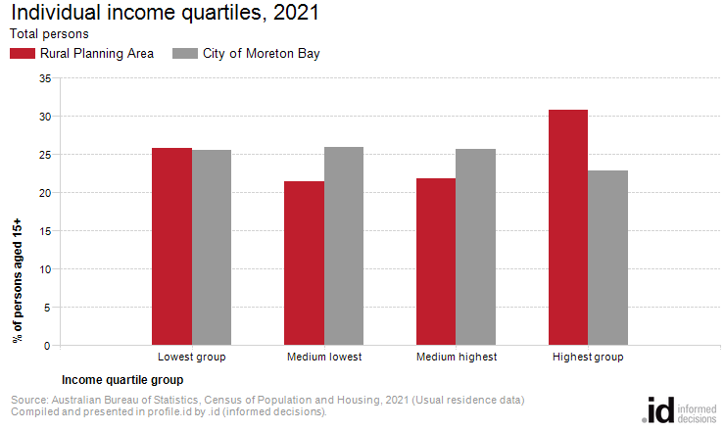
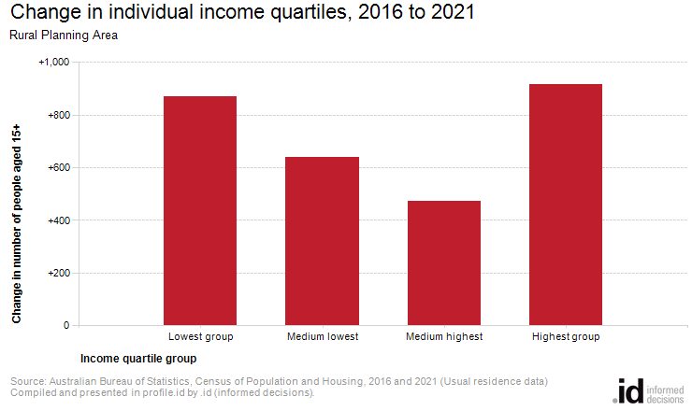
Income quartiles allow us to compare relative income-earning capabilities across time. Analysis of the distribution of the population by income quartile in Rural Planning Area compared to City of Moreton Bay shows that there was greater proportion of persons in the highest income quartile and a similar proportion in the lowest income quartile.
The most significant change in Rural Planning Area in persons between 2016 and 2021 was in the highest quartile which showed an increase of 914 persons.

