City of Merri-bek

Housing tenure
Pascoe Vale South's Housing Tenure data provides insights into its socio-economic status as well as the role it plays in the housing market. For example, a high concentration of private renters may indicate a transient area attractive to young singles and couples, while a concentration of home owners indicates a more settled area with mature families and empty-nesters (Household Summary). Tenure can also reflect built form (Dwelling Type), with a significantly higher share of renters in high density housing and a substantially larger proportion of home-owners in separate houses, although this is not always the case.
In conjunction with other socio-economic status indicators in Pascoe Vale South, Tenure data is useful for analysing housing markets, housing affordability and identifying public housing areas.
Further reading: How can Councils influence affordable housing.
Housing tenure
Pascoe Vale South - Households (Enumerated) | 2021 |  |  | 2016 |  |  | Change
Tenure type | Number | % | City of Merri-bek % | Number | % | City of Merri-bek % | 2016 to 2021
Fully owned | 1,407 | 36.3 | 27.1 | 1,360 | 37.4 | 28.5 | +47
Mortgage | 1,420 | 36.6 | 30.0 | 1,294 | 35.6 | 27.3 | +126
Renting - Total | 914 | 23.6 | 37.1 | 717 | 19.7 | 35.3 | +197
Renting - Social housing | 19 | 0.5 | 2.3 | 19 | 0.5 | 2.5 | -1
Renting - Private | 892 | 23.0 | 34.7 | 697 | 19.2 | 32.6 | +195
Renting - Not stated | 3 | 0.1 | 0.1 | 0 | 0.0 | 0.2 | +3
Other tenure type | 31 | 0.8 | 1.3 | 21 | 0.6 | 1.4 | +9
Not stated | 109 | 2.8 | 4.5 | 246 | 6.8 | 7.4 | -138
Total households | 3,881 | 100.0 | 100.0 | 3,640 | 100.0 | 100.0 | +240
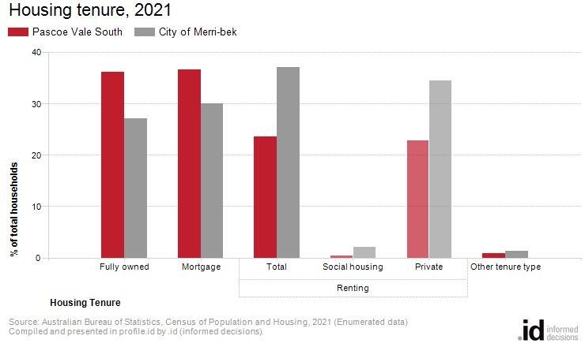
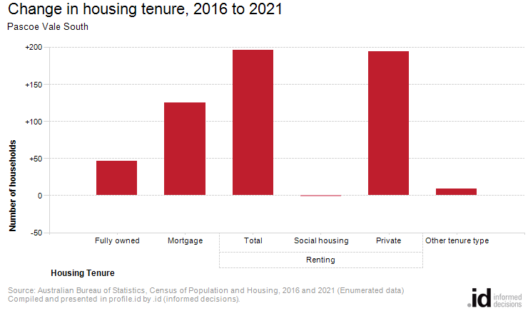
Analysis of the housing tenure of households of Pascoe Vale South in 2021 compared to the City of Merri-bek shows that there was a larger proportion of households who owned their dwelling; a larger proportion purchasing their dwelling; and a smaller proportion who were renters.
Overall, 36.3% of households owned their dwelling; 36.6% were purchasing, and 23.6% were renting, compared with 27.1%, 30.0% and 37.1% respectively for the City of Merri-bek.
The largest changes in housing tenure categories for the households in Pascoe Vale South between 2016 and 2021 were:
- Renting - Private (+195 households)
- Mortgage (+126 households)
The total number of households in Pascoe Vale South increased by 241 between 2016 and 2021.

