City of Merri-bek

Housing tenure
Brunswick East's Housing Tenure data provides insights into its socio-economic status as well as the role it plays in the housing market. For example, a high concentration of private renters may indicate a transient area attractive to young singles and couples, while a concentration of home owners indicates a more settled area with mature families and empty-nesters (Household Summary). Tenure can also reflect built form (Dwelling Type), with a significantly higher share of renters in high density housing and a substantially larger proportion of home-owners in separate houses, although this is not always the case.
In conjunction with other socio-economic status indicators in Brunswick East, Tenure data is useful for analysing housing markets, housing affordability and identifying public housing areas.
Further reading: How can Councils influence affordable housing.
Housing tenure
Brunswick East - Households (Enumerated) | 2021 |  |  | 2016 |  |  | Change
Tenure type | Number | % | City of Merri-bek % | Number | % | City of Merri-bek % | 2016 to 2021
Fully owned | 1,263 | 18.1 | 27.1 | 1,159 | 20.3 | 28.5 | +104
Mortgage | 1,785 | 25.6 | 30.0 | 1,222 | 21.4 | 27.3 | +563
Renting - Total | 3,554 | 51.0 | 37.1 | 2,820 | 49.4 | 35.3 | +733
Renting - Social housing | 125 | 1.8 | 2.3 | 127 | 2.2 | 2.5 | -2
Renting - Private | 3,426 | 49.2 | 34.7 | 2,693 | 47.1 | 32.6 | +732
Renting - Not stated | 3 | 0.0 | 0.1 | 0 | 0.0 | 0.2 | +3
Other tenure type | 82 | 1.2 | 1.3 | 76 | 1.3 | 1.4 | +6
Not stated | 286 | 4.1 | 4.5 | 435 | 7.6 | 7.4 | -149
Total households | 6,970 | 100.0 | 100.0 | 5,714 | 100.0 | 100.0 | +1,256
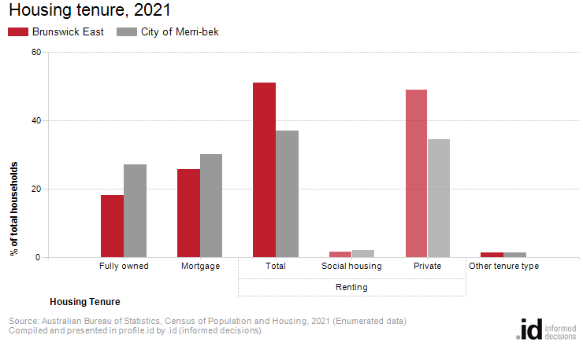
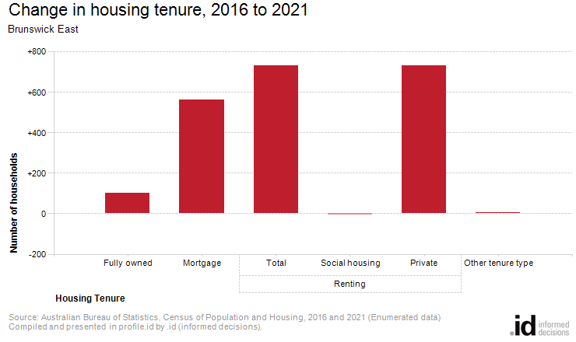
Analysis of the housing tenure of households of Brunswick East in 2021 compared to the City of Merri-bek shows that there was a smaller proportion of households who owned their dwelling; a smaller proportion purchasing their dwelling; and a larger proportion who were renters.
Overall, 18.1% of households owned their dwelling; 25.6% were purchasing, and 51.0% were renting, compared with 27.1%, 30.0% and 37.1% respectively for the City of Merri-bek.
The largest changes in housing tenure categories for the households in Brunswick East between 2016 and 2021 were:
- Renting - Private (+732 households)
- Mortgage (+563 households)
- Fully owned (+104 households)
The total number of households in Brunswick East increased by 1,256 between 2016 and 2021.

