City of Merri-bek

Highest level of schooling
Brunswick's school completion data is a useful indicator of socio-economic status. With other indicators, such as Proficiency in English, the data informs planners and decision-makers about people's ability to access services. Combined with Educational Qualifications it also allows assessment of the skill base of the population.
Learn more about planning education provision here.
Persons aged 15 years and over
Highest level of secondary schooling completed
Brunswick - Total persons (Usual residence) | 2021 |  |  | 2016 |  |  | Change
Level of schooling | Number | % | City of Merri-bek % | Number | % | City of Merri-bek % | 2016 to 2021
Year 8 or below | 909 | 4.1 | 5.7 | 1,131 | 5.2 | 7.7 | -223
Year 9 or equivalent | 385 | 1.7 | 3.3 | 371 | 1.7 | 3.7 | +14
Year 10 or equivalent | 1,001 | 4.5 | 7.1 | 991 | 4.6 | 8.0 | +10
Year 11 or equivalent | 1,059 | 4.7 | 7.0 | 1,045 | 4.8 | 7.3 | +14
Year 12 or equivalent | 17,904 | 79.8 | 69.9 | 16,292 | 74.9 | 63.6 | +1,612
Did not go to school | 319 | 1.4 | 1.7 | 327 | 1.5 | 1.9 | -9
Not stated | 849 | 3.8 | 5.3 | 1,583 | 7.3 | 7.9 | -735
Total persons aged 15+ | 22,426 | 100.0 | 100.0 | 21,742 | 100.0 | 100.0 | +683
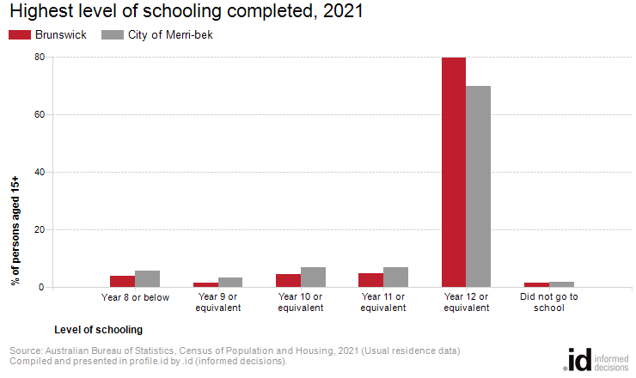
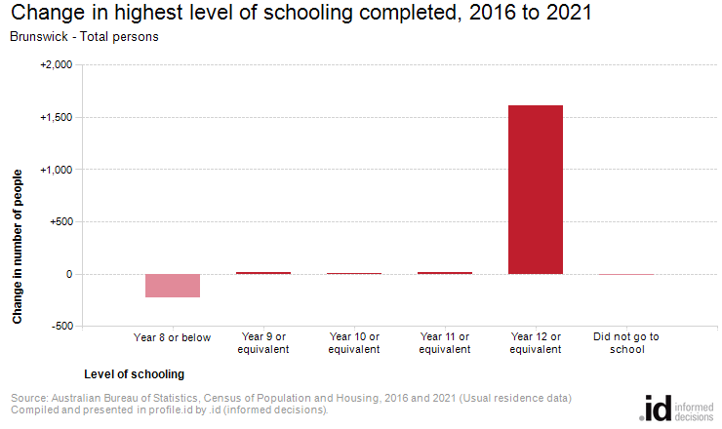
Analysis of the highest level of schooling attained by the population in Brunswick in 2021 compared to the City of Merri-bek shows that there was a lower proportion of people who had left school at an early level (Year 10 or less) and a higher proportion of people who completed Year 12 or equivalent.
Overall, 11.7% of the population left school at Year 10 or below, and 79.8% went on to complete Year 12 or equivalent, compared with 17.9% and 69.9% respectively for the City of Merri-bek.
The major differences between the level of schooling attained by the population in Brunswick and the City of Merri-bek were:
- A larger percentage of persons who completed year 12 or equivalent (79.8% compared to 69.9%)
- A smaller percentage of persons who completed year 10 or equivalent (4.5% compared to 7.1%)
- A smaller percentage of persons who completed year 11 or equivalent (4.7% compared to 7.0%)
- A smaller percentage of persons who completed year 8 or below (4.1% compared to 5.7%)
The largest changes in the level of schooling attained by the population in Brunswick, between 2016 and 2021 were:
- Year 12 or equivalent (+1,612 persons)
- Year 8 or below (-223 persons)

