City of Merri-bek

Residents place of work
Where do the City of Merri-bek's residents go to work? Journey to Work data shows how many residents work locally, and how many commute out of the area and where they commute to. Some areas consist mainly of dormitory' suburbs and the majority of the residents commute out to work. Other areas have large employment centres which attract a local workforce. Understanding where the City of Merri-bek's residents go to work assists in planning and advocacy for roads and public transport provision. It also helps to clarify the economic and employment drivers across areas and assists in understanding the degree of employment self-containment within the City of Merri-bek.
Please note: Although this page references the Developing East Arnhem area, the data given is based on the East Arnhem LGA.
Employment location of resident workers
City of Merri-bek | 2016
Location | Number | %
Live and work in the area | 17,658 | 19.0
Live in the area, but work outside | 71,964 | 77.4
No fixed place of work | 3,374 | 3.6
Total | 92,996 | 100.0
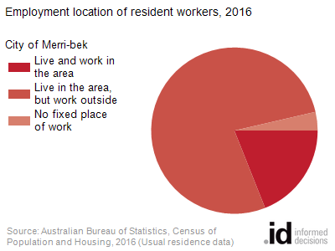
Employment location of resident workers by LGA
City of Merri-bek | 2021
LGA | Number | %
Melbourne | 29,985 | 32.2
Moreland | 17,658 | 19.0
Hume | 6,309 | 6.8
Yarra | 5,821 | 6.3
Darebin | 3,927 | 4.2
Moonee Valley | 3,817 | 4.1
No usual address (Vic.) | 3,344 | 3.6
Port Phillip | 2,860 | 3.1
Brimbank | 2,443 | 2.6
Whittlesea | 2,239 | 2.4
Maribyrnong | 1,755 | 1.9
Boroondara | 1,604 | 1.7
Banyule | 1,584 | 1.7
Stonnington | 1,210 | 1.3
Monash | 987 | 1.1
Wyndham | 916 | 1.0
Whitehorse | 804 | 0.9
Hobsons Bay | 687 | 0.7
Melton | 537 | 0.6
Manningham | 386 | 0.4
Glen Eira | 377 | 0.4
Greater Dandenong | 345 | 0.4
Kingston (Vic.) | 338 | 0.4
Knox | 322 | 0.3
Greater Geelong | 236 | 0.3
Sydney | 225 | 0.2
Bayside (Vic.) | 213 | 0.2
Maroondah | 191 | 0.2
Nillumbik | 184 | 0.2
Casey | 121 | 0.1
Mitchell | 116 | 0.1
Macedon Ranges | 114 | 0.1
Yarra Ranges | 106 | 0.1
Unincorporated ACT | 94 | 0.1
Frankston | 93 | 0.1
Brisbane | 76 | 0.1
Mornington Peninsula | 61 | 0.1
Ballarat | 53 | 0.1
North Sydney | 41 | 0.0
Greater Shepparton | 38 | 0.0
Moorabool | 37 | 0.0
Ryde | 33 | 0.0
Greater Bendigo | 29 | 0.0
Bass Coast | 24 | 0.0
Unincorporated Vic | 22 | 0.0
Cardinia | 21 | 0.0
Willoughby | 19 | 0.0
Parramatta | 19 | 0.0
Gold Coast | 19 | 0.0
Adelaide | 19 | 0.0
Surf Coast | 19 | 0.0
Perth | 17 | 0.0
Latrobe (Vic.) | 17 | 0.0
Bayside (NSW) | 16 | 0.0
No usual address (NSW) | 16 | 0.0
Mount Alexander | 15 | 0.0
East Gippsland | 14 | 0.0
Campaspe | 13 | 0.0
Lane Cove | 13 | 0.0
Blacktown | 12 | 0.0
Darwin | 12 | 0.0
Wodonga | 12 | 0.0
Byron | 10 | 0.0
Newcastle | 10 | 0.0
Northern Beaches | 10 | 0.0
Hepburn | 10 | 0.0

