City of Merri-bek

Overseas arrivals
The Year of Arrival data records when the overseas born population arrived in Australia. The data shows the degree to which areas are 'ports' for new overseas arrivals and reveals the role of Hadfield in housing the overseas-born. The number of recent overseas arrivals in an area is often determined by housing affordability, employment opportunities and pre-existing communities located in the area.
Hadfield's Year of Arrival data, when used with Birthplace, Religion and Language Spoken at Home data, is a good indicator of the likely need for services in migrant communities.
Overseas arrivals
Hadfield - Overseas born (Enumerated) | 2021
Year of arrival in Australia | Number | % | City of Merri-bek %
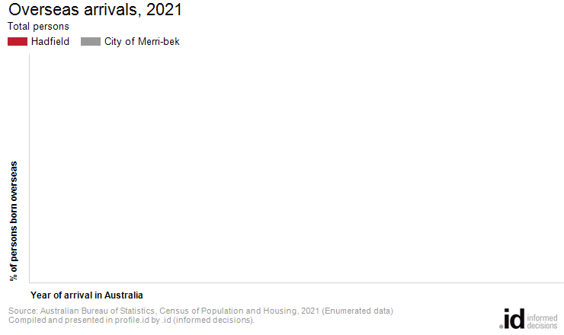
Analysis of the year of arrival for the overseas born population of Hadfield in 2021 compared to the City of Merri-bek shows that there was a [YearOfArrival].[Compare_Pre2001] proportion of people who arrived before 2001, [YearOfArrival].[Compare_Join] [YearOfArrival].[Compare_Recent] proportion of recent overseas arrivals (those who arrived between [YearOfArrival].[Recent_Label]).
Overall, [YearOfArrival].[Sum_Pre2001]% of the overseas born population arrived before 2001, and [YearOfArrival].[Sum_Recent]% arrived during or after 2016, compared with [YearOfArrival].[Sum_BM_Pre2001]% and [YearOfArrival].[Sum_BM_Recent]% respectively for the City of Merri-bek.
[YearOfArrival].[SpatialList1]

