City of Merri-bek

Occupation of employment
Brunswick's occupation statistics quantify the occupations in which the residents work (which may be within the residing area or elsewhere). This will be influenced by the economic base and employment opportunities available in the area, education levels, and the working and social aspirations of the population. When viewed with other indicators, such as Educational Qualifications and Individual Income, Occupation is a key measure for evaluating Brunswick's socio-economic status and skill base.
Occupation of employment
Brunswick - Employed persons (Usual residence) | 2021 |  |  | 2016 |  |  | Change
Occupation | Number | % | City of Merri-bek % | Number | % | City of Merri-bek % | 2016 to 2021
Managers | 2,321 | 14.6 | 13.6 | 1,942 | 13.5 | 12.2 | +378
Professionals | 7,034 | 44.2 | 34.7 | 5,858 | 40.6 | 31.1 | +1,175
Technicians and Trades Workers | 1,242 | 7.8 | 10.5 | 1,227 | 8.5 | 11.5 | +15
Community and Personal Service Workers | 1,499 | 9.4 | 10.0 | 1,495 | 10.4 | 10.2 | +4
Clerical and Administrative Workers | 1,750 | 11.0 | 12.4 | 1,708 | 11.8 | 13.5 | +41
Sales Workers | 899 | 5.6 | 6.9 | 1,028 | 7.1 | 8.5 | -130
Machinery Operators And Drivers | 299 | 1.9 | 3.7 | 290 | 2.0 | 4.2 | +9
Labourers | 635 | 4.0 | 6.2 | 699 | 4.8 | 7.1 | -64
Not stated or inadequately described | 223 | 1.4 | 1.8 | 175 | 1.2 | 1.7 | +47
Total employed persons aged 15+ | 15,912 | 100.0 | 100.0 | 14,427 | 100.0 | 100.0 | +1,485
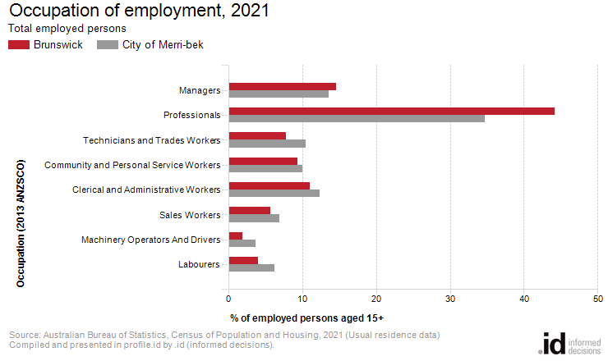
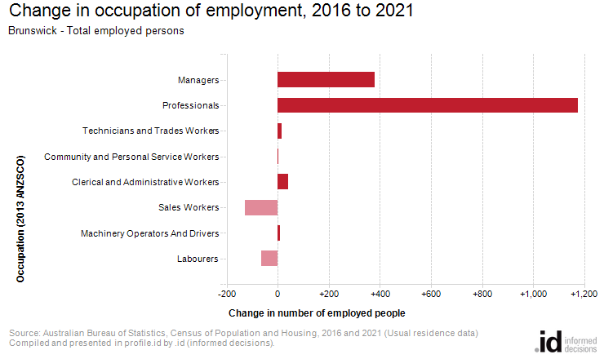
An analysis of the jobs held by the resident population in Brunswick in 2021 shows the three most popular occupations were:
- Professionals (7,034 people or 44.2%)
- Managers (2,321 people or 14.6%)
- Clerical and Administrative Workers (1,750 people or 11.0%)
In combination these three occupations accounted for 11,105 people in total or 69.8% of the employed resident population.
In comparison, the City of Merri-bek employed 34.7% in Professionals; 13.6% in Managers; and 12.4% in Clerical and Administrative Workers.
The major differences between the jobs held by the population of Brunswick and the City of Merri-bek were:
- A larger percentage of persons employed as Professionals (44.2% compared to 34.7%)
- A smaller percentage of persons employed as Technicians and Trades Workers (7.8% compared to 10.5%)
- A smaller percentage of persons employed as Labourers (4.0% compared to 6.2%)
- A smaller percentage of persons employed as Machinery Operators And Drivers (1.9% compared to 3.7%)
The number of employed people in Brunswick increased by 1,485 between 2016 and 2021.
The largest changes in the occupations of residents between 2016 and 2021 in Brunswick were for those employed as:
- Professionals (+1,175 persons)
- Managers (+378 persons)
- Sales Workers (-130 persons)
- Labourers (-64 persons)

