City of Merri-bek

Household size
The size of households in general follows the life-cycle of families. Households are usually small at the stage of relationship formation (early marriage), and then increase in size with the advent of children. They later reduce in size again as these children reach adulthood and leave home. Household size can also be influenced by a lack (or abundance) of affordable housing. Overseas migrants and indigenous persons often have a tradition of living with extended family members which significantly affects household size.
Household size in Australia has generally declined since the 1970s, but the rate of decline has slowed in recent years.
An increasing household size in an area may indicate a lack of affordable housing opportunities for young people, an increase in the birth rate or an increase in family formation in the area. A declining household size may indicate children leaving the area when they leave home, an increase in retirees settling in the area, or an attraction of young singles and couples to the area.
For greater insight, Hadfield's Household Size data should be viewed in conjunction with Household Summary, Age Structure, Dwelling Type, Household Income and Language Spoken at Home.
Household size
Hadfield - Households (Enumerated) | 2021 |  |  | 2016 |  |  | Change
Number of persons usually resident | Number | % | City of Merri-bek % | Number | % | City of Merri-bek % | 2016 to 2021
1 person | 669 | 28.3 | 29.5 | 616 | 27.7 | 27.0 | +52
2 persons | 734 | 31.0 | 32.8 | 705 | 31.7 | 33.0 | +29
3 persons | 393 | 16.6 | 16.3 | 352 | 15.8 | 17.0 | +41
4 persons | 332 | 14.0 | 14.6 | 308 | 13.9 | 14.9 | +23
5 persons | 142 | 6.0 | 4.6 | 140 | 6.3 | 5.3 | +1
6 or more persons | 96 | 4.1 | 2.1 | 100 | 4.5 | 2.8 | -5
Total classifiable households | 2,366 | 100.0 | 100.0 | 2,224 | 100.0 | 100.0 | +141
Household size - Summary
Hadfield - Enumerated | 2021 |  |  | 2016 |  |  | Change
Dwellings | Number | % | City of Merri-bek % | Number | % | City of Merri-bek % | 2016 to 2021
Occupied private dwellings | 2,481 |  |  | 2,357 |  |  | +124
Persons in occupied private dwellings | 6,264 |  |  | 5,931 |  |  | +333
Average household size (persons per dwelling) | 2.52 |  | 2.37 | 2.52 |  | 2.45 | 0.01
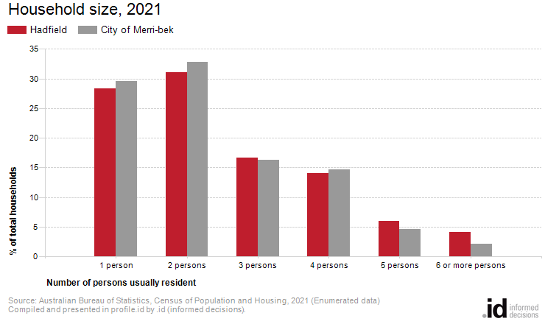
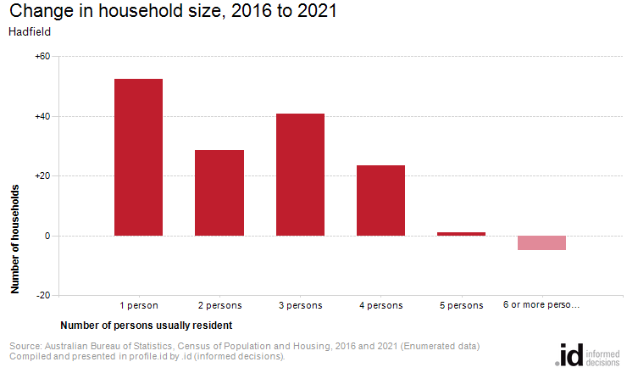
Analysis of the number of persons usually resident in a household in Hadfield compared with the City of Merri-bek shows that there were a lower proportion of lone person households, and a higher proportion of larger households (those with 4 persons or more). Overall there were 28.3% of lone person households, and 24.1% of larger households, compared with 29.5% and 21.3% respectively for the City of Merri-bek.
The major differences in the household size for Hadfield and the City of Merri-bek were:
- A larger percentage of households with 6 or more persons usually resident (4.1% compared to 2.1%)
- A larger percentage of households with 5 persons usually resident (6.0% compared to 4.6%)
- A smaller percentage of households with 2 persons usually resident (31.0% compared to 32.8%)
- A smaller percentage of households with 1 person usually resident (28.3% compared to 29.5%)
The number of households in Hadfield increased by 142 between 2016 and 2021.
The largest change in the number of persons usually resident in a household in Hadfield between 2016 and 2021 was:
- 1 person (+52 households)

