City of Merri-bek

Education institution attending
The share of Coburg North's population attending educational institutions reflects the age structure of the population, as it is influenced by the number of children attending school; proximity to tertiary education, which can mean young adults leaving home to be nearer to educational facilities and; the degree to which people are seeking out educational opportunities in adulthood, especially in their late teens and early twenties.
This data is often combined with Age Structure to identify areas with significant university student populations.
Learn more about planning education provision here.
Education institution attending
Coburg North - Total persons (Usual residence) | 2021 |  |  | 2016 |  |  | Change
Type of institution | Number | % | City of Merri-bek % | Number | % | City of Merri-bek % | 2016 to 2021
Pre-school | 218 | 2.6 | 2.1 | 142 | 1.9 | 1.5 | +76
Primary school | 625 | 7.5 | 6.6 | 458 | 6.1 | 6.5 | +167
Primary - Government | 401 | 4.8 | 4.2 | 293 | 3.9 | 3.9 | +107
Primary - Catholic | 164 | 2.0 | 1.6 | 139 | 1.9 | 1.8 | +24
Primary - Independent | 60 | 0.7 | 0.8 | 24 | 0.3 | 0.7 | +35
Secondary school | 451 | 5.4 | 4.8 | 353 | 4.7 | 4.4 | +97
Secondary - Government | 283 | 3.4 | 2.9 | 180 | 2.4 | 2.6 | +102
Secondary - Catholic | 136 | 1.6 | 1.2 | 130 | 1.7 | 1.2 | +6
Secondary - Independent | 32 | 0.4 | 0.8 | 42 | 0.6 | 0.7 | -11
TAFE/Vocational | 231 | 2.8 | 2.8 | 139 | 1.8 | 1.7 | +92
University | 491 | 5.9 | 7.5 | 539 | 7.1 | 8.2 | -49
Other | 80 | 1.0 | 1.1 | 88 | 1.2 | 1.1 | -8
Not attending | 5,793 | 69.5 | 70.7 | 5,254 | 69.6 | 69.8 | +539
Not stated | 451 | 5.4 | 4.4 | 571 | 7.6 | 6.6 | -121
Total | 8,340 | 100.0 | 100.0 | 7,547 | 100.0 | 100.0 | +793
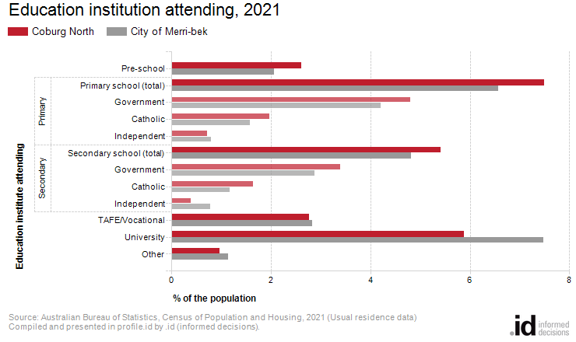
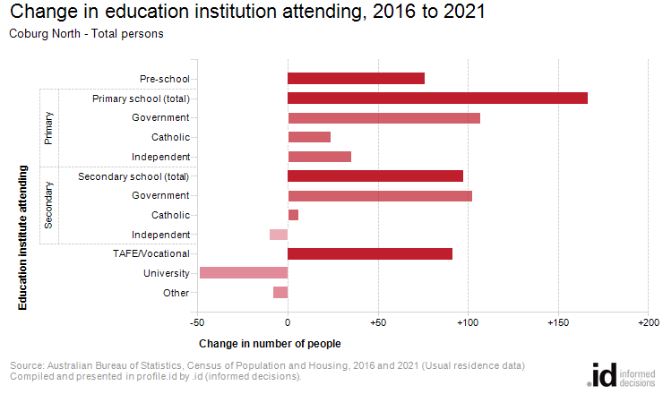
Analysis of the share of the population attending educational institutions in Coburg North in 2021 compared to the City of Merri-bek shows that there was a higher proportion attending primary school, a higher proportion attending secondary school, and a lower proportion engaged in tertiary level education.
Overall, 7.5% of the population were attending primary school, 5.4% of the population were attending secondary institutions, and 8.7% were learning at a tertiary level, compared with 6.6%, 4.8% and 10.3% respectively for the City of Merri-bek.
The major differences between the share of the population attending learning institutions in Coburg North and the City of Merri-bek were:
- A smaller percentage of persons attending University (5.9% compared to 7.5%)
- A smaller percentage of persons not attending (69.5% compared to 70.7%)
From 2016 to 2021, Coburg North's population increased by 799 people (+10.6%). This represents an average annual change of 2.03% per year over the period.
The largest changes in the number of persons attending education institutions in Coburg North, between 2016 and 2021 were in those who nominated:
- Primary school (+167 persons)
- Primary - Government (+107 persons)
- Secondary - Government (+102 persons)
- Secondary school (+97 persons)

