City of Merri-bek

Education institution attending
The share of Brunswick's population attending educational institutions reflects the age structure of the population, as it is influenced by the number of children attending school; proximity to tertiary education, which can mean young adults leaving home to be nearer to educational facilities and; the degree to which people are seeking out educational opportunities in adulthood, especially in their late teens and early twenties.
This data is often combined with Age Structure to identify areas with significant university student populations.
Learn more about planning education provision here.
Education institution attending
Brunswick - Total persons (Usual residence) | 2021 |  |  | 2016 |  |  | Change
Type of institution | Number | % | City of Merri-bek % | Number | % | City of Merri-bek % | 2016 to 2021
Pre-school | 354 | 1.4 | 2.1 | 275 | 1.1 | 1.5 | +78
Primary school | 1,083 | 4.3 | 6.6 | 981 | 4.0 | 6.5 | +102
Primary - Government | 850 | 3.4 | 4.2 | 759 | 3.1 | 3.9 | +91
Primary - Catholic | 161 | 0.6 | 1.6 | 185 | 0.8 | 1.8 | -24
Primary - Independent | 72 | 0.3 | 0.8 | 36 | 0.2 | 0.7 | +35
Secondary school | 766 | 3.1 | 4.8 | 594 | 2.4 | 4.4 | +172
Secondary - Government | 575 | 2.3 | 2.9 | 441 | 1.8 | 2.6 | +133
Secondary - Catholic | 85 | 0.3 | 1.2 | 103 | 0.4 | 1.2 | -18
Secondary - Independent | 106 | 0.4 | 0.8 | 49 | 0.2 | 0.7 | +57
TAFE/Vocational | 675 | 2.7 | 2.8 | 476 | 2.0 | 1.7 | +198
University | 2,794 | 11.2 | 7.5 | 3,230 | 13.3 | 8.2 | -436
Other | 204 | 0.8 | 1.1 | 237 | 1.0 | 1.1 | -33
Not attending | 18,316 | 73.3 | 70.7 | 16,959 | 69.7 | 69.8 | +1,356
Not stated | 782 | 3.1 | 4.4 | 1,588 | 6.5 | 6.6 | -806
Total | 24,974 | 100.0 | 100.0 | 24,343 | 100.0 | 100.0 | +631
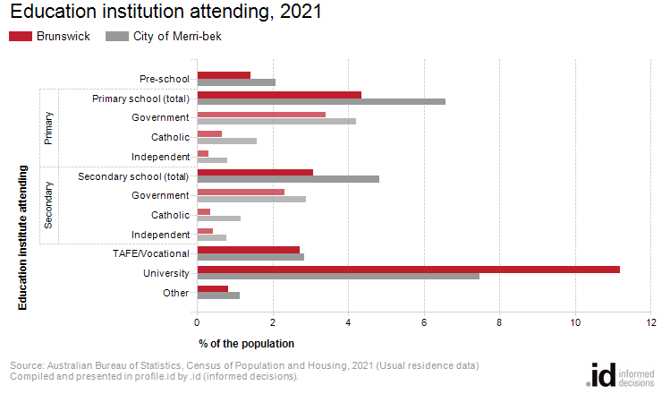
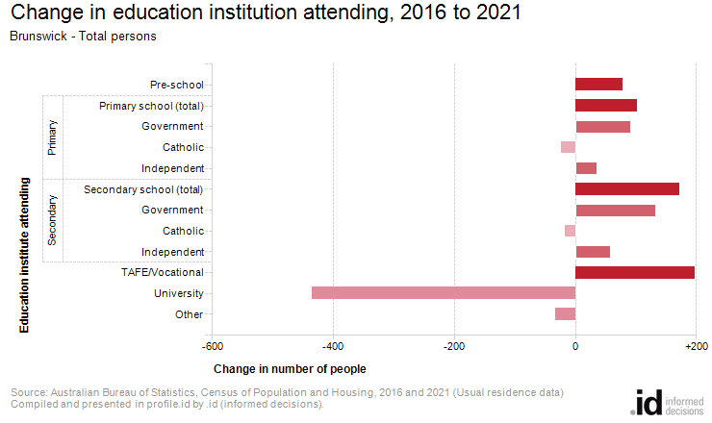
Analysis of the share of the population attending educational institutions in Brunswick in 2021 compared to the City of Merri-bek shows that there was a lower proportion attending primary school, a lower proportion attending secondary school, and a higher proportion engaged in tertiary level education.
Overall, 4.3% of the population were attending primary school, 3.1% of the population were attending secondary institutions, and 13.9% were learning at a tertiary level, compared with 6.6%, 4.8% and 10.3% respectively for the City of Merri-bek.
The major differences between the share of the population attending learning institutions in Brunswick and the City of Merri-bek were:
- A larger percentage of persons attending University (11.2% compared to 7.5%)
- A larger percentage of persons not attending (73.3% compared to 70.7%)
- A smaller percentage of persons attending a primary school (any type) (4.3% compared to 6.6%)
- A smaller percentage of persons attending a secondary school (any type) (3.1% compared to 4.8%)
From 2016 to 2021, Brunswick's population increased by 636 people (+2.6%). This represents an average annual change of 0.52% per year over the period.
The largest changes in the number of persons attending education institutions in Brunswick, between 2016 and 2021 were in those who nominated:
- University (-436 persons)
- TAFE/Vocational (+198 persons)
- Secondary school (+172 persons)
- Secondary - Government (+133 persons)

