City of Merri-bek

Number of cars per household
The ability of the population to access services and employment is strongly influenced by access to transport. The number of motor vehicles per household in Brunswick East quantifies access to private transport and will be influenced by Age Structure and Household Type, which determine the number of adults present; access to Public Transport; distance to shops, services, employment and education; and Household Income. Depending on these factors, car ownership can be seen as a measure of advantage or disadvantage, or a neutral socio-economic measure, which impacts on the environment and quality of life.
Car ownership
Brunswick East - Households (Enumerated) | 2021 |  |  | 2016 |  |  | Change
Number of cars | Number | % | City of Merri-bek % | Number | % | City of Merri-bek % | 2016 to 2021
No motor vehicles | 1,255 | 18.0 | 12.6 | 993 | 17.5 | 13.0 | +262
1 motor vehicle | 3,822 | 54.8 | 45.3 | 2,772 | 49.0 | 41.8 | +1,049
2 motor vehicles | 1,256 | 18.0 | 27.4 | 1,154 | 20.4 | 27.3 | +101
3 or more motor vehicles | 361 | 5.2 | 10.2 | 276 | 4.9 | 10.0 | +85
Not stated | 283 | 4.1 | 4.5 | 465 | 8.2 | 8.0 | -183
Total households | 6,977 | 100.0 | 100.0 | 5,662 | 100.0 | 100.0 | +1,314
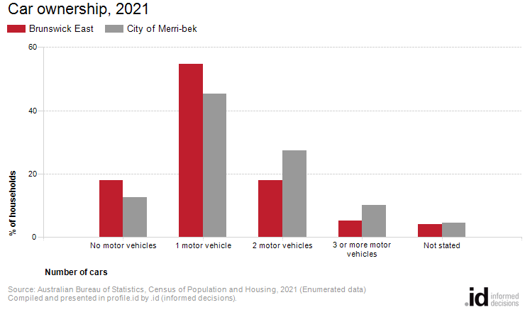
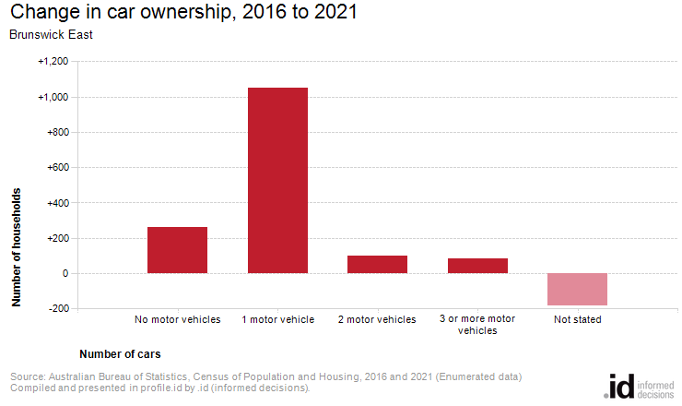
Analysis of the car ownership of the households in Brunswick East in 2021 compared to the City of Merri-bek shows that 78.0% of the households owned at least one car, while 18.0% did not, compared with 82.9% and 12.6% respectively in the City of Merri-bek.
Of those that owned at least one vehicle, there was a larger proportion who owned just one car; a smaller proportion who owned two cars; and a smaller proportion who owned three cars or more.
Overall, 54.8% of the households owned one car; 18.0% owned two cars; and 5.2% owned three cars or more, compared with 45.3%; 27.4% and 10.2% respectively for the City of Merri-bek.
The largest changes in the household car ownership in Brunswick East between 2016 and 2021 were:
- 1 motor vehicle (+1,049 households)
- No motor vehicles (+262 households)
- 2 motor vehicles (+101 households)
- 3 or more motor vehicles (+85 households)

