City of Merri-bek

Birthplace
Country of Birth data identifies where people were born and is indicative of the level of cultural diversity in Hadfield. The mix of Country of Birth groups is also indicative of historical settlement patterns, as source countries for Australia's immigration program have varied significantly over time.
To get a more complete picture of cultural and ethnic characteristics, Hadfield's Country of Birth data should be viewed together with Ancestry, Language Spoken at Home and Religion.
Please note: Due to changes in ABS rules around perturbation and additivity of data to protect the confidentiality of individuals, counts of individual birthplace groups and totals derived from them may differ slightly from those published by the ABS. For more information see notes on data confidentiality.
Birthplace - Summary
Hadfield - Total persons (Usual residence) | 2021 |  |  | 2016 |  |  | Change
Birthplace | Number | % | City of Merri-bek % | Number | % | City of Merri-bek % | 2016 to 2021
Total overseas born | 2,049 | 32.7 | 32.9 | 1,966 | 33.1 | 33.9 | +82
Australia | 3,823 | 61.0 | 62.9 | 3,523 | 59.2 | 59.2 | +300
Not stated | 395 | 6.3 | 4.2 | 457 | 7.7 | 6.8 | -62
Total Population | 6,267 | 100.0 | 100.0 | 5,947 | 100.0 | 100.0 | +320
Birthplace - Ranked by size
Hadfield - Overseas born (Usual residence) | 2021 |  |  | 2016 |  |  | Change
Birthplace | Number | % | City of Merri-bek % | Number | % | City of Merri-bek % | 2016 to 2021
Italy | 329 | 5.2 | 3.8 | 425 | 7.2 | 4.9 | -97
Lebanon | 254 | 4.1 | 1.6 | 233 | 3.9 | 1.6 | +20
Pakistan | 165 | 2.6 | 1.5 | 125 | 2.1 | 1.9 | +39
India | 136 | 2.2 | 2.4 | 91 | 1.5 | 2.5 | +45
United Kingdom | 96 | 1.5 | 2.6 | 65 | 1.1 | 2.4 | +31
Greece | 93 | 1.5 | 1.8 | 105 | 1.8 | 2.1 | -13
Malta | 91 | 1.5 | 0.4 | 122 | 2.1 | 0.5 | -32
New Zealand | 89 | 1.4 | 1.8 | 65 | 1.1 | 1.8 | +23
Turkey | 84 | 1.3 | 1.1 | 97 | 1.6 | 1.0 | -14
Philippines | 49 | 0.8 | 0.8 | 34 | 0.6 | 0.7 | +14
Iran | 36 | 0.6 | 0.3 | 11 | 0.2 | 0.4 | +24
Vietnam | 35 | 0.6 | 0.7 | 27 | 0.5 | 0.7 | +8
Syria | 32 | 0.5 | 0.2 | 17 | 0.3 | 0.2 | +14
China | 32 | 0.5 | 1.2 | 31 | 0.5 | 1.6 | +1
Poland | 29 | 0.5 | 0.2 | 15 | 0.3 | 0.3 | +13
Malaysia | 27 | 0.4 | 0.7 | 15 | 0.3 | 0.6 | +11
Nepal | 27 | 0.4 | 2.1 | 16 | 0.3 | 1.4 | +10
Croatia | 26 | 0.4 | 0.2 | 19 | 0.3 | 0.2 | +7
Egypt | 26 | 0.4 | 0.3 | 25 | 0.4 | 0.4 | 0
Sri Lanka | 26 | 0.4 | 0.6 | 25 | 0.4 | 0.6 | +1
Iraq | 24 | 0.4 | 0.4 | 30 | 0.5 | 0.4 | -6
Germany | 22 | 0.4 | 0.4 | 18 | 0.3 | 0.4 | +3
Colombia | 22 | 0.4 | 0.3 | 6 | 0.1 | 0.2 | +15
Saudi Arabia | 15 | 0.2 | 0.1 | 14 | 0.2 | 0.2 | 0
Bangladesh | 14 | 0.2 | 0.3 | 7 | 0.1 | 0.3 | +6
United States of America | 14 | 0.2 | 0.6 | 1 | 0.0 | 0.5 | +13
Serbia / Montenegro (fmr Yugoslavia) | 13 | 0.2 | 0.2 | 16 | 0.3 | 0.2 | -3
Cyprus | 13 | 0.2 | 0.2 | 11 | 0.2 | 0.2 | +2
Argentina | 12 | 0.2 | 0.1 | 0 | 0.0 | 0.1 | +12
Brazil | 12 | 0.2 | 0.2 | 0 | 0.0 | 0.1 | +12
Ireland | 10 | 0.2 | 0.3 | 10 | 0.2 | 0.3 | -1
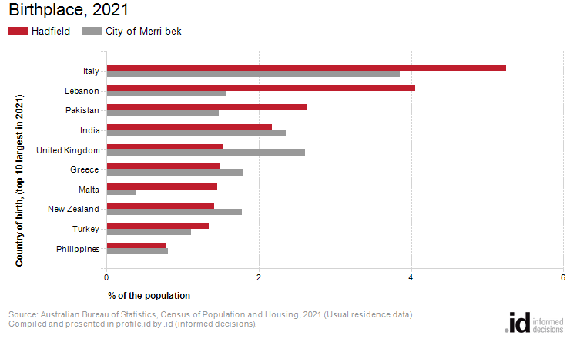
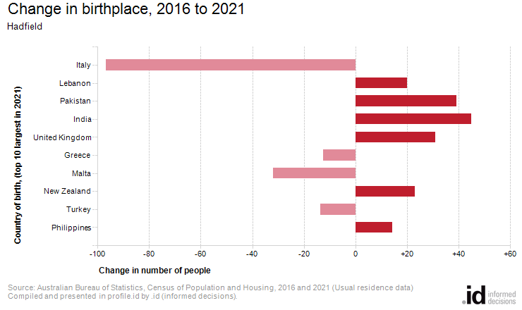
Analysis of the country of birth of the population in Hadfield in 2021 compared to the City of Merri-bek shows that there was a similar proportion of people born overseas.
Overall, 32.7% of the population was born overseas, compared with 32.9% for the City of Merri-bek.
The largest non-English speaking country of birth in Hadfield was Italy, where 5.2% of the population, or 329 people, were born.
The major differences between the countries of birth of the population in Hadfield and the City of Merri-bek were:
- A larger percentage of people born in Lebanon (4.1% compared to 1.6%)
- A larger percentage of people born in Italy (5.2% compared to 3.8%)
- A larger percentage of people born in Pakistan (2.6% compared to 1.5%)
- A smaller percentage of people born in Nepal (0.4% compared to 2.1%)
The largest non-English speaking country of birth in Hadfield was Italy, where 5.2% of the population, or 329 people, were born.
The major differences between the countries of birth of the population in Hadfield and the City of Merri-bek were:
- A larger percentage of people born in Lebanon (4.1% compared to 1.6%)
- A larger percentage of people born in Italy (5.2% compared to 3.8%)
- A larger percentage of people born in Pakistan (2.6% compared to 1.5%)
- A smaller percentage of people born in Nepal (0.4% compared to 2.1%)
Between 2016 and 2021, the number of people born overseas increased by 83 or 4.2%.
The largest change in birthplace countries of the population in this area between 2016 and 2021 was for those born in:
- Italy (-97 persons)

