City of Moonee Valley

Occupation of employment
Ascot Vale (N)'s occupation statistics quantify the occupations in which the residents work (which may be within the residing area or elsewhere). This will be influenced by the economic base and employment opportunities available in the area, education levels, and the working and social aspirations of the population. When viewed with other indicators, such as Educational Qualifications and Individual Income, Occupation is a key measure for evaluating Ascot Vale (N)'s socio-economic status and skill base.
Occupation of employment
Ascot Vale (N) - Employed persons (Usual residence) | 2016 |  |  | 2011 |  |  | Change
Occupation | Number | % | City of Moonee Valley % | Number | % | City of Moonee Valley % | 2011 to 2016
Managers | 1,218 | 16.0 | 15.0 | 1,010 | 14.6 | 13.9 | +208
Professionals | 2,679 | 35.3 | 29.3 | 2,248 | 32.4 | 27.8 | +431
Technicians and Trades Workers | 578 | 7.6 | 10.2 | 619 | 8.9 | 11.1 | -41
Community and Personal Service Workers | 793 | 10.4 | 9.5 | 661 | 9.5 | 8.6 | +132
Clerical and Administrative Workers | 996 | 13.1 | 15.4 | 1,119 | 16.1 | 17.1 | -123
Sales Workers | 590 | 7.8 | 9.6 | 533 | 7.7 | 9.6 | +57
Machinery Operators And Drivers | 218 | 2.9 | 3.6 | 199 | 2.9 | 3.9 | +19
Labourers | 428 | 5.6 | 5.7 | 375 | 5.4 | 5.9 | +53
Not stated or inadequately described | 100 | 1.3 | 1.7 | 166 | 2.4 | 2.3 | -66
Total employed persons aged 15+ | 7,600 | 100.0 | 100.0 | 6,930 | 100.0 | 100.0 | +670
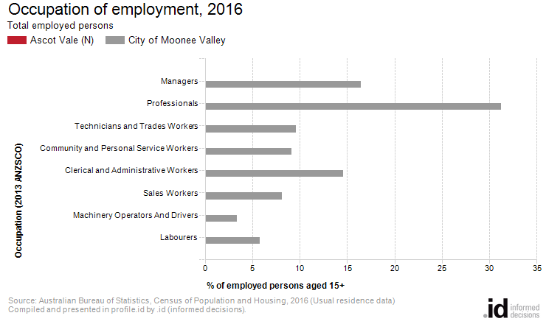
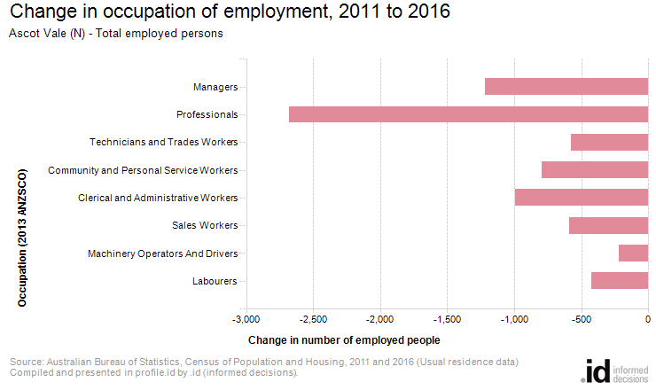
An analysis of the jobs held by the resident population in Ascot Vale (N) in 2016 shows the three most popular occupations were:
- Managers (0 people or %)
- Professionals (0 people or %)
- Technicians and Trades Workers (0 people or %)
In combination these three occupations accounted for 0 people in total or 0.0% of the employed resident population.
In comparison, the City of Moonee Valley employed 16.4% in Managers; 31.3% in Professionals; and 9.6% in Technicians and Trades Workers.
The major differences between the jobs held by the population of Ascot Vale (N) and the City of Moonee Valley were:
- A smaller percentage of persons employed as Professionals (0.0% compared to 31.3%)
- A smaller percentage of persons employed as Managers (0.0% compared to 16.4%)
- A smaller percentage of persons employed as Clerical and Administrative Workers (0.0% compared to 14.6%)
- A smaller percentage of persons employed as Technicians and Trades Workers (0.0% compared to 9.6%)
The number of employed people in Ascot Vale (N) decreased by 7,600 between 2011 and 2016.
The largest changes in the occupations of residents between 2011 and 2016 in Ascot Vale (N) were for those employed as:
- Professionals (-2,679 persons)
- Managers (-1,218 persons)
- Clerical and Administrative Workers (-996 persons)
- Community and Personal Service Workers (-793 persons)

