City of Monash

Unpaid childcare
The role of unpaid childcare in the City of Monash is determined by many different factors. For example areas with high levels of unpaid child care may have a dominance of single income families with one significant earner, or there could be a lack of provision of paid child care in the area. The level to which people care for others children can also indicate the role of extended family (eg. grandparents caring for grandchildren, family day care).
The role of unpaid child care is a complex one so this topic should be viewed in conjunction with several others, including Household Type, Employment, Household Income and Educational Attendance.
Unpaid childcare
City of Monash - Persons aged 15+ (Usual residence) | 2021 |  |  | 2016 |  |  | Change
Unpaid child care | Number | % | Greater Melbourne % | Number | % | Greater Melbourne % | 2016 to 2021
Provided unpaid child care (all) | 39,236 | 24.4 | 26.5 | 39,057 | 25.4 | 27.5 | +179
Cared for own child/ren | 31,317 | 19.5 | 20.9 | 28,730 | 18.7 | 20.3 | +2,587
Cared for other child/ren | 7,521 | 4.7 | 5.2 | 9,612 | 6.3 | 6.5 | -2,091
Cared for own child/ren and other child/ren | 398 | 0.2 | 0.5 | 715 | 0.5 | 0.7 | -317
No unpaid child care provided | 113,612 | 70.7 | 68.1 | 105,711 | 68.8 | 65.2 | +7,901
Not stated | 7,961 | 5.0 | 5.4 | 8,948 | 5.8 | 7.3 | -987
Total persons aged 15+ | 160,809 | 100.0 | 100.0 | 153,716 | 100.0 | 100.0 | +7,093
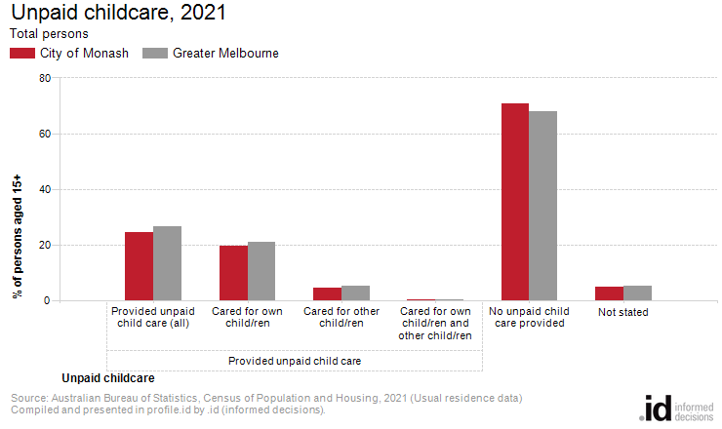
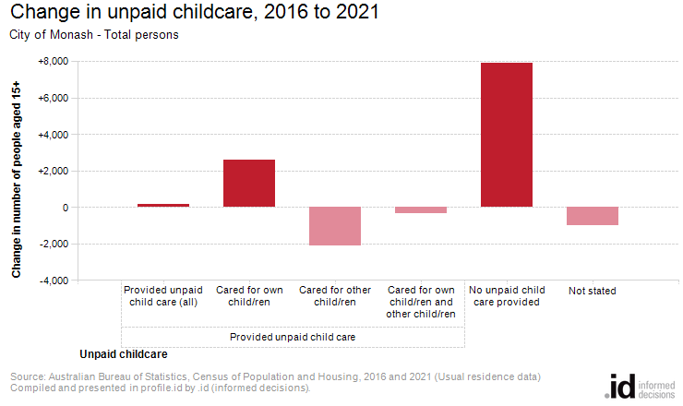
Analysis of the unpaid child care provided by the population in the City of Monash in 2021 compared to Greater Melbourne shows that there was a lower proportion of people who provided unpaid child care either to their own or to other children. Overall, 24.4% of the population provided unpaid child care, compared with 26.5% for Greater Melbourne.
The major differences between the share of the population providing unpaid child care in the City of Monash and Greater Melbourne were:
- A larger percentage who did not provide care for children (70.7% compared to 68.1%)
- A smaller percentage who provided unpaid childcare for own child/ren (19.5% compared to 20.9%)
The number of people who provided unpaid child care for their own and/or other people's children in City of Monash increased by 179 between 2016 and 2021.
The largest changes in the number of people performing unpaid child care in the City of Monash, between 2016 and 2021 were those who:
- Provided no unpaid child care (+7,901 persons)
- Cared for their own child/ren (+2,587 persons)
- Cared for other child/ren (-2,091 persons)
- Cared for their own child/ren and other child/ren (-317 persons)

