City of Monash

Unpaid care
The proportion of people providing unpaid care for the aged and disabled in the City of Monash can be an important indicator of the level of demand for aged care services and facilities by local and state governments. An increasing proportion of carers among the population may indicate inadequate aged care provision, or the need for in-home support, or support for the carers themselves. The level of care provided by individuals is likely to be affected by Household Income, Age Structure and the ethnic makeup of the community (Language Spoken), as well as the sense of community cohesiveness.
Unpaid care
City of Monash - Persons aged 15+ (Usual residence) | 2021 |  |  | 2016 |  |  | Change
Assistance to a person with a disability, long term illness or old age | Number | % | Greater Melbourne % | Number | % | Greater Melbourne % | 2016 to 2021
Provided unpaid assistance | 19,293 | 12.0 | 12.6 | 16,996 | 11.1 | 11.3 | +2,297
No unpaid assistance provided | 133,183 | 82.8 | 81.8 | 127,069 | 82.7 | 80.8 | +6,114
Not stated | 8,339 | 5.2 | 5.6 | 9,651 | 6.3 | 7.9 | -1,312
Total persons aged 15+ | 160,815 | 100.0 | 100.0 | 153,716 | 100.0 | 100.0 | +7,099
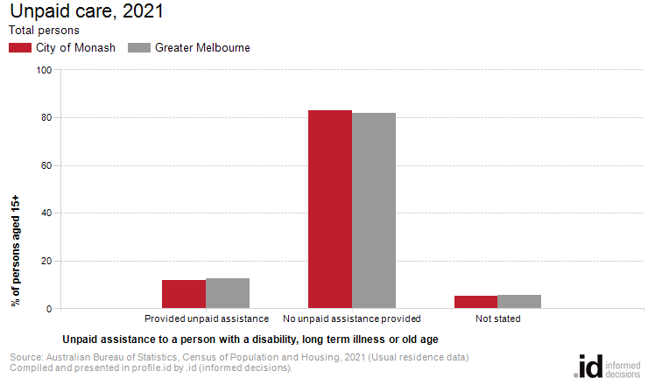
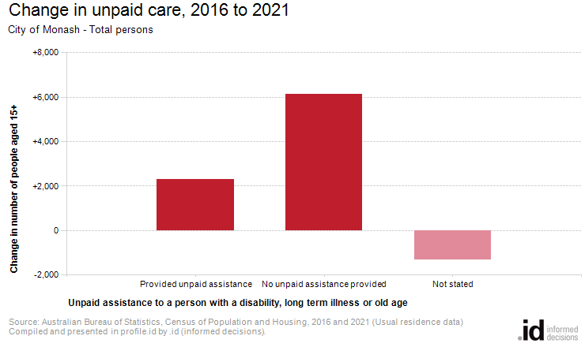
Analysis of the unpaid care provided by the population in the City of Monash in 2021 compared to Greater Melbourne shows that there was a lower proportion of people who provided unpaid care either to family members or others.
Overall, 12.0% of the population provided unpaid care, compared with 12.6% for Greater Melbourne.
The number of people who provided unpaid assistance to a person with a disability, long term illness or old age in the City of Monash increased by 2,297 between 2016 and 2021.

