City of Monash

Industry sector of employment
The City of Monash's industry statistics identify the industry sectors in which the residents work (which may be within the residing area or elsewhere). This will be influenced by the skill base and socio-economic status of the residents as well as the industries and employment opportunities present in the region.
When viewed in conjunction with Residents Place of Work data and Method of Travel to Work, industry sector statistics provide insights into the relationship between the economic and residential role of the area.
Industry sector of employment
City of Monash - Employed persons (Usual residence) | 2021 |  |  | 2016 |  |  | Change
Industry sector | Number | % | Greater Melbourne % | Number | % | Greater Melbourne % | 2016 to 2021
Agriculture, Forestry and Fishing | 248 | 0.3 | 0.6 | 207 | 0.3 | 0.6 | +41
Mining | 117 | 0.1 | 0.2 | 112 | 0.1 | 0.2 | +5
Manufacturing | 5,987 | 6.5 | 6.9 | 5,746 | 7.1 | 7.7 | +241
Electricity, Gas, Water and Waste Services | 876 | 1.0 | 1.0 | 760 | 0.9 | 1.0 | +116
Construction | 6,120 | 6.6 | 9.3 | 4,652 | 5.8 | 8.2 | +1,468
Wholesale trade | 3,415 | 3.7 | 3.0 | 3,453 | 4.3 | 3.5 | -38
Retail Trade | 9,305 | 10.1 | 9.4 | 8,593 | 10.7 | 10.1 | +712
Accommodation and Food Services | 6,251 | 6.8 | 6.1 | 5,504 | 6.8 | 6.5 | +747
Transport, Postal and Warehousing | 3,514 | 3.8 | 4.9 | 2,896 | 3.6 | 5.0 | +618
Information Media and Telecommunications | 1,822 | 2.0 | 1.8 | 2,002 | 2.5 | 2.2 | -180
Financial and Insurance Services | 5,247 | 5.7 | 4.7 | 4,267 | 5.3 | 4.5 | +980
Rental, Hiring and Real Estate Services | 1,474 | 1.6 | 1.6 | 1,479 | 1.8 | 1.7 | -5
Professional, Scientific and Technical Services | 10,615 | 11.5 | 9.6 | 8,920 | 11.1 | 9.0 | +1,695
Administrative and Support Services | 3,204 | 3.5 | 3.2 | 3,004 | 3.7 | 3.6 | +200
Public Administration and Safety | 3,750 | 4.1 | 5.4 | 3,192 | 4.0 | 5.0 | +558
Education and Training | 9,060 | 9.8 | 8.8 | 7,960 | 9.9 | 8.6 | +1,100
Health Care and Social Assistance | 12,438 | 13.5 | 13.5 | 9,728 | 12.1 | 12.0 | +2,710
Arts and Recreation Services | 1,254 | 1.4 | 1.8 | 1,345 | 1.7 | 2.1 | -91
Other Services | 2,874 | 3.1 | 3.4 | 2,599 | 3.2 | 3.6 | +275
Inadequately described or not stated | 4,509 | 4.9 | 4.8 | 3,975 | 4.9 | 4.9 | +534
Total employed persons aged 15+ | 92,080 | 100.0 | 100.0 | 80,394 | 100.0 | 100.0 | +11,686
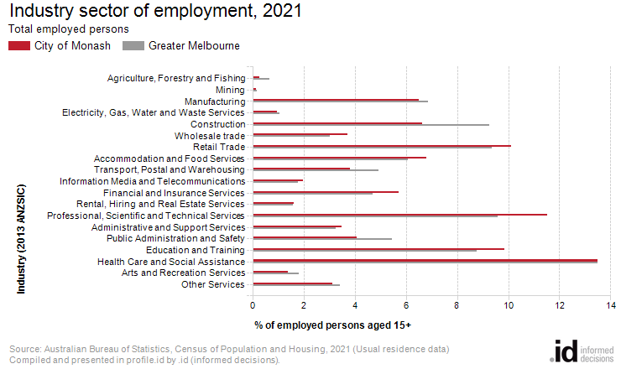
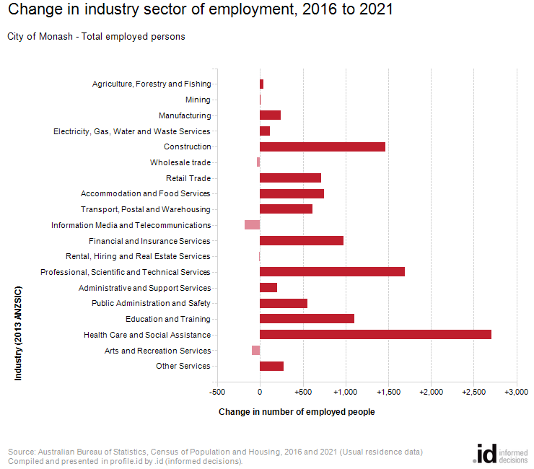
An analysis of the jobs held by the resident population in City of Monash in 2021 shows the three most popular industry sectors were:
- Health Care and Social Assistance (12,438 people or 13.5%)
- Professional, Scientific and Technical Services (10,615 people or 11.5%)
- Retail Trade (9,305 people or 10.1%)
In combination, these three industries employed 32,358 people in total or 35.1% of the total employed resident population.
In comparison, Greater Melbourne employed 13.5% in Health Care and Social Assistance; 9.6% in Professional, Scientific and Technical Services; and 9.4% in Retail Trade.
The major differences between the jobs held by the population of the City of Monash and Greater Melbourne were:
- A larger percentage of persons employed in professional, scientific and technical services (11.5% compared to 9.6%)
- A smaller percentage of persons employed in construction (6.6% compared to 9.3%)
- A smaller percentage of persons employed in public administration and safety (4.1% compared to 5.4%)
- A smaller percentage of persons employed in transport, postal and warehousing (3.8% compared to 4.9%)
The number of employed people in City of Monash increased by 11,686 between 2016 and 2021.
The largest changes in the jobs held by the resident population between 2016 and 2021 in the City of Monash were for those employed in:
- Health Care and Social Assistance (+2,710 persons)
- Professional, Scientific and Technical Services (+1,695 persons)
- Construction (+1,468 persons)
- Education and Training (+1,100 persons)

