Manningham City Council

Volunteer work
The voluntary work sector is an important part of Australia's economy. The level of volunteering can indicate the cohesiveness of the community and how readily individuals are able to contribute to that community. Factors impacting on the level of volunteering in Doncaster Hill include the Age Structure of the population, the level of Proficiency in English, Income and Education levels.
Volunteer numbers for the 2021 Census declined in many parts of Australia due to lockdowns and COVID-19 distancing measures.
Volunteer work
Doncaster Hill - Persons aged 15+ (Usual residence) | 2021 |  |  | 2016 |  |  | Change
Volunteer status | Number | % | City of Manningham % | Number | % | City of Manningham % | 2016 to 2021
Volunteer | 314 | 9.5 | 13.4 | 359 | 16.2 | 19.6 | -45
Not a volunteer | 2,820 | 84.9 | 83.1 | 1,713 | 77.1 | 75.2 | +1,107
Volunteer work not stated | 188 | 5.7 | 3.5 | 150 | 6.7 | 5.2 | +38
Total persons aged 15+ | 3,322 | 100.0 | 100.0 | 2,222 | 100.0 | 100.0 | +1,100
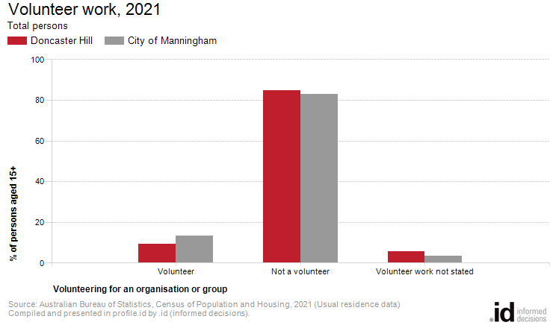
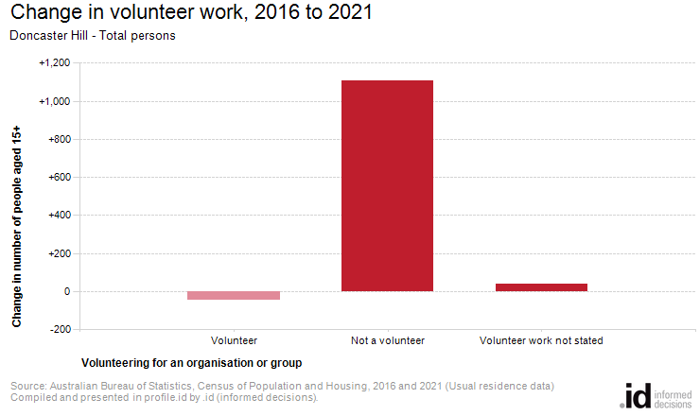
Analysis of the voluntary work performed by the population in Doncaster Hill in 2021 compared to City of Manningham shows that there was a lower proportion of people who volunteered for an organisation or group.
Overall, 9.5% of the population reported performing voluntary work, compared with 13.4% for City of Manningham.
The number of volunteers in Doncaster Hill decreased by 45 people between 2016 and 2021.

