Manningham City Council

Highest level of schooling
Doncaster Hill's school completion data is a useful indicator of socio-economic status. With other indicators, such as Proficiency in English, the data informs planners and decision-makers about people's ability to access services. Combined with Educational Qualifications it also allows assessment of the skill base of the population.
Learn more about planning education provision here.
Persons aged 15 years and over
Highest level of secondary schooling completed
Doncaster Hill - Total persons (Usual residence) | 2021 |  |  | 2016 |  |  | Change
Level of schooling | Number | % | City of Manningham % | Number | % | City of Manningham % | 2016 to 2021
Year 8 or below | 84 | 2.5 | 5.1 | 92 | 4.2 | 5.8 | -9
Year 9 or equivalent | 74 | 2.2 | 4.1 | 71 | 3.2 | 4.5 | +2
Year 10 or equivalent | 202 | 6.1 | 8.5 | 154 | 7.0 | 9.8 | +47
Year 11 or equivalent | 189 | 5.7 | 8.7 | 129 | 5.8 | 9.5 | +60
Year 12 or equivalent | 2,543 | 76.7 | 68.5 | 1,605 | 72.4 | 63.5 | +938
Did not go to school | 34 | 1.0 | 1.2 | 29 | 1.3 | 1.2 | +5
Not stated | 188 | 5.7 | 3.9 | 133 | 6.0 | 5.7 | +54
Total persons aged 15+ | 3,314 | 100.0 | 100.0 | 2,216 | 100.0 | 100.0 | +1,097
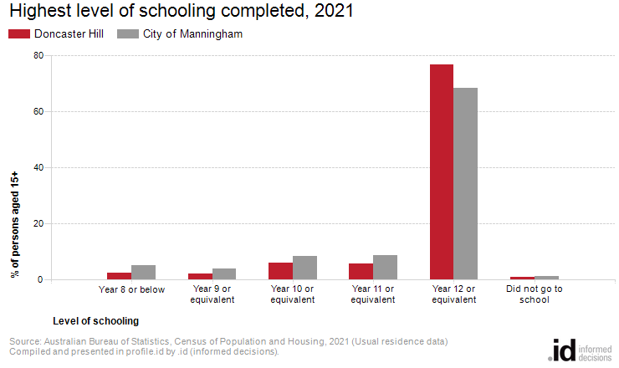
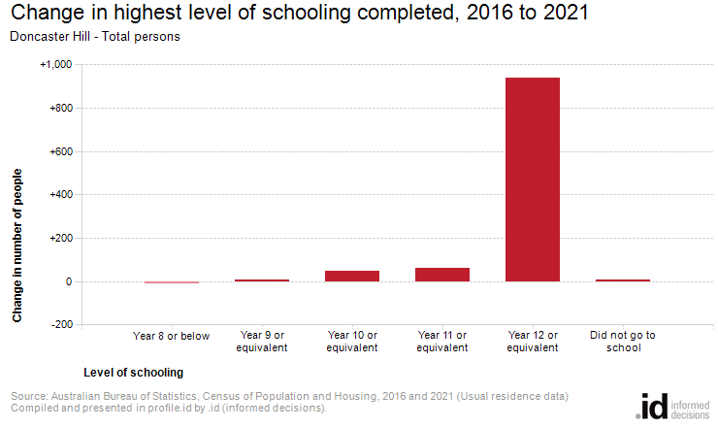
Analysis of the highest level of schooling attained by the population in Doncaster Hill in 2021 compared to City of Manningham shows that there was a lower proportion of people who had left school at an early level (Year 10 or less) and a higher proportion of people who completed Year 12 or equivalent.
Overall, 11.9% of the population left school at Year 10 or below, and 76.7% went on to complete Year 12 or equivalent, compared with 18.9% and 68.5% respectively for City of Manningham.
The major differences between the level of schooling attained by the population in Doncaster Hill and City of Manningham were:
- A larger percentage of persons who completed year 12 or equivalent (76.7% compared to 68.5%)
- A smaller percentage of persons who completed year 11 or equivalent (5.7% compared to 8.7%)
- A smaller percentage of persons who completed year 8 or below (2.5% compared to 5.1%)
- A smaller percentage of persons who completed year 10 or equivalent (6.1% compared to 8.5%)
The largest changes in the level of schooling attained by the population in Doncaster Hill, between 2016 and 2021 were:
- Year 12 or equivalent (+938 persons)
- Year 11 or equivalent (+60 persons)

