Manningham City Council

Qualifications
Educational Qualifications relate to education outside of primary and secondary school and are one of the most important indicators of socio-economic status. With other data sources, such as Employment Status, Income and Occupation, Doncaster Hill's Educational Qualifications help to evaluate the economic opportunities and socio-economic status of the area and identify skill gaps in the labour market.
Learn more about planning education provision here.
Highest qualification achieved
Doncaster Hill - Persons aged 15+ (Enumerated) | 2016 |  |  | 2011 |  |  | Change
Qualification level | Number | % | City of Manningham % | Number | % | City of Manningham % | 2011 to 2016
Bachelor or Higher degree | 841 | 38.0 | 32.5 | 303 | 33.6 | 28.4 | +538
Advanced Diploma or Diploma | 239 | 10.8 | 9.7 | 95 | 10.6 | 9.9 | +144
Vocational | 211 | 9.5 | 12.1 | 75 | 8.3 | 12.5 | +136
No qualification | 753 | 34.0 | 38.4 | 330 | 36.5 | 41.0 | +423
Not stated | 168 | 7.6 | 7.2 | 99 | 11.0 | 8.1 | +69
Total persons aged 15+ | 2,214 | 100.0 | 100.0 | 904 | 100.0 | 100.0 | +1,310
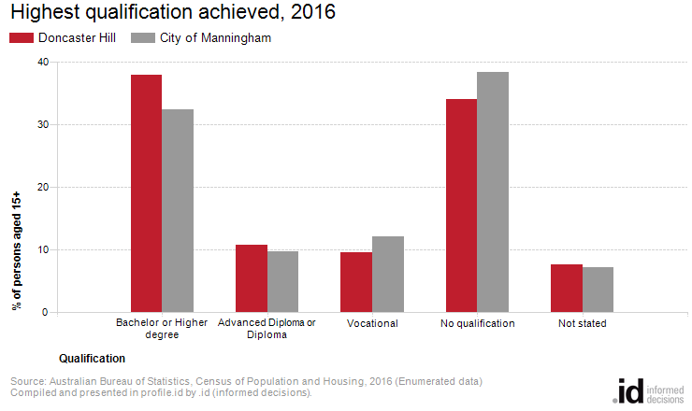
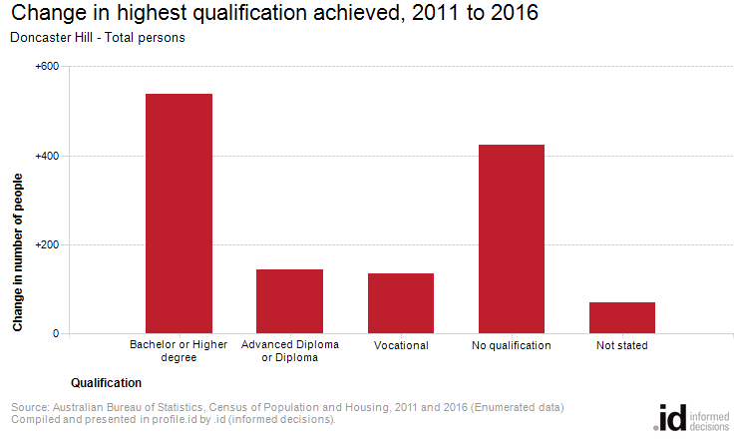
Analysis of the qualifications of the population in Doncaster Hill in 2016 compared to City of Manningham shows that there was a higher proportion of people holding formal qualifications (Bachelor or higher degree; Advanced Diploma or Diploma; or Vocational qualifications), and a lower proportion of people with no formal qualifications.
Overall, 58.4% of the population aged 15 and over held educational qualifications, and 34.0% had no qualifications, compared with 54.4% and 38.4% respectively for City of Manningham.
The major differences between qualifications held by the population of Doncaster Hill and City of Manningham were:
- A larger percentage of persons with Bachelor or Higher degrees (38.0% compared to 32.5%)
- A larger percentage of persons with Advanced Diploma or Diplomas (10.8% compared to 9.7%)
- A smaller percentage of persons with No qualifications (34.0% compared to 38.4%)
- A smaller percentage of persons with Vocational qualifications (9.5% compared to 12.1%)
The largest changes in the qualifications of the population in Doncaster Hill between 2011 and 2016 were in those with:
- Bachelor or Higher degrees (+538 persons)
- No qualifications (+423 persons)
- Advanced Diploma or Diplomas (+144 persons)
- Vocational qualifications (+136 persons)

