Manningham City Council

Birthplace
Country of Birth data identifies where people were born and is indicative of the level of cultural diversity in Doncaster Hill. The mix of Country of Birth groups is also indicative of historical settlement patterns, as source countries for Australia's immigration program have varied significantly over time.
To get a more complete picture of cultural and ethnic characteristics, Doncaster Hill's Country of Birth data should be viewed together with Ancestry, Language Spoken at Home and Religion.
Please note: Due to changes in ABS rules around perturbation and additivity of data to protect the confidentiality of individuals, counts of individual birthplace groups and totals derived from them may differ slightly from those published by the ABS. For more information see notes on data confidentiality.
Birthplace - Summary
Doncaster Hill - Total persons (Usual residence) | 2021 |  |  | 2016 |  |  | Change
Birthplace | Number | % | City of Manningham % | Number | % | City of Manningham % | 2016 to 2021
Total overseas born | 2,455 | 64.8 | 43.5 | 1,493 | 60.0 | 39.8 | +961
Australia | 1,152 | 30.4 | 53.5 | 840 | 33.8 | 55.7 | +311
Not stated | 182 | 4.8 | 3.0 | 156 | 6.3 | 4.5 | +26
Total Population | 3,789 | 100.0 | 100.0 | 2,490 | 100.0 | 100.0 | +1,299
Birthplace - Ranked by size
Doncaster Hill - Overseas born (Usual residence) | 2021 |  |  | 2016 |  |  | Change
Birthplace | Number | % | City of Manningham % | Number | % | City of Manningham % | 2016 to 2021
China | 767 | 20.2 | 11.2 | 516 | 20.8 | 9.3 | +250
Malaysia | 238 | 6.3 | 3.8 | 133 | 5.4 | 3.3 | +104
Iran | 237 | 6.3 | 2.4 | 104 | 4.2 | 1.7 | +133
Hong Kong | 195 | 5.1 | 3.0 | 124 | 5.0 | 2.6 | +71
India | 112 | 3.0 | 1.9 | 48 | 2.0 | 1.5 | +63
South Korea | 80 | 2.1 | 0.7 | 61 | 2.5 | 0.7 | +18
Taiwan | 62 | 1.6 | 0.7 | 38 | 1.6 | 0.6 | +23
United Kingdom | 51 | 1.3 | 2.3 | 34 | 1.4 | 2.6 | +17
Singapore | 50 | 1.3 | 0.7 | 36 | 1.4 | 0.8 | +14
Sri Lanka | 50 | 1.3 | 0.7 | 12 | 0.5 | 0.6 | +37
Philippines | 50 | 1.3 | 0.5 | 22 | 0.9 | 0.4 | +27
Greece | 47 | 1.2 | 2.4 | 43 | 1.8 | 2.4 | +3
Italy | 47 | 1.2 | 2.3 | 44 | 1.8 | 2.7 | +2
Vietnam | 39 | 1.0 | 1.0 | 31 | 1.3 | 0.9 | +7
Pakistan | 33 | 0.9 | 0.5 | 4 | 0.2 | 0.3 | +28
New Zealand | 32 | 0.8 | 0.9 | 21 | 0.9 | 0.9 | +10
Thailand | 30 | 0.8 | 0.2 | 2 | 0.1 | 0.2 | +27
South Africa | 28 | 0.7 | 0.9 | 10 | 0.4 | 1.0 | +18
Indonesia | 22 | 0.6 | 0.5 | 10 | 0.4 | 0.4 | +12
Japan | 19 | 0.5 | 0.2 | 12 | 0.5 | 0.2 | +7
Egypt | 18 | 0.5 | 0.6 | 14 | 0.6 | 0.6 | +3
Colombia | 18 | 0.5 | 0.1 | 0 | 0.0 | 0.1 | +18
Malta | 14 | 0.4 | 0.2 | 2 | 0.1 | 0.2 | +11
Zimbabwe | 12 | 0.3 | 0.1 | 4 | 0.2 | 0.1 | +7
Somalia | 10 | 0.3 | 0.0 | 6 | 0.3 | 0.0 | +4
United Arab Emirates | 10 | 0.3 | 0.1 | 0 |  | 0.1 | +10
Mauritius | 10 | 0.3 | 0.1 | 1 | 0.1 | 0.1 | +8
Poland | 10 | 0.3 | 0.2 | 4 | 0.2 | 0.2 | +5
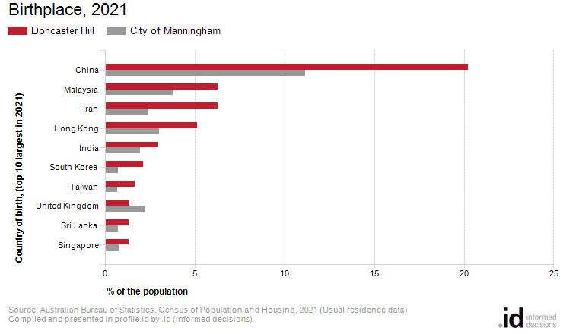
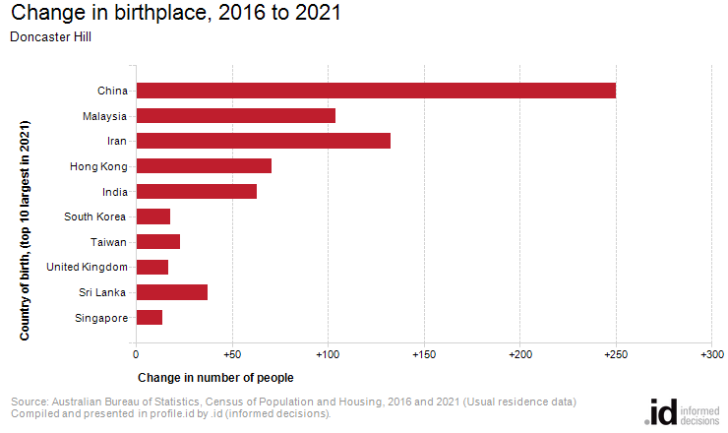
Analysis of the country of birth of the population in Doncaster Hill in 2021 compared to City of Manningham shows that there was a larger proportion of people born overseas.
Overall, 64.8% of the population was born overseas, compared with 43.5% for City of Manningham.
The largest non-English speaking country of birth in Doncaster Hill was China, where 20.2% of the population, or 767 people, were born.
The major differences between the countries of birth of the population in Doncaster Hill and City of Manningham were:
- A larger percentage of people born in China (20.2% compared to 11.2%)
- A larger percentage of people born in Iran (6.3% compared to 2.4%)
- A larger percentage of people born in Malaysia (6.3% compared to 3.8%)
- A larger percentage of people born in Hong Kong (5.1% compared to 3.0%)
The largest non-English speaking country of birth in Doncaster Hill was China, where 20.2% of the population, or 767 people, were born.
The major differences between the countries of birth of the population in Doncaster Hill and City of Manningham were:
- A larger percentage of people born in China (20.2% compared to 11.2%)
- A larger percentage of people born in Iran (6.3% compared to 2.4%)
- A larger percentage of people born in Malaysia (6.3% compared to 3.8%)
- A larger percentage of people born in Hong Kong (5.1% compared to 3.0%)
Between 2016 and 2021, the number of people born overseas increased by 962 or 64.4%.
The largest changes in birthplace countries of the population in this area between 2016 and 2021 were for those born in:
- China (+250 persons)
- Iran (+133 persons)
- Malaysia (+104 persons)
- Hong Kong (+71 persons)

