Lithgow City Council

Religion
Rural North - Marrangaroo's religion statistics provide an indicator of cultural identity and ethnicity when observed in conjunction with other key variables. Religion data reveal the major concentrations of religions as well as revealing the proportion of people with no religious affiliation. There are a number of reasons for different religious compositions across areas including the country of birth and ethnic background of the population, the age of the population (belief in religion is generally stronger, the older the population) and changes in values and belief systems.
Rural North - Marrangaroo's religion statistics should be analysed in conjunction with other ethnicity statistics such as Country of Birth data and Language Spoken data to assist in identifying specific cultural and ethnic groups.
Please note: Due to changes in ABS rules around perturbation and additivity of data to protect the confidentiality of individuals, counts of individual religion groups and totals derived from them may differ slightly from those published by the ABS.
Religion - Summary
Rural North - Marrangaroo - Total persons (Usual residence) | 2021 |  |  | 2016 |  |  | Change
Religion totals | Number | % | Lithgow City % | Number | % | Lithgow City % | 2016 to 2021
Christian total | 909 | 46.6 | 52.3 | 1,064 | 49.1 | 61.6 | -155
Non Christian total | 18 | 0.9 | 2.3 | 9 | 0.5 | 1.7 | +8
Non-classifiable religious belief | 9 | 0.5 | 0.5 | 3 | 0.1 | 0.6 | +6
No Religion/secular beliefs | 564 | 28.9 | 35.5 | 377 | 17.4 | 22.8 | +187
Not stated | 451 | 23.1 | 9.4 | 714 | 33.0 | 13.4 | -264
Total Population | 1,951 | 100.0 | 100.0 | 2,168 | 100.0 | 100.0 | -218
Religion - Ranked by size
Rural North - Marrangaroo - Total persons (Usual residence) | 2021 |  |  | 2016 |  |  | Change
Religion | Number | % | Lithgow City % | Number | % | Lithgow City % | 2016 to 2021
Western (Roman) Catholic | 376 | 19.3 | 21.3 | 382 | 17.6 | 24.1 | -6
Anglican | 275 | 14.1 | 16.7 | 403 | 18.5 | 20.6 | -128
Uniting Church | 78 | 4.0 | 4.9 | 96 | 4.5 | 6.2 | -19
Presbyterian and Reformed | 62 | 3.2 | 3.1 | 73 | 3.4 | 4.2 | -12
Christian,nfd | 40 | 2.1 | 1.6 | 30 | 1.4 | 1.7 | +10
Brethren | 21 | 1.1 | 0.8 | 6 | 0.3 | 0.7 | +15
Baptist | 19 | 1.0 | 1.3 | 5 | 0.2 | 1.4 | +14
Pentecostal | 11 | 0.6 | 0.7 | 11 | 0.5 | 0.5 | 0
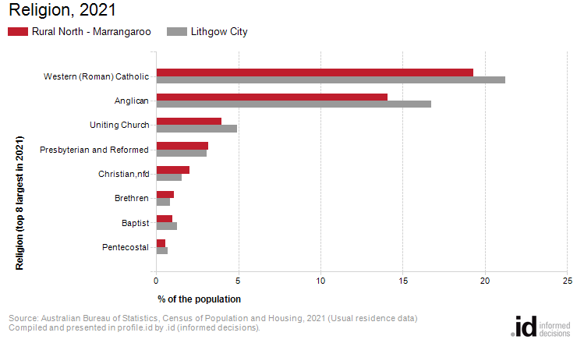
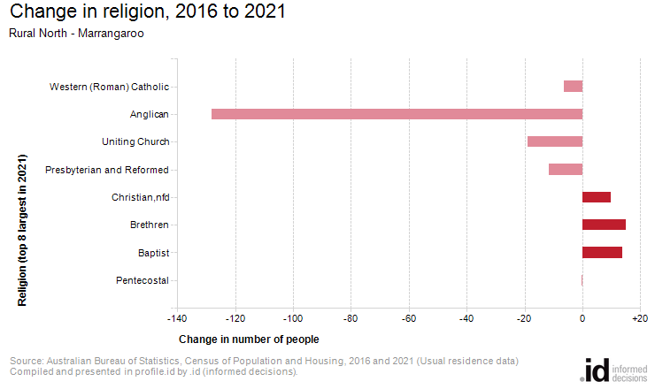
Analysis of the religious affiliation of the population of Rural North - Marrangaroo in 2021 compared to Lithgow City shows that there was a lower proportion of people who professed a religion as well as a lower proportion who stated they had no religion.
Overall, 47.5% of the population nominated a religion, and 28.9% said they had no religion, compared with 54.7% and 35.5% respectively for Lithgow City.
The largest single religion in Rural North - Marrangaroo was Western (Roman) Catholic, with 19.3% of the population or 376 people as adherents.
The major differences between the religious affiliation for the population of Rural North - Marrangaroo and Lithgow City were:
- A smaller percentage who nominated Anglican (14.1% compared to 16.7%)
- A smaller percentage who nominated Western (Roman) Catholic (19.3% compared to 21.3%)
The largest change in the religious affiliation of the population in Rural North - Marrangaroo between 2016 and 2021 was for those who nominated:
- Anglican (-128 persons)

