City of Joondalup

Occupation of employment
Warwick's occupation statistics quantify the occupations in which the residents work (which may be within the residing area or elsewhere). This will be influenced by the economic base and employment opportunities available in the area, education levels, and the working and social aspirations of the population. When viewed with other indicators, such as Educational Qualifications and Individual Income, Occupation is a key measure for evaluating Warwick's socio-economic status and skill base.
Occupation of employment
Warwick - Employed persons (Enumerated) | 2016 |  |  | 2011 |  |  | Change
Occupation | Number | % | City of Joondalup % | Number | % | City of Joondalup % | 2011 to 2016
Managers | 190 | 10.7 | 12.6 | 209 | 10.9 | 12.1 | -19
Professionals | 416 | 23.5 | 23.5 | 426 | 22.1 | 21.9 | -10
Technicians and Trades Workers | 279 | 15.8 | 15.6 | 302 | 15.7 | 16.4 | -23
Community and Personal Service Workers | 203 | 11.5 | 10.7 | 187 | 9.7 | 10.0 | +16
Clerical and Administrative Workers | 270 | 15.3 | 15.2 | 321 | 16.7 | 17.0 | -51
Sales Workers | 171 | 9.7 | 10.0 | 205 | 10.7 | 10.2 | -34
Machinery Operators And Drivers | 71 | 4.0 | 3.8 | 100 | 5.2 | 4.1 | -29
Labourers | 144 | 8.1 | 6.9 | 152 | 7.9 | 7.0 | -8
Not stated or inadequately described | 24 | 1.4 | 1.5 | 22 | 1.1 | 1.2 | +2
Total employed persons aged 15+ | 1,768 | 100.0 | 100.0 | 1,924 | 100.0 | 100.0 | -156
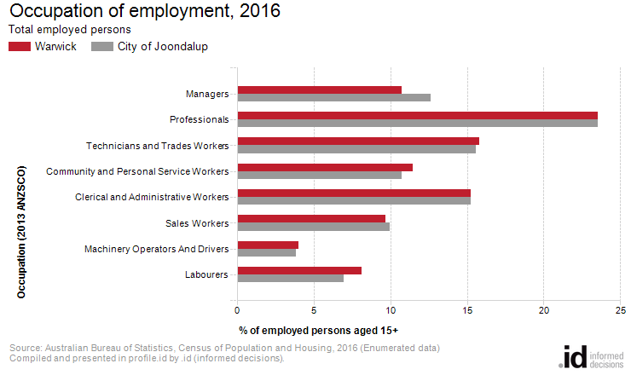
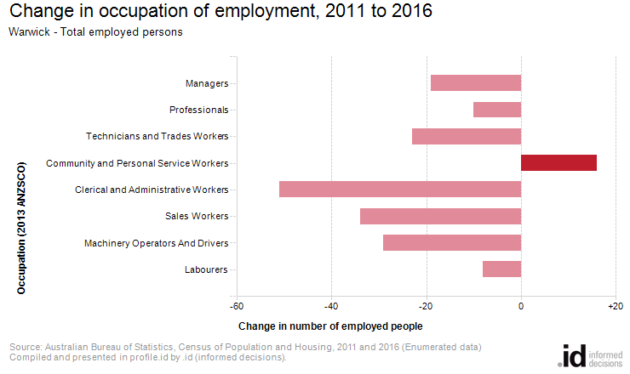
An analysis of the jobs held by the resident population in Warwick in 2016 shows the three most popular occupations were:
- Professionals (416 people or 23.5%)
- Technicians and Trades Workers (279 people or 15.8%)
- Clerical and Administrative Workers (270 people or 15.3%)
In combination these three occupations accounted for 965 people in total or 54.6% of the employed resident population.
In comparison, City of Joondalup employed 23.5% in Professionals; 15.6% in Technicians and Trades Workers; and 15.2% in Clerical and Administrative Workers.
The major differences between the jobs held by the population of Warwick and City of Joondalup were:
- A larger percentage of persons employed as Labourers (8.1% compared to 6.9%)
- A smaller percentage of persons employed as Managers (10.7% compared to 12.6%)
The number of employed people in Warwick decreased by 156 between 2011 and 2016.
The largest change in the occupations of residents between 2011 and 2016 in Warwick was for those employed as:
- Clerical and Administrative Workers (-51 persons)

