Hume City

Volunteer work
The voluntary work sector is an important part of Australia's economy. The level of volunteering can indicate the cohesiveness of the community and how readily individuals are able to contribute to that community. Factors impacting on the level of volunteering in Bulla - Rural include the Age Structure of the population, the level of Proficiency in English, Income and Education levels.
Volunteer numbers for the 2021 Census declined in many parts of Australia due to lockdowns and COVID-19 distancing measures.
Volunteer work
Bulla - Rural - Persons aged 15+ (Usual residence) | 2021 |  |  | 2016 |  |  | Change
Volunteer status | Number | % | Hume City % | Number | % | Hume City % | 2016 to 2021
Volunteer | 126 | 9.9 | 7.3 | 173 | 14.2 | 11.8 | -47
Not a volunteer | 1,006 | 78.9 | 86.6 | 872 | 71.4 | 80.8 | +134
Volunteer work not stated | 144 | 11.3 | 6.1 | 177 | 14.5 | 7.4 | -33
Total persons aged 15+ | 1,276 | 100.0 | 100.0 | 1,222 | 100.0 | 100.0 | +54
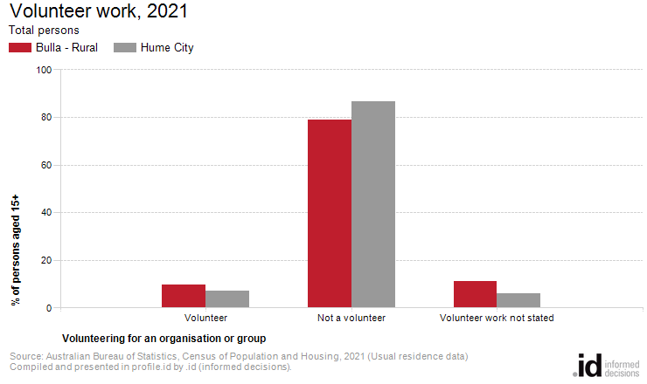
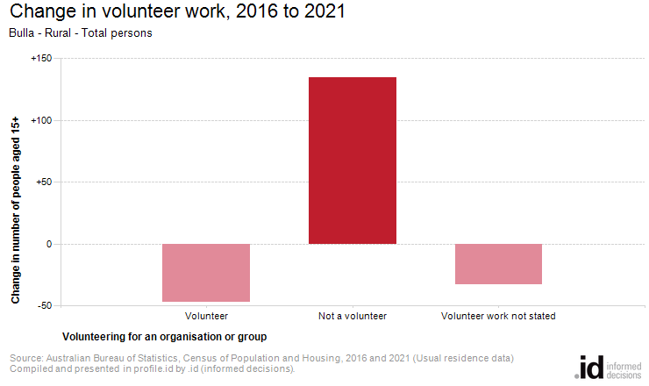
Analysis of the voluntary work performed by the population in Bulla - Rural in 2021 compared to Hume City shows that there was a higher proportion of people who volunteered for an organisation or group.
Overall, 9.9% of the population reported performing voluntary work, compared with 7.3% for Hume City.
The number of volunteers in Bulla - Rural decreased by 47 people between 2016 and 2021.

