Hume City

Housing tenure
Bulla - Rural's Housing Tenure data provides insights into its socio-economic status as well as the role it plays in the housing market. For example, a high concentration of private renters may indicate a transient area attractive to young singles and couples, while a concentration of home owners indicates a more settled area with mature families and empty-nesters (Household Summary). Tenure can also reflect built form (Dwelling Type), with a significantly higher share of renters in high density housing and a substantially larger proportion of home-owners in separate houses, although this is not always the case.
In conjunction with other socio-economic status indicators in Bulla - Rural, Tenure data is useful for analysing housing markets, housing affordability and identifying public housing areas.
Further reading: How can Councils influence affordable housing.
Housing tenure
Bulla - Rural - Households (Enumerated) | 2021 |  |  | 2016 |  |  | Change
Tenure type | Number | % | Hume City % | Number | % | Hume City % | 2016 to 2021
Fully owned | 215 | 40.7 | 23.5 | 184 | 37.6 | 25.2 | +31
Mortgage | 189 | 35.7 | 45.3 | 176 | 35.9 | 43.3 | +13
Renting - Total | 52 | 9.8 | 24.2 | 42 | 8.6 | 23.0 | +10
Renting - Social housing | 0 | 0.0 | 2.3 | 0 | 0.0 | 2.7 | 0
Renting - Private | 52 | 9.8 | 21.7 | 42 | 8.6 | 20.1 | +10
Renting - Not stated | 0 | 0.0 | 0.2 | 0 | 0.0 | 0.2 | 0
Other tenure type | 9 | 1.8 | 1.1 | 9 | 2.0 | 1.1 | 0
Not stated | 62 | 11.9 | 5.9 | 78 | 15.9 | 7.3 | -15
Total households | 529 | 100.0 | 100.0 | 490 | 100.0 | 100.0 | +38
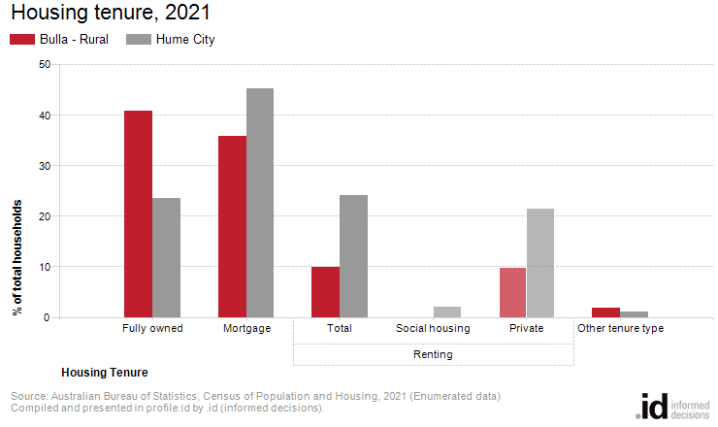
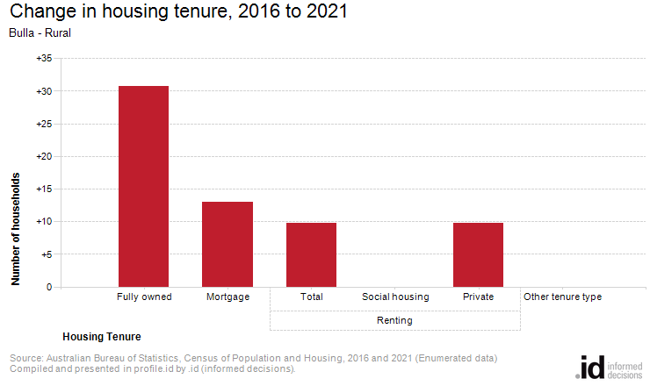
Analysis of the housing tenure of households of Bulla - Rural in 2021 compared to Hume City shows that there was a larger proportion of households who owned their dwelling; a smaller proportion purchasing their dwelling; and a smaller proportion who were renters.
Overall, 40.7% of households owned their dwelling; 35.7% were purchasing, and 9.8% were renting, compared with 23.5%, 45.3% and 24.2% respectively for Hume City.
There were no major differences in Bulla - Rural between 2016 and 2021.
The total number of households in Bulla - Rural increased by 39 between 2016 and 2021.

