Hume City

Highest level of schooling
Bulla - Rural's school completion data is a useful indicator of socio-economic status. With other indicators, such as Proficiency in English, the data informs planners and decision-makers about people's ability to access services. Combined with Educational Qualifications it also allows assessment of the skill base of the population.
Learn more about planning education provision here.
Persons aged 15 years and over
Highest level of secondary schooling completed
Bulla - Rural - Total persons (Usual residence) | 2021 |  |  | 2016 |  |  | Change
Level of schooling | Number | % | Hume City % | Number | % | Hume City % | 2016 to 2021
Year 8 or below | 83 | 6.6 | 6.7 | 103 | 8.4 | 7.8 | -20
Year 9 or equivalent | 105 | 8.3 | 5.9 | 77 | 6.3 | 6.5 | +28
Year 10 or equivalent | 206 | 16.3 | 12.2 | 198 | 16.0 | 14.1 | +8
Year 11 or equivalent | 179 | 14.2 | 10.1 | 179 | 14.5 | 11.7 | 0
Year 12 or equivalent | 528 | 41.7 | 56.1 | 479 | 38.8 | 50.0 | +48
Did not go to school | 24 | 1.9 | 2.9 | 14 | 1.2 | 2.4 | +10
Not stated | 139 | 11.0 | 6.1 | 183 | 14.8 | 7.4 | -44
Total persons aged 15+ | 1,267 | 100.0 | 100.0 | 1,237 | 100.0 | 100.0 | +30
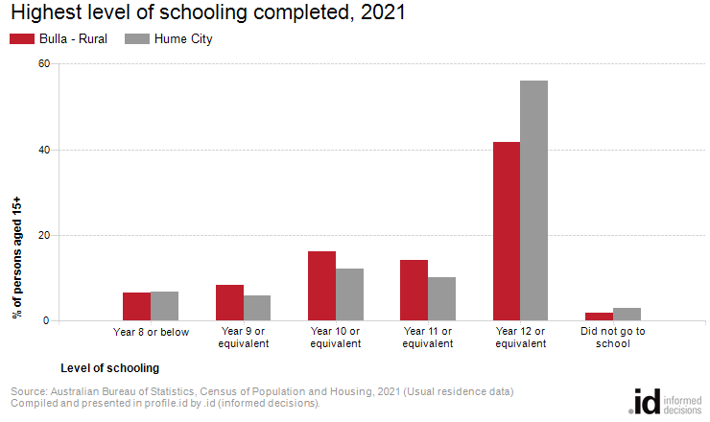
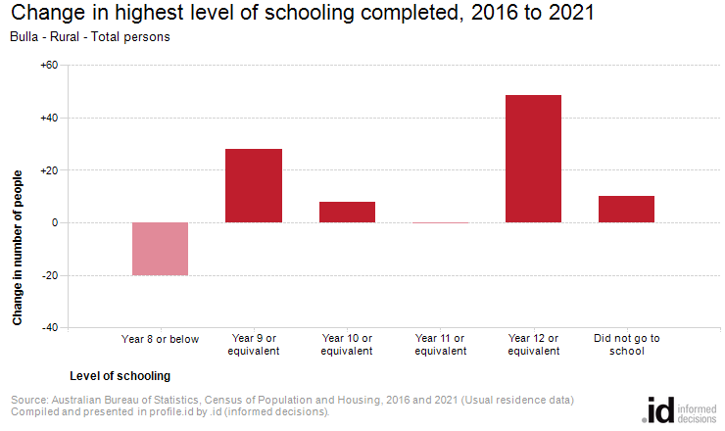
Analysis of the highest level of schooling attained by the population in Bulla - Rural in 2021 compared to Hume City shows that there was a higher proportion of people who had left school at an early level (Year 10 or less) and a lower proportion of people who completed Year 12 or equivalent.
Overall, 33.2% of the population left school at Year 10 or below, and 41.7% went on to complete Year 12 or equivalent, compared with 27.7% and 56.1% respectively for Hume City.
The major differences between the level of schooling attained by the population in Bulla - Rural and Hume City were:
- A larger percentage of persons who completed year 11 or equivalent (14.2% compared to 10.1%)
- A larger percentage of persons who completed year 10 or equivalent (16.3% compared to 12.2%)
- A larger percentage of persons who completed year 9 or equivalent (8.3% compared to 5.9%)
- A smaller percentage of persons who completed year 12 or equivalent (41.7% compared to 56.1%)
There were no major differences in Bulla - Rural between 2016 and 2021.

