Hume City

Household size
The size of households in general follows the life-cycle of families. Households are usually small at the stage of relationship formation (early marriage), and then increase in size with the advent of children. They later reduce in size again as these children reach adulthood and leave home. Household size can also be influenced by a lack (or abundance) of affordable housing. Overseas migrants and indigenous persons often have a tradition of living with extended family members which significantly affects household size.
Household size in Australia has generally declined since the 1970s, but the rate of decline has slowed in recent years.
An increasing household size in an area may indicate a lack of affordable housing opportunities for young people, an increase in the birth rate or an increase in family formation in the area. A declining household size may indicate children leaving the area when they leave home, an increase in retirees settling in the area, or an attraction of young singles and couples to the area.
For greater insight, Bulla - Rural's Household Size data should be viewed in conjunction with Household Summary, Age Structure, Dwelling Type, Household Income and Language Spoken at Home.
Household size
Bulla - Rural - Households (Enumerated) | 2021 |  |  | 2016 |  |  | Change
Number of persons usually resident | Number | % | Hume City % | Number | % | Hume City % | 2016 to 2021
1 person | 74 | 15.5 | 17.1 | 48 | 11.5 | 16.6 | +26
2 persons | 150 | 31.3 | 26.1 | 135 | 32.4 | 26.0 | +14
3 persons | 89 | 18.7 | 19.0 | 75 | 18.0 | 18.6 | +14
4 persons | 89 | 18.7 | 20.7 | 101 | 24.2 | 20.5 | -12
5 persons | 44 | 9.2 | 10.1 | 37 | 9.0 | 10.7 | +6
6 or more persons | 31 | 6.6 | 7.1 | 20 | 4.8 | 7.6 | +11
Total classifiable households | 479 | 100.0 | 100.0 | 419 | 100.0 | 100.0 | +60
Household size - Summary
Bulla - Rural - Enumerated | 2021 |  |  | 2016 |  |  | Change
Dwellings | Number | % | Hume City % | Number | % | Hume City % | 2016 to 2021
Occupied private dwellings | 519 |  |  | 505 |  |  | +14
Persons in occupied private dwellings | 1,517 |  |  | 1,522 |  |  | -5
Average household size (persons per dwelling) | 2.92 |  | 3.04 | 3.01 |  | 3.08 | 0.09
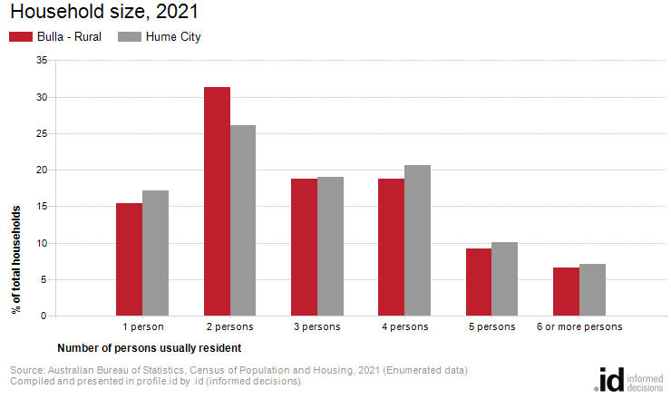
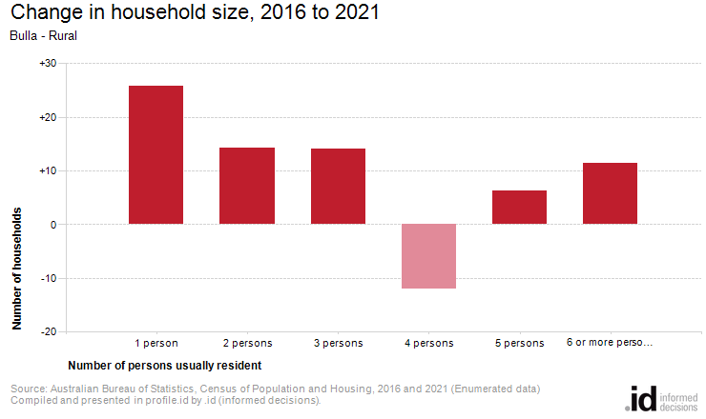
Analysis of the number of persons usually resident in a household in Bulla - Rural compared with Hume City shows that there were a lower proportion of lone person households, and a lower proportion of larger households (those with 4 persons or more). Overall there were 15.5% of lone person households, and 34.5% of larger households, compared with 17.1% and 37.9% respectively for Hume City.
The major differences in the household size for Bulla - Rural and Hume City were:
- A larger percentage of households with 2 persons usually resident (31.3% compared to 26.1%)
- A smaller percentage of households with 4 persons usually resident (18.7% compared to 20.7%)
- A smaller percentage of households with 1 person usually resident (15.5% compared to 17.1%)
The number of households in Bulla - Rural increased by 60 between 2016 and 2021.
There were no major differences in Bulla - Rural between 2016 and 2021.

