Hornsby Shire Council

Internet connection
Please note: For the 2021 Census, the ABS dropped the question regarding household internet connection. This page shows data for the 2016 and previous Censuses only.
An internet connection is now an important utility for most households in Australia. It is increasingly required for accessing essential information and taking part in the digital economy. Australia-wide in 2016, nearly 80% of all households had internet access. However, this decreases with age – seniors are less likely to have internet access at home. The lack of internet access is likely to indicate a level of disadvantage and could be related to socio-economic factors, age, or geographical isolation.
Internet connectivity in Epping North should be looked at in conjunction with Household Type and Age Structure, as well as Education Levels.
Type of internet connection
Epping North - Households | 2016 |  |  | 2011 |  |  | Change
Connection type | Number | % | Hornsby Shire % | Number | % | Hornsby Shire % | 2011 to 2016
Internet connection | 1,324 | 89.6 | 88.6 | 1,250 | 85.4 | 84.9 | +74
No internet connection | 82 | 5.6 | 7.2 | 156 | 10.7 | 10.7 | -74
Not stated | 71 | 4.8 | 4.2 | 58 | 4.0 | 4.4 | +13
Total households | 1,477 | 100.0 | 100.0 | 1,464 | 100.0 | 100.0 | +13
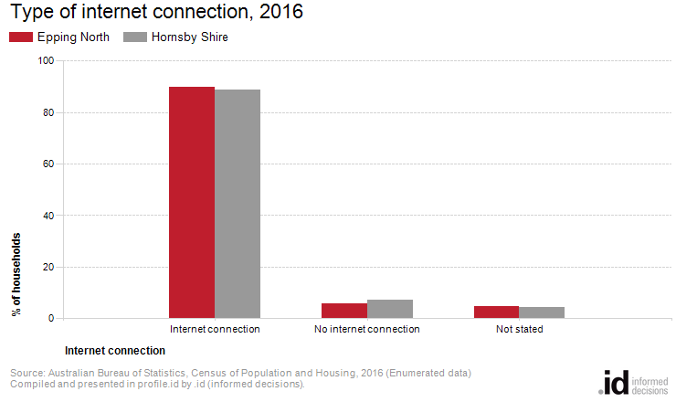
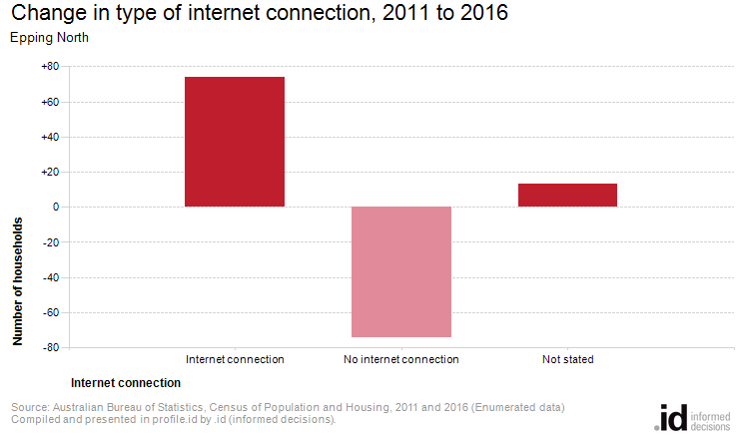
Analysis of the type of internet connection of households in Epping North compared to Hornsby Shire shows that there was a higher proportion of households with an internet connection
Overall 89.6% of households had an internet connection, compared with 88.6% in Hornsby Shire.
Between 2011 and 2016 the number of households with an internet connection increased by 74.

