Hornsby Shire Council

Number of cars per household
The ability of the population to access services and employment is strongly influenced by access to transport. The number of motor vehicles per household in Beecroft - Cheltenham quantifies access to private transport and will be influenced by Age Structure and Household Type, which determine the number of adults present; access to Public Transport; distance to shops, services, employment and education; and Household Income. Depending on these factors, car ownership can be seen as a measure of advantage or disadvantage, or a neutral socio-economic measure, which impacts on the environment and quality of life.
Car ownership
Beecroft - Cheltenham - Households (Enumerated) | 2021 |  |  | 2016 |  |  | Change
Number of cars | Number | % | Hornsby Shire % | Number | % | Hornsby Shire % | 2016 to 2021
No motor vehicles | 121 | 3.7 | 6.6 | 85 | 3.1 | 6.2 | +35
1 motor vehicle | 1,062 | 32.4 | 37.6 | 762 | 27.6 | 34.4 | +299
2 motor vehicles | 1,410 | 43.0 | 36.2 | 1,275 | 46.2 | 37.1 | +135
3 or more motor vehicles | 600 | 18.3 | 17.0 | 550 | 19.9 | 17.8 | +50
Not stated | 87 | 2.7 | 2.6 | 88 | 3.2 | 4.5 | -2
Total households | 3,280 | 100.0 | 100.0 | 2,762 | 100.0 | 100.0 | +517
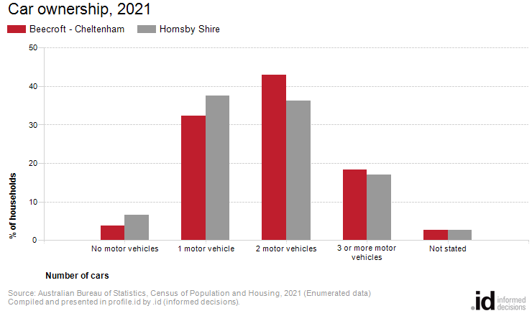
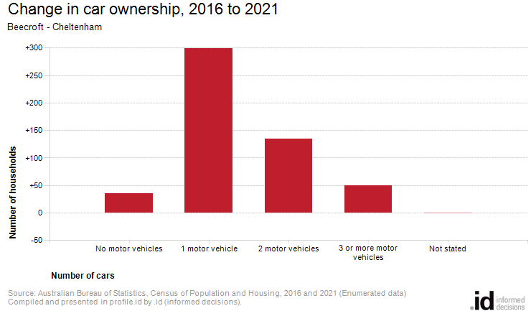
Analysis of the car ownership of the households in Beecroft - Cheltenham in 2021 compared to Hornsby Shire shows that 93.7% of the households owned at least one car, while 3.7% did not, compared with 90.7% and 6.6% respectively in Hornsby Shire.
Of those that owned at least one vehicle, there was a smaller proportion who owned just one car; a larger proportion who owned two cars; and a larger proportion who owned three cars or more.
Overall, 32.4% of the households owned one car; 43.0% owned two cars; and 18.3% owned three cars or more, compared with 37.6%; 36.2% and 17.0% respectively for Hornsby Shire.
The largest changes in the household car ownership in Beecroft - Cheltenham between 2016 and 2021 were:
- 1 motor vehicle (+299 households)
- 2 motor vehicles (+135 households)
- 3 or more motor vehicles (+50 households)

