Hawkesbury City

Birthplace
Country of Birth data identifies where people were born and is indicative of the level of cultural diversity in South Windsor. The mix of Country of Birth groups is also indicative of historical settlement patterns, as source countries for Australia's immigration program have varied significantly over time.
To get a more complete picture of cultural and ethnic characteristics, South Windsor's Country of Birth data should be viewed together with Ancestry, Language Spoken at Home and Religion.
Please note: Due to changes in ABS rules around perturbation and additivity of data to protect the confidentiality of individuals, counts of individual birthplace groups and totals derived from them may differ slightly from those published by the ABS. For more information see notes on data confidentiality.
Birthplace - Summary
South Windsor - Total persons (Usual residence) | 2021 |  |  | 2016 |  |  | Change
Birthplace | Number | % | Hawkesbury City % | Number | % | Hawkesbury City % | 2016 to 2021
Total overseas born | 836 | 14.1 | 13.3 | 700 | 11.9 | 12.3 | +136
Australia | 4,694 | 79.0 | 82.3 | 4,713 | 80.0 | 81.4 | -19
Not stated | 411 | 6.9 | 4.4 | 479 | 8.1 | 6.4 | -68
Total Population | 5,941 | 100.0 | 100.0 | 5,892 | 100.0 | 100.0 | +49
Birthplace - Ranked by size
South Windsor - Overseas born (Usual residence) | 2021 |  |  | 2016 |  |  | Change
Birthplace | Number | % | Hawkesbury City % | Number | % | Hawkesbury City % | 2016 to 2021
United Kingdom | 219 | 3.7 | 3.8 | 252 | 4.3 | 4.3 | -33
India | 103 | 1.7 | 0.8 | 13 | 0.2 | 0.2 | +90
New Zealand | 95 | 1.6 | 1.2 | 93 | 1.6 | 1.3 | +2
Philippines | 92 | 1.5 | 0.5 | 55 | 0.9 | 0.4 | +37
Malta | 21 | 0.4 | 0.7 | 26 | 0.4 | 0.7 | -5
Lebanon | 19 | 0.3 | 0.2 | 8 | 0.1 | 0.1 | +11
Ireland | 17 | 0.3 | 0.3 | 6 | 0.1 | 0.3 | +11
China | 17 | 0.3 | 0.4 | 12 | 0.2 | 0.4 | +5
Germany | 17 | 0.3 | 0.4 | 18 | 0.3 | 0.5 | -1
Greece | 16 | 0.3 | 0.1 | 16 | 0.3 | 0.1 | 0
Thailand | 15 | 0.3 | 0.2 | 22 | 0.4 | 0.1 | -7
Vietnam | 15 | 0.3 | 0.1 | 6 | 0.1 | 0.1 | +9
South Africa | 13 | 0.2 | 0.4 | 13 | 0.2 | 0.4 | 0
Netherlands | 12 | 0.2 | 0.3 | 14 | 0.2 | 0.4 | -2
South Korea | 11 | 0.2 | 0.1 | 3 | 0.1 | 0.1 | +8
Sri Lanka | 10 | 0.2 | 0.1 | 3 | 0.1 | 0.0 | +7
Uruguay | 10 | 0.2 | 0.1 | 4 | 0.1 | 0.1 | +6
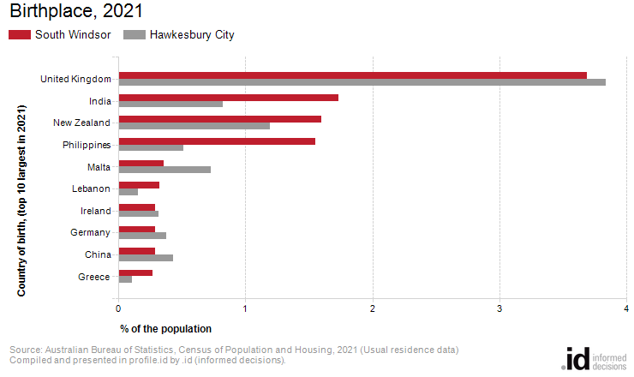
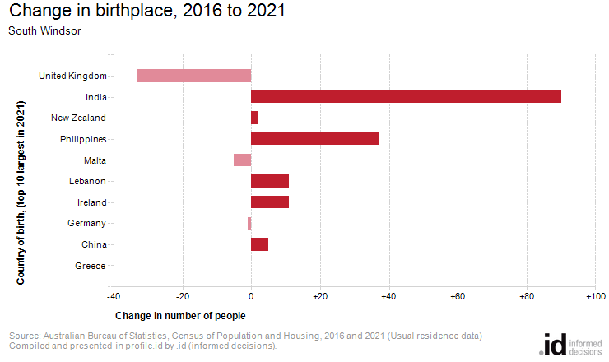
Analysis of the country of birth of the population in South Windsor in 2021 compared to Hawkesbury City shows that there was a larger proportion of people born overseas.
Overall, 14.1% of the population was born overseas, compared with 13.3% for Hawkesbury City.
The major difference between the countries of birth of the population in South Windsor and Hawkesbury City was:
- A larger percentage of people born in Philippines (1.5% compared to 0.5%)
The major difference between the countries of birth of the population in South Windsor and Hawkesbury City was:
- A larger percentage of people born in Philippines (1.5% compared to 0.5%)
Between 2016 and 2021, the number of people born overseas increased by 136 or 19.4%.
The largest change in birthplace countries of the population in this area between 2016 and 2021 was for those born in:
- India (+90 persons)

