Fairfield City

Religion
Mount Pritchard's religion statistics provide an indicator of cultural identity and ethnicity when observed in conjunction with other key variables. Religion data reveal the major concentrations of religions as well as revealing the proportion of people with no religious affiliation. There are a number of reasons for different religious compositions across areas including the country of birth and ethnic background of the population, the age of the population (belief in religion is generally stronger, the older the population) and changes in values and belief systems.
Mount Pritchard's religion statistics should be analysed in conjunction with other ethnicity statistics such as Country of Birth data and Language Spoken data to assist in identifying specific cultural and ethnic groups.
Please note: Due to changes in ABS rules around perturbation and additivity of data to protect the confidentiality of individuals, counts of individual religion groups and totals derived from them may differ slightly from those published by the ABS.
Religion - Summary
Mount Pritchard - Total persons (Usual residence) | 2021 |  |  | 2016 |  |  | Change
Religion totals | Number | % | Fairfield City % | Number | % | Fairfield City % | 2016 to 2021
Christian total | 4,423 | 44.9 | 50.3 | 4,874 | 51.5 | 51.6 | -451
Non Christian total | 2,803 | 28.4 | 27.8 | 2,452 | 25.9 | 28.3 | +351
Non-classifiable religious belief | 35 | 0.4 | 0.3 | 38 | 0.4 | 0.4 | -4
No Religion/secular beliefs | 1,802 | 18.3 | 14.7 | 1,288 | 13.6 | 12.7 | +513
Not stated | 792 | 8.0 | 7.0 | 818 | 8.6 | 7.0 | -26
Total Population | 9,855 | 100.0 | 100.0 | 9,471 | 100.0 | 100.0 | +383
Religion - Ranked by size
Mount Pritchard - Total persons (Usual residence) | 2021 |  |  | 2016 |  |  | Change
Religion | Number | % | Fairfield City % | Number | % | Fairfield City % | 2016 to 2021
Western (Roman) Catholic | 2,241 | 22.7 | 26.3 | 2,387 | 25.1 | 28.1 | -146
Buddhism | 1,798 | 18.2 | 19.9 | 1,635 | 17.2 | 20.7 | +162
Islam | 814 | 8.3 | 6.3 | 644 | 6.8 | 5.9 | +170
Anglican | 454 | 4.6 | 2.6 | 661 | 7.0 | 3.7 | -207
Christian,nfd | 373 | 3.8 | 4.0 | 306 | 3.2 | 3.6 | +67
Serbian Orthodox | 373 | 3.8 | 1.4 | 374 | 3.9 | 1.5 | -1
Greek Orthodox | 165 | 1.7 | 1.3 | 166 | 1.8 | 1.3 | -1
Baptist | 136 | 1.4 | 1.1 | 125 | 1.3 | 1.3 | +11
Other Non-Christian Religions | 117 | 1.2 | 0.7 | 106 | 1.1 | 0.7 | +10
Other Eastern Orthodox | 65 | 0.7 | 0.3 | 57 | 0.6 | 0.2 | +8
Assyrian Apostolic | 64 | 0.6 | 4.8 | 47 | 0.5 | 3.8 | +17
Latter Day Saints (Mormons) | 62 | 0.6 | 0.3 | 99 | 1.0 | 0.5 | -37
Pentecostal | 62 | 0.6 | 0.5 | 113 | 1.2 | 0.8 | -51
Presbyterian and Reformed | 55 | 0.6 | 0.4 | 86 | 0.9 | 0.6 | -31
Other Eastern Catholic | 53 | 0.5 | 3.7 | 15 | 0.2 | 2.5 | +37
Other Protestant | 51 | 0.5 | 0.4 | 33 | 0.3 | 0.4 | +18
Hinduism | 50 | 0.5 | 0.6 | 50 | 0.5 | 0.7 | 0
Jehova's Witnesses | 46 | 0.5 | 0.3 | 52 | 0.6 | 0.4 | -7
Uniting Church | 44 | 0.4 | 0.5 | 97 | 1.0 | 0.7 | -53
Seventh Day Adventist | 32 | 0.3 | 0.2 | 41 | 0.4 | 0.3 | -9
Macedonian Orthodox | 30 | 0.3 | 0.4 | 41 | 0.4 | 0.5 | -11
Coptic Orthodox | 28 | 0.3 | 0.2 | 19 | 0.2 | 0.2 | +9
Russian Orthodox | 21 | 0.2 | 0.3 | 27 | 0.3 | 0.4 | -6
Lutheran | 20 | 0.2 | 0.1 | 15 | 0.2 | 0.1 | +5
Sikhism | 16 | 0.2 | 0.1 | 10 | 0.1 | 0.1 | +6
Maronite Catholic | 12 | 0.1 | 0.3 | 10 | 0.1 | 0.3 | +2
Other Christian | 12 | 0.1 | 0.0 | 0 | 0.0 | 0.1 | +12
Other Oriental Orthodox | 12 | 0.1 | 0.4 | 13 | 0.1 | 0.2 | -1
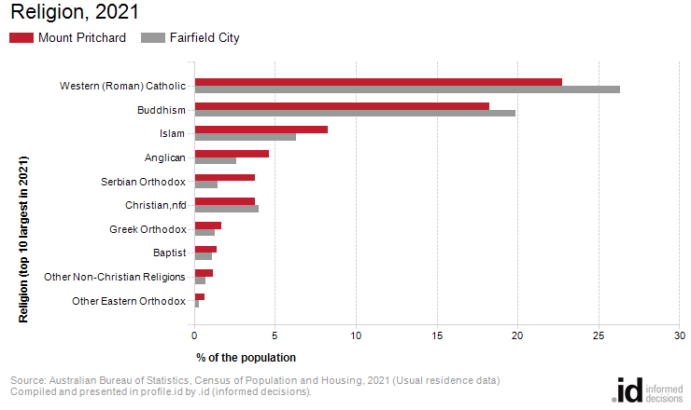
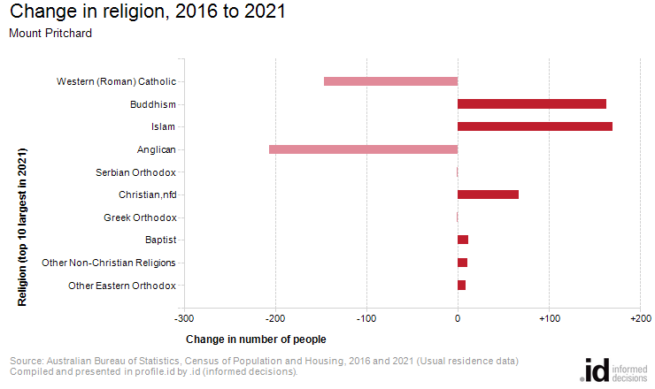
Analysis of the religious affiliation of the population of Mount Pritchard in 2021 compared to Fairfield City shows that there was a lower proportion of people who professed a religion and a higher proportion who stated they had no religion.
Overall, 73.3% of the population nominated a religion, and 18.3% said they had no religion, compared with 78.0% and 14.7% respectively for Fairfield City.
The largest single religion in Mount Pritchard was Western (Roman) Catholic, with 22.7% of the population or 2,241 people as adherents.
The major differences between the religious affiliation for the population of Mount Pritchard and Fairfield City were:
- A larger percentage who nominated Serbian Orthodox (3.8% compared to 1.4%)
- A smaller percentage who nominated Assyrian Apostolic (0.6% compared to 4.8%)
- A smaller percentage who nominated Western (Roman) Catholic (22.7% compared to 26.3%)
- A smaller percentage who nominated Other Eastern Catholic (0.5% compared to 3.7%)
The largest changes in the religious affiliation of the population in Mount Pritchard between 2016 and 2021 were for those who nominated:
- Anglican (-207 persons)
- Islam (+170 persons)
- Buddhism (+162 persons)
- Western (Roman) Catholic (-146 persons)

