Eastern Metropolitan Regional Council

Workers' place of residence
Where does the EMRC area's workforce come from? Journey to Work data sheds light on how many workers live locally, how many commute from other areas and which areas they commute from. Some areas attract a large external workforce because they have major employment centres or because local residents have a different set of skills or aspirations than the local jobs require. Understanding where workers reside assists in planning and advocacy for roads and public transport provision. It also helps to clarify economic and employment drivers across areas and assists in understanding the degree to which the EMRC area provides local employment.
Please note: Although this page references the Developing East Arnhem area, the data given is based on the East Arnhem LGA.
Residential location of local workers
EMRC area | 2021
Location | Number | %
Live and work in the area | 51,495 | 51.0
Live and work in the same LGA | 35,181 | 34.8
Work in but live outside in a different LGA | 16,314 | 16.1
Work in the area, but live outside | 49,562 | 49.0
Total | 101,057 | 100.0
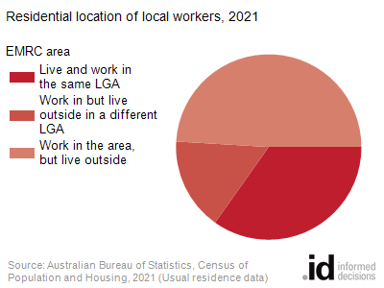
Residential location of local workers by LGA
EMRC area | 2021
LGA | Number | Percentage
Swan | 30,776 | 30.5
Stirling | 9,885 | 9.8
Bayswater | 9,550 | 9.5
Wanneroo | 9,124 | 9.0
Mundaring | 8,443 | 8.4
Joondalup | 5,169 | 5.1
Kalamunda | 4,256 | 4.2
Gosnells | 3,079 | 3.0
Bassendean | 2,726 | 2.7
Canning | 2,166 | 2.1
Armadale | 2,072 | 2.1
Belmont | 1,946 | 1.9
Cockburn | 1,369 | 1.4
Melville | 1,175 | 1.2
Vincent | 1,143 | 1.1
Victoria Park | 1,010 | 1.0
Rockingham | 841 | 0.8
South Perth | 815 | 0.8
Perth | 655 | 0.6
Chittering | 616 | 0.6
Serpentine-Jarrahdale | 491 | 0.5
Cambridge | 439 | 0.4
Kwinana | 422 | 0.4
Northam | 380 | 0.4
Mandurah | 326 | 0.3
Nedlands | 259 | 0.3
Fremantle | 235 | 0.2
Subiaco | 218 | 0.2
Toodyay | 194 | 0.2
Claremont | 93 | 0.1
Mosman Park | 83 | 0.1
Gingin | 81 | 0.1
Cottesloe | 78 | 0.1
Murray | 58 | 0.1
York | 57 | 0.1
Busselton | 48 | 0.0
East Fremantle | 45 | 0.0
No usual address (WA) | 43 | 0.0
Broome | 35 | 0.0
Harvey | 26 | 0.0
Capel | 20 | 0.0
Greater Geraldton | 19 | 0.0
Beverley | 19 | 0.0
Gold Coast | 18 | 0.0
Bunbury | 17 | 0.0
Brisbane | 16 | 0.0
Karratha | 16 | 0.0
Albany | 15 | 0.0
Augusta Margaret River | 14 | 0.0
East Pilbara | 14 | 0.0
Port Adelaide Enfield | 12 | 0.0
Ashburton | 11 | 0.0
Logan | 11 | 0.0
Townsville | 11 | 0.0
Dandaragan | 11 | 0.0
Port Hedland | 11 | 0.0
Victoria Plains | 10 | 0.0
Esperance | 10 | 0.0
Laverton | 10 | 0.0
Northern Beaches | 10 | 0.0

