Eastern Metropolitan Regional Council

Occupation of employment
City of Bayswater's occupation statistics quantify the occupations in which the residents work (which may be within the residing area or elsewhere). This will be influenced by the economic base and employment opportunities available in the area, education levels, and the working and social aspirations of the population. When viewed with other indicators, such as Educational Qualifications and Individual Income, Occupation is a key measure for evaluating City of Bayswater's socio-economic status and skill base.
Occupation of employment
City of Bayswater - Employed persons (Enumerated) | 2016 |  |  | 2011 |  |  | Change
Occupation | Number | % | EMRC area % | Number | % | EMRC area % | 2011 to 2016
Managers | 3,677 | 11.4 | 10.7 | 3,401 | 10.6 | 10.7 | +276
Professionals | 7,731 | 23.9 | 18.2 | 7,145 | 22.4 | 17.5 | +586
Technicians and Trades Workers | 4,783 | 14.8 | 16.4 | 5,085 | 15.9 | 17.1 | -302
Community and Personal Service Workers | 3,572 | 11.1 | 11.6 | 3,140 | 9.8 | 10.1 | +432
Clerical and Administrative Workers | 4,545 | 14.1 | 14.6 | 5,118 | 16.0 | 16.3 | -573
Sales Workers | 2,903 | 9.0 | 9.5 | 2,864 | 9.0 | 9.4 | +39
Machinery Operators And Drivers | 1,785 | 5.5 | 7.7 | 2,008 | 6.3 | 7.9 | -223
Labourers | 2,789 | 8.6 | 9.6 | 2,730 | 8.5 | 9.5 | +59
Not stated or inadequately described | 537 | 1.7 | 1.7 | 459 | 1.4 | 1.5 | +78
Total employed persons aged 15+ | 32,322 | 100.0 | 100.0 | 31,950 | 100.0 | 100.0 | +372
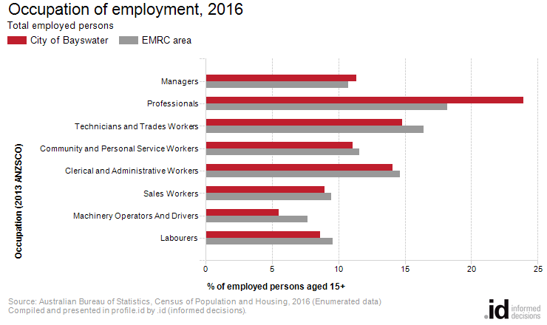
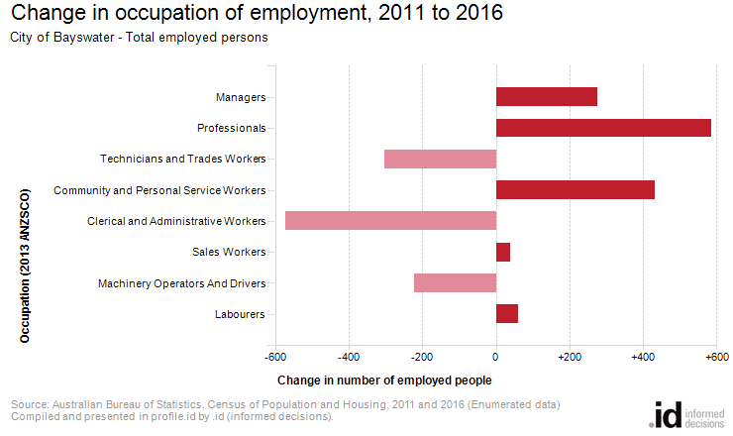
An analysis of the jobs held by the resident population in City of Bayswater in 2016 shows the three most popular occupations were:
- Professionals (7,731 people or 23.9%)
- Technicians and Trades Workers (4,783 people or 14.8%)
- Clerical and Administrative Workers (4,545 people or 14.1%)
In combination these three occupations accounted for 17,059 people in total or 52.8% of the employed resident population.
In comparison, EMRC area employed 18.2% in Professionals; 16.4% in Technicians and Trades Workers; and 14.6% in Clerical and Administrative Workers.
The major differences between the jobs held by the population of City of Bayswater and EMRC area were:
- A larger percentage of persons employed as Professionals (23.9% compared to 18.2%)
- A smaller percentage of persons employed as Machinery Operators And Drivers (5.5% compared to 7.7%)
- A smaller percentage of persons employed as Technicians and Trades Workers (14.8% compared to 16.4%)
The number of employed people in City of Bayswater increased by 372 between 2011 and 2016.
The largest changes in the occupations of residents between 2011 and 2016 in City of Bayswater were for those employed as:
- Professionals (+586 persons)
- Clerical and Administrative Workers (-573 persons)
- Community and Personal Service Workers (+432 persons)
- Technicians and Trades Workers (-302 persons)

