City of Darebin

Method of travel to work
The City of Darebin's commuting statistics reveal the main modes of transport by which residents get to work. There are a number of reasons why people use different modes of transport to get to work including the availability of affordable and effective public transport options, the number of motor vehicles available within a household, and the distance travelled to work.
Commuting data is very useful in transport planning as it informs decision-makers about the availability, effectiveness and utilisation of local transport options, particularly when analysed with Residents Place of Work data and Car Ownership.
WARNING: Method of travel to work relates to Census day, which for the 2021 Census occurred during COVID-19 lockdowns for large parts of Australia. In lockdown, many occupations were required to work from home if possible, and some industries were closed, so people did not go to work. For this reason, these categories may have increased, with corresponding declines in other methods of travel. Use the data with caution when comparing over time. For more details, please refer to the data notes.
Method of travel to work
City of Darebin - Employed persons (Usual residence) | 2021 |  |  | 2016 |  |  | Change
Main method of travel | Number | % | Greater Melbourne % | Number | % | Greater Melbourne % | 2016 to 2021
Train | 3,558 | 4.5 | 3.6 | 11,657 | 16.6 | 11.5 | -8,099
Bus | 929 | 1.2 | 0.8 | 1,572 | 2.2 | 1.5 | -643
Tram | 1,106 | 1.4 | 0.8 | 3,517 | 5.0 | 2.4 | -2,411
Ferry | 8 | 0.0 | 0.0 | 17 | 0.0 | 0.0 | -9
Taxi/ride-share | 185 | 0.2 | 0.2 | 154 | 0.2 | 0.2 | +31
Car - as driver | 28,663 | 36.2 | 46.5 | 35,039 | 49.8 | 60.2 | -6,376
Car - as passenger | 1,790 | 2.3 | 3.2 | 2,213 | 3.1 | 3.9 | -423
Truck | 242 | 0.3 | 0.5 | 286 | 0.4 | 0.6 | -44
Motorbike | 274 | 0.3 | 0.2 | 408 | 0.6 | 0.4 | -134
Bicycle | 1,890 | 2.4 | 0.7 | 3,237 | 4.6 | 1.4 | -1,347
Walked only | 1,371 | 1.7 | 2.0 | 1,628 | 2.3 | 3.0 | -257
Other | 803 | 1.0 | 1.0 | 1,012 | 1.4 | 1.2 | -209
Worked at home | 28,459 | 36.0 | 28.8 | 2,553 | 3.6 | 4.2 | +25,906
Did not go to work | 9,521 | 12.0 | 11.2 | 6,365 | 9.1 | 8.7 | +3,156
Not stated | 287 | 0.4 | 0.4 | 649 | 0.9 | 0.9 | -362
Total employed persons aged 15+ | 79,086 | 100.0 | 100.0 | 70,307 | 100.0 | 100.0 | +8,779
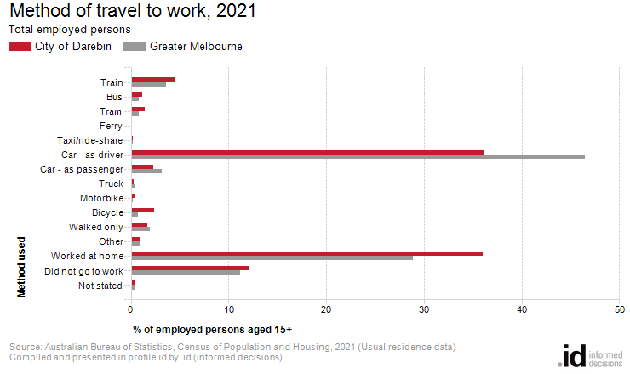
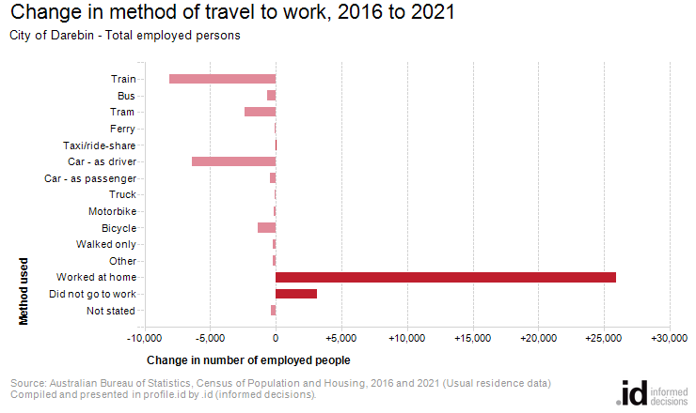
In 2021, there were 5,601 people who caught public transport to work (train, bus, tram or ferry) in City of Darebin, compared with 30,969 who drove in private vehicles (car – as driver, car – as passenger, motorbike, or truck).
Analysis of the method of travel to work of the residents in the City of Darebin in 2021, compared to Greater Melbourne, shows that 7.1% used public transport, while 38.5% used a private vehicle, compared with 5.3% and 49.7% respectively in Greater Melbourne.
The major differences in persons between the method of travel to work of the City of Darebin and Greater Melbourne were:
- A larger percentage of persons who worked at home (36.0% compared to 28.8%)
- A larger percentage of persons who travelled by bicycle (2.4% compared to 0.7%)
- A smaller percentage of persons who travelled by car (as driver) (36.2% compared to 46.5%)
The number of employed people in City of Darebin increased by 8,779 between 2016 and 2021.
The largest changes in the method of travel to work by resident population in the City of Darebin between 2016 and 2021 were for those nominated:
- Worked at home (+25,906 persons)
- Train (-8,099 persons)
- Car - as driver (-6,376 persons)
- Did not go to work (+3,156 persons)

