City of Darebin

Method of travel to work
Northcote's commuting statistics reveal the main modes of transport by which residents get to work. There are a number of reasons why people use different modes of transport to get to work including the availability of affordable and effective public transport options, the number of motor vehicles available within a household, and the distance travelled to work.
Commuting data is very useful in transport planning as it informs decision-makers about the availability, effectiveness and utilisation of local transport options, particularly when analysed with Residents Place of Work data and Car Ownership.
WARNING: Method of travel to work relates to Census day, which for the 2021 Census occurred during COVID-19 lockdowns for large parts of Australia. In lockdown, many occupations were required to work from home if possible, and some industries were closed, so people did not go to work. For this reason, these categories may have increased, with corresponding declines in other methods of travel. Use the data with caution when comparing over time. For more details, please refer to the data notes.
Method of travel to work
Northcote - Employed persons (Usual residence) | 2021 |  |  | 2016 |  |  | Change
Main method of travel | Number | % | Victoria % | Number | % | Victoria % | 2016 to 2021
Train | 602 | 4.0 | 2.9 | 2,652 | 19.7 | 9.2 | -2,050
Bus | 139 | 0.9 | 0.8 | 268 | 2.0 | 1.3 | -129
Tram | 244 | 1.6 | 0.6 | 984 | 7.3 | 1.9 | -741
Ferry | 0 |  | 0.0 | 0 |  | 0.0 | 0
Taxi/ride-share | 27 | 0.2 | 0.2 | 3 | 0.0 | 0.2 | +24
Car - as driver | 3,674 | 24.6 | 49.9 | 5,266 | 39.1 | 61.8 | -1,592
Car - as passenger | 211 | 1.4 | 3.5 | 273 | 2.0 | 4.0 | -63
Truck | 30 | 0.2 | 0.5 | 7 | 0.1 | 0.6 | +22
Motorbike | 40 | 0.3 | 0.2 | 65 | 0.5 | 0.4 | -26
Bicycle | 665 | 4.5 | 0.7 | 1,302 | 9.7 | 1.2 | -638
Walked only | 366 | 2.5 | 2.3 | 450 | 3.3 | 3.2 | -84
Other | 132 | 0.9 | 1.0 | 210 | 1.6 | 1.2 | -79
Worked at home | 6,975 | 46.7 | 25.7 | 682 | 5.1 | 4.6 | +6,292
Did not go to work | 1,797 | 12.0 | 11.2 | 1,190 | 8.8 | 9.3 | +606
Not stated | 26 | 0.2 | 0.5 | 107 | 0.8 | 1.0 | -82
Total employed persons aged 15+ | 14,928 | 100.0 | 100.0 | 13,467 | 100.0 | 100.0 | +1,461
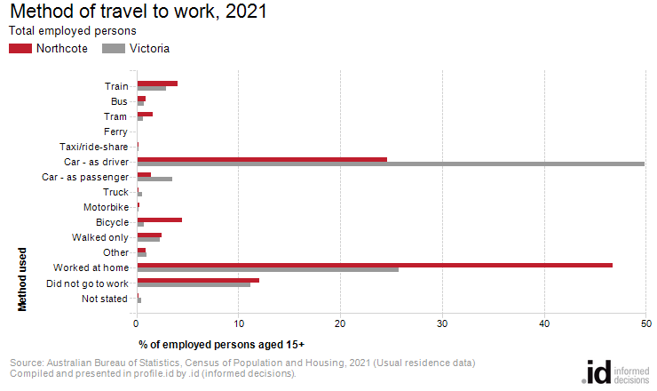
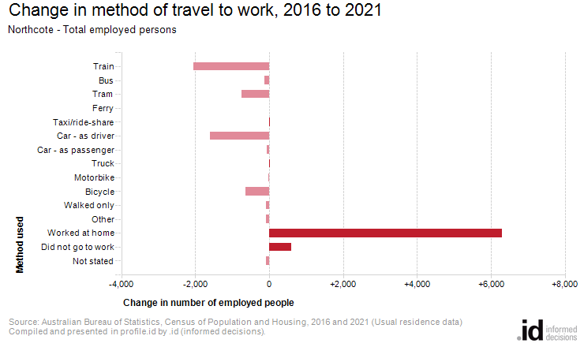
In 2021, there were 985 people who caught public transport to work (train, bus, tram or ferry) in Northcote, compared with 3,955 who drove in private vehicles (car – as driver, car – as passenger, motorbike, or truck).
Analysis of the method of travel to work of the residents in Northcote in 2021, compared to Victoria, shows that 6.6% used public transport, while 26.0% used a private vehicle, compared with 4.3% and 53.4% respectively in Victoria.
The major differences in persons between the method of travel to work of Northcote and Victoria were:
- A larger percentage of persons who worked at home (46.7% compared to 25.7%)
- A larger percentage of persons who travelled by bicycle (4.5% compared to 0.7%)
- A smaller percentage of persons who travelled by car (as driver) (24.6% compared to 49.9%)
- A smaller percentage of persons who travelled by car (as a passenger) (1.4% compared to 3.5%)
The number of employed people in Northcote increased by 1,461 between 2016 and 2021.
The largest changes in the method of travel to work by resident population in Northcote between 2016 and 2021 were for those nominated:
- Worked at home (+6,292 persons)
- Train (-2,050 persons)
- Car - as driver (-1,592 persons)
- Tram (-741 persons)

